Module 1 - Operations using Data Types and Operators
1.1 Introduction
What is Python?
Python is a powerful and easy-to-learn programming language created by Guido van Rossum and officially released in 1991. Its simple syntax and versatility make it one of the most widely used languages in the world.
Python is commonly used for:
- Web application development
- Software and application development
- Data analysis and mathematics
- Automation and scripting tasks
What Can Python Do?
Python helps developers build a wide range of applications and solutions efficiently.
With Python, you can:
- Develop dynamic websites and web applications
- Automate repetitive workflows and processes
- Connect with databases and manage files
- Analyze large datasets and perform advanced calculations
- Build scalable and production-ready software solutions
Why Choose Python?
Python is popular among beginners and professionals because of its simplicity, flexibility, and wide industry adoption.
Key advantages of Python:
- Works across multiple platforms such as Windows, macOS, and Linux
- Uses clean and readable syntax that is easy to understand
- Reduces development time with concise and efficient code
- Supports rapid prototyping and faster application development
- Has a large community and extensive library ecosystem
Where Python Is Used:
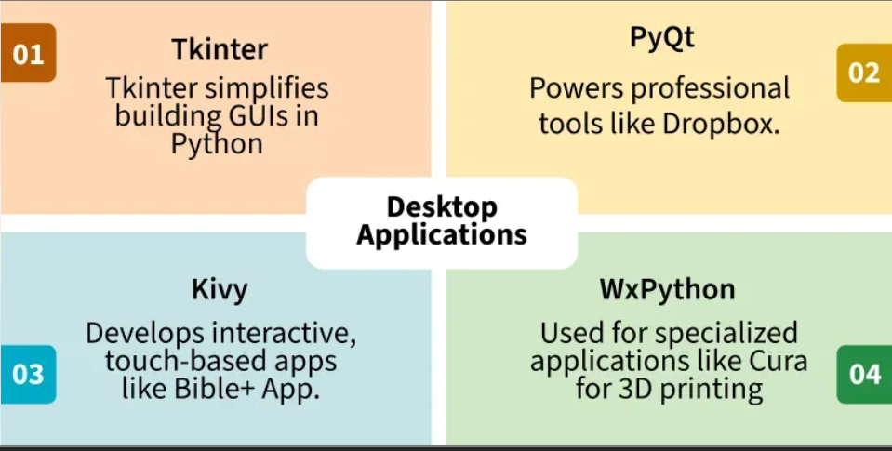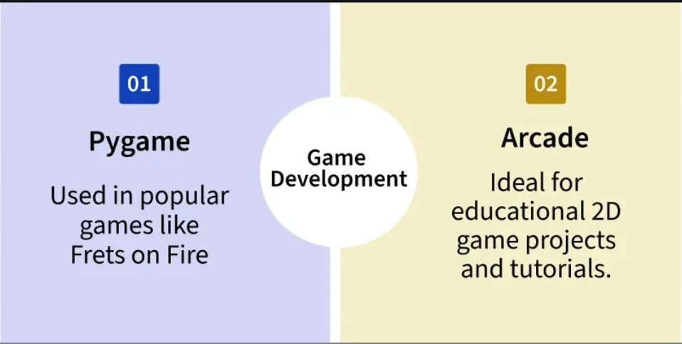
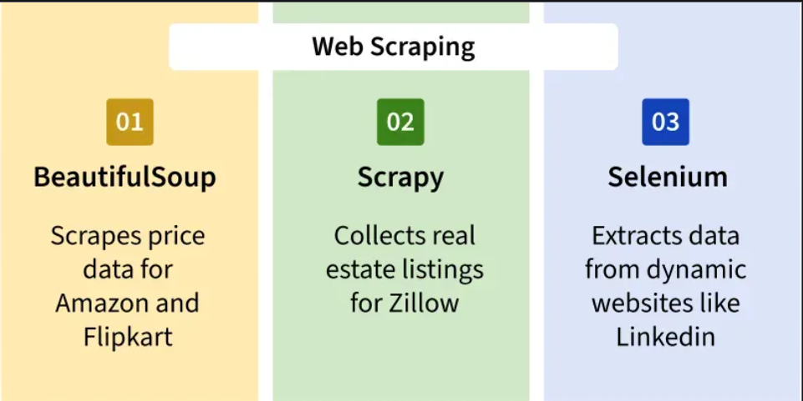
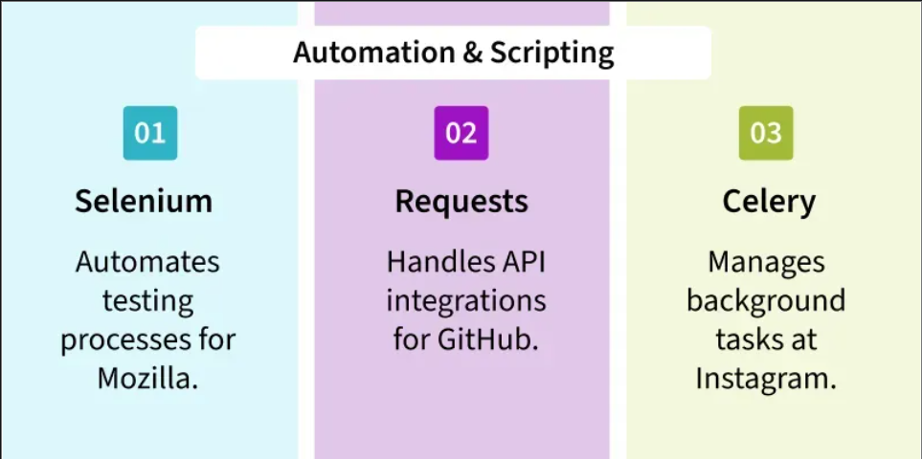
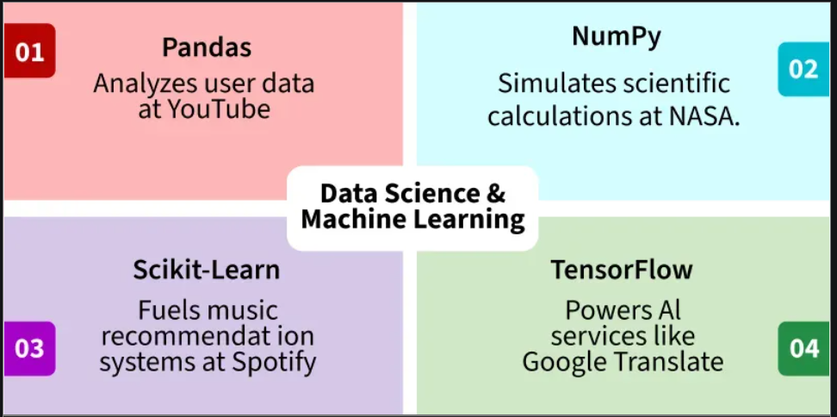
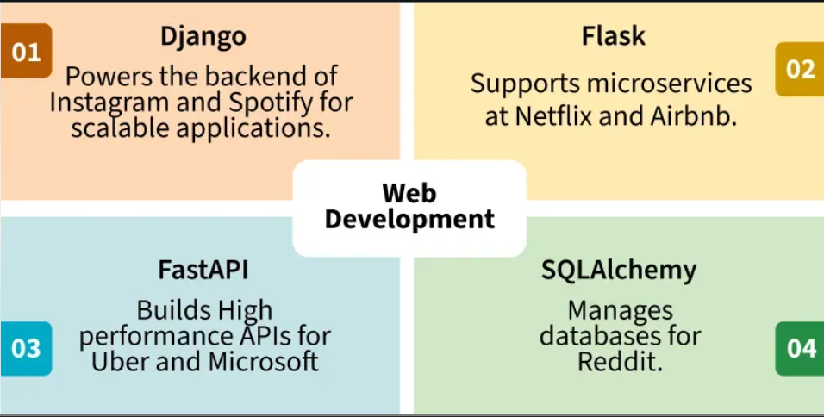
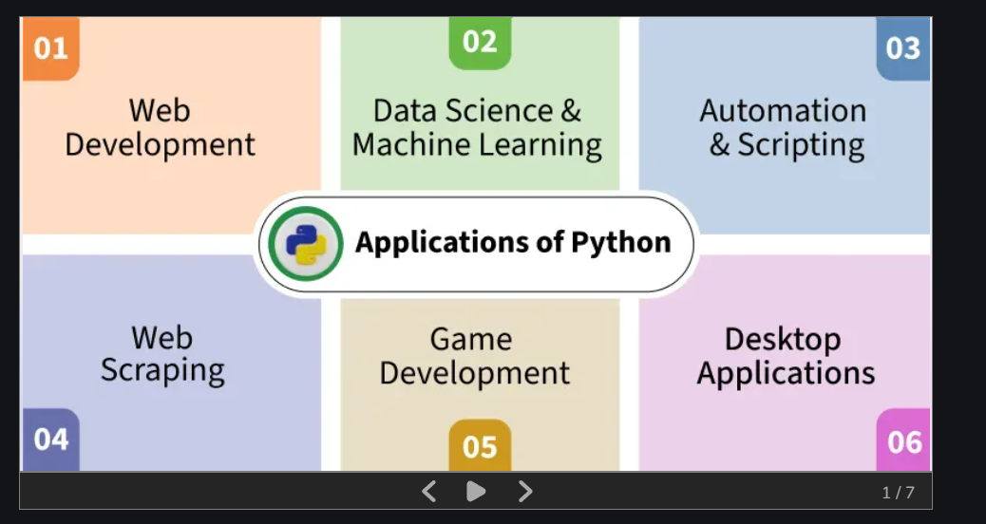
Slide formats make it
Python Coding Platforms Installation
Google Colab
Google Colab is an online Python coding platform that runs directly in the browser. No installation is required.
Steps
- Open your browser.
- Visit: Google Colab
- Sign in with your Google account.
- Click New Notebook to start coding in Python.
VS Code Installation
Visual Studio Code (VS Code) is a lightweight and powerful code editor for Python development.
Steps
- Download VS Code from:
Visual Studio Code
- Install the software.
- Open VS Code and install the Python Extension from the Extensions section.
- Create a .py file and start coding.
Jupyter Notebook Installation
Jupyter Notebook is widely used for data analysis, machine learning, and interactive Python coding.
Steps
- Open Command Prompt.
- Install Jupyter Notebook using:
pip install notebook
- Start Jupyter Notebook using:
jupyter notebook
- Jupyter Notebook will open in your browser automatically.
Writing Your First Python Program
Now that Python is installed, let us write and run our first Python program.
In Python, the print () function is used to display output on the screen.
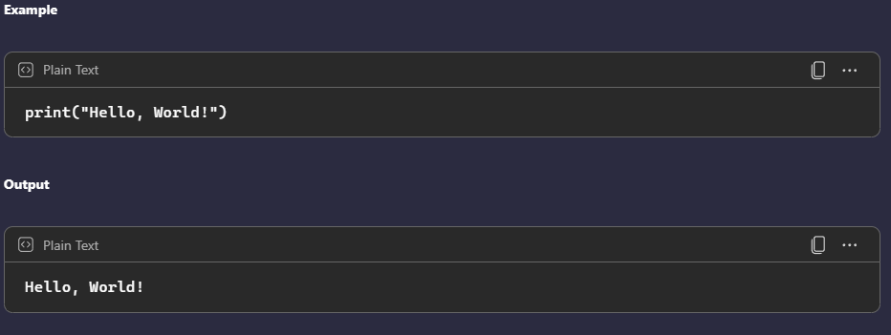
Explanation
- print() displays text or values on the screen.
- "Hello, World!" is the message shown as output.
- This is the first program commonly written by beginners while learning Python.
Python Comments
Comments can be used to explain Python code.
Comments can be used to make the code more readable.
Comments can be used to prevent execution when testing code.
Creating a Comment
Comments starts with a #, and Python will ignore them:
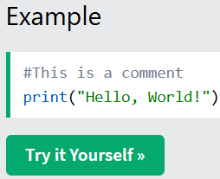
Comments can be placed at the end of a line, and Python will ignore the rest of the line:
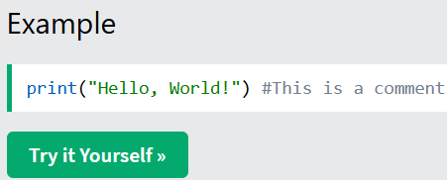
A comment does not have to be text that explains the code, it can also be used to prevent Python from executing code:
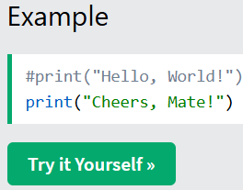
Multiline Comments
Python does not really have a syntax for multiline comments.
To add a multiline comment, you could insert a # for each line:
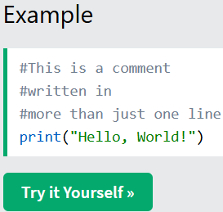
Or, not quite as intended, you can use a multiline string.
Since Python will ignore string literals that are not assigned to a variable, you can add a multiline string (triple quotes) in your code, and place your comment inside it:
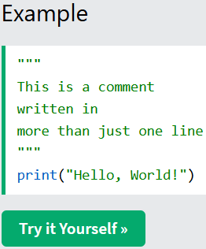
As long as the string is not assigned to a variable, Python will read the code, but then ignore it, and you have made a multiline comment.
Practice: Python Comment
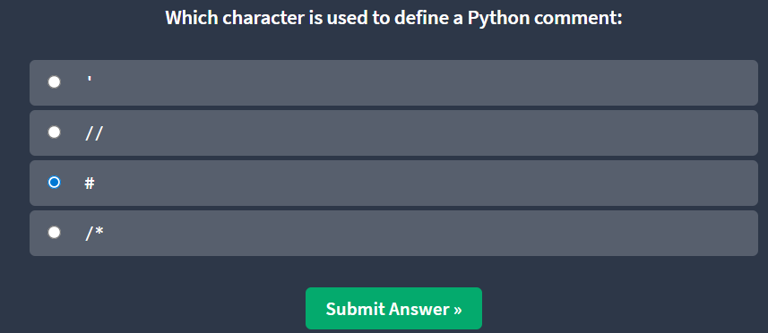
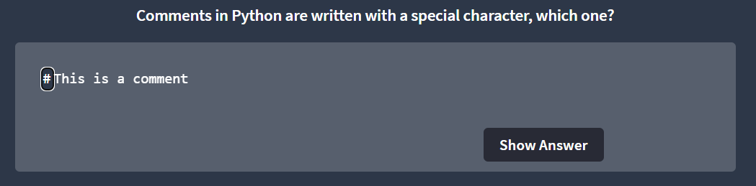
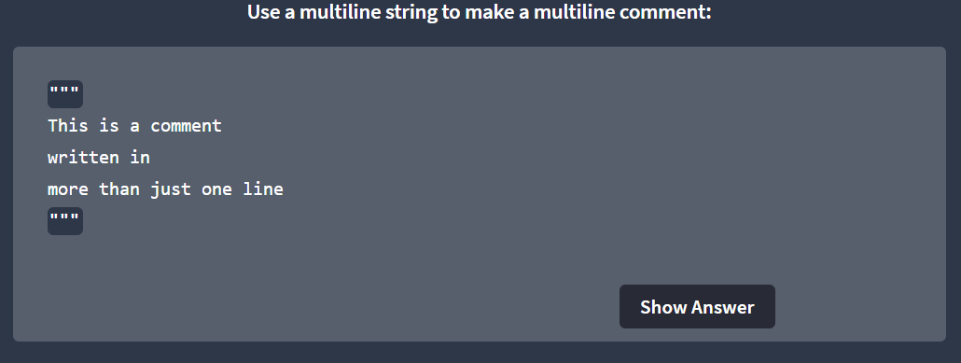

1.2 Understanding Variable and Datatype
Variables
- Variables are containers for storing data values.
Creating Variables
- Python has no command for declaring a variable.
- A variable is created the moment you first assign a value to it.
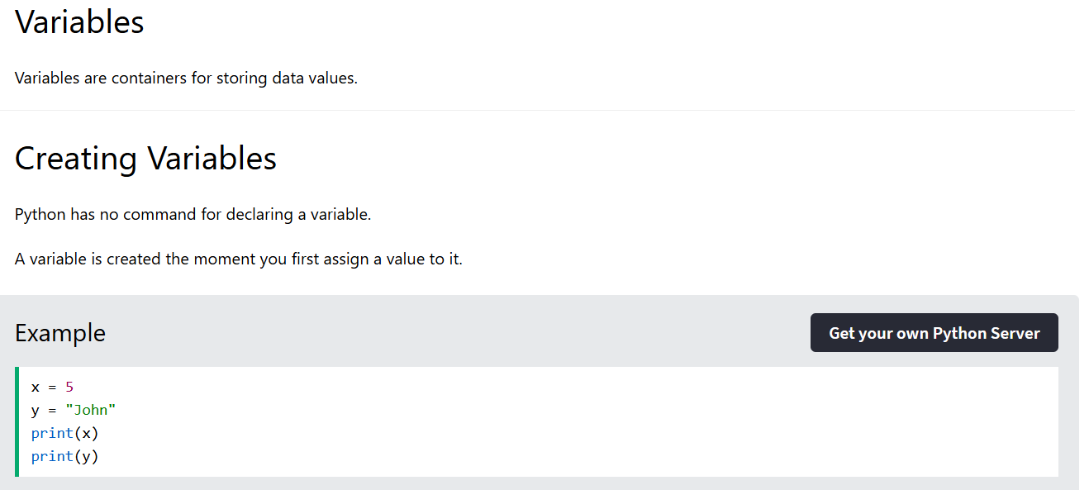
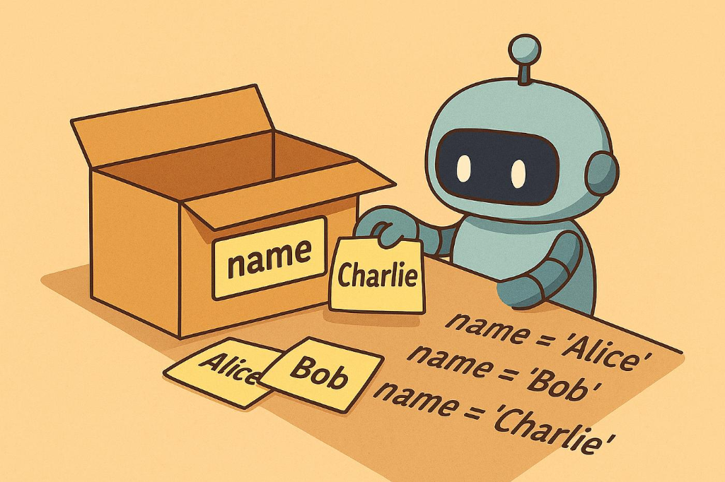

Built-in Data Types
In programming, data type is an important concept.
Variables can store data of different types, and different types can do different things.
Python has the following data types built-in by default, in these categories:

Text Type: | str
Numeric Types: | int, float, complex
Sequence Types: | list, tuple, range
Mapping Type: | dict
Set Types: | set, frozenset
Boolean Type: | bool
Binary Types: | bytes, bytearray, memoryview
None Type: | NoneType

Python Numbers
There are three numeric types in Python:
- int
- float
- complex
Variables of numeric types are created when you assign a value to them.
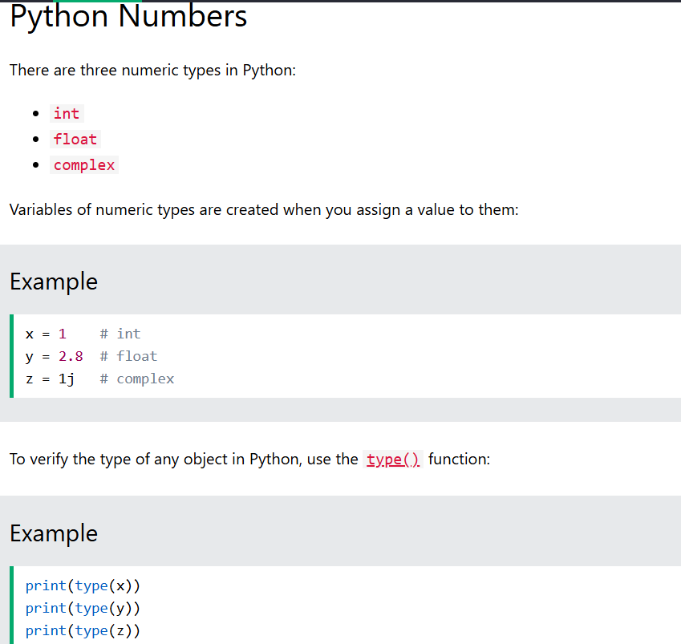
Int
Int, or integer, is a whole number, positive or negative, without decimals, of unlimited length.
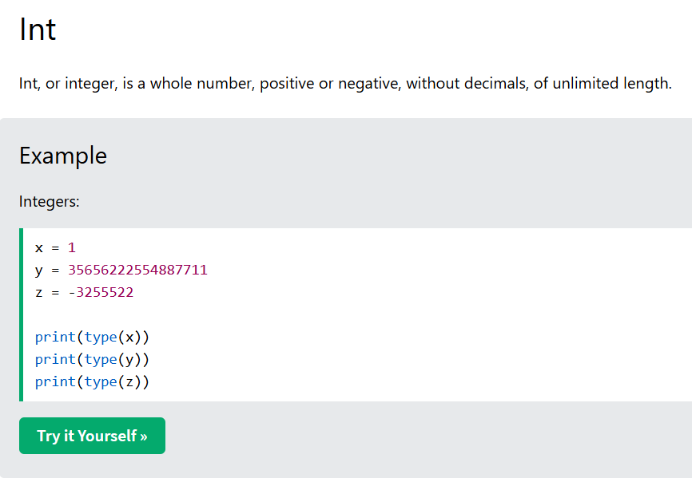
Float
Float, or "floating point number", is a number, positive or negative, containing one or more decimals.
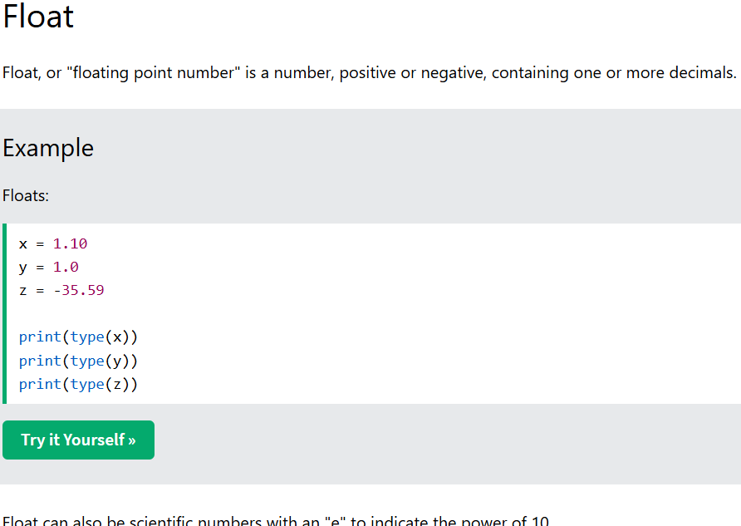
Complex
Complex numbers are numbers that contain both a real part and an imaginary part. In Python, complex numbers are written using j as the imaginary part.
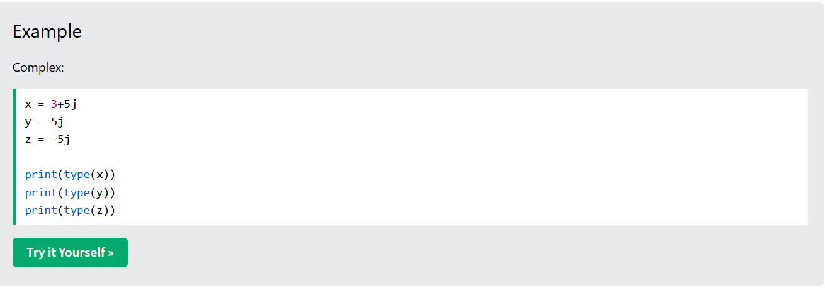
Python Strings
Strings
Strings in python are surrounded by either single quotation marks, or double quotation marks.
'hello' is the same as "hello".
You can display a string literal with the print() function:
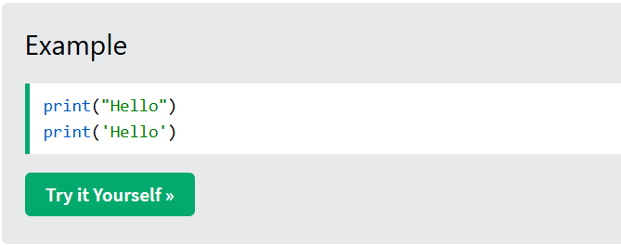
Quotes Inside Quotes
You can use quotes inside a string, as long as they don't match the quotes surrounding the string:
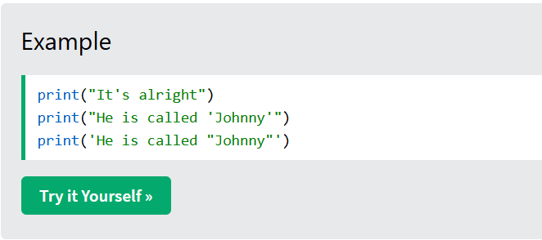
Assign String to a Variable
Assigning a string to a variable is done with the variable name followed by an equal sign and the string:

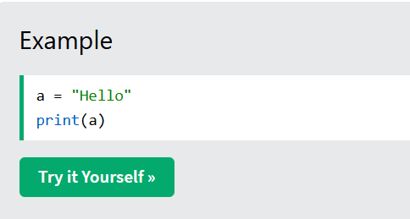
Multiline Strings
You can assign a multiline string to a variable by using three quotes:

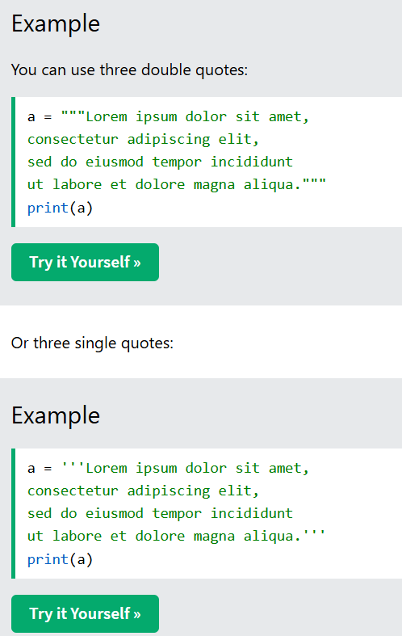
Python - Slicing Strings
Slicing
You can return a range of characters by using the slice syntax .
Specify the start index and the end index, separated by a colon, to return a part of the string.
Note: The first character has index 0.
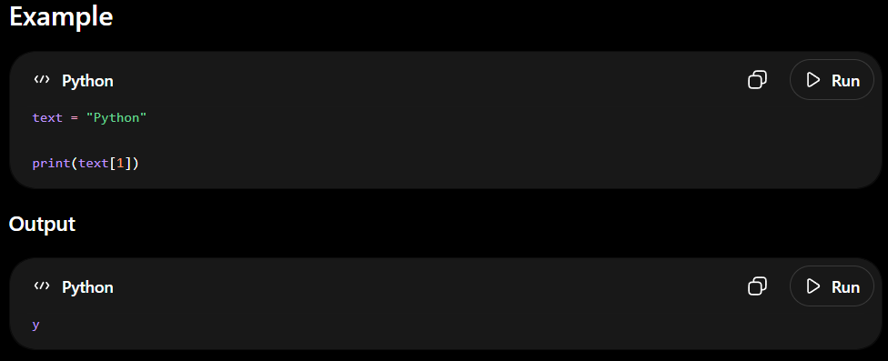
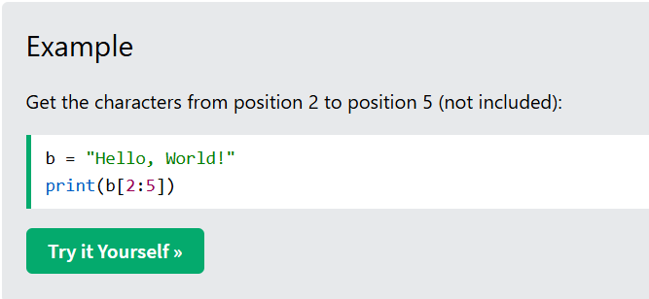
Slice From the Start
By leaving out the start index, the range will start at the first character:
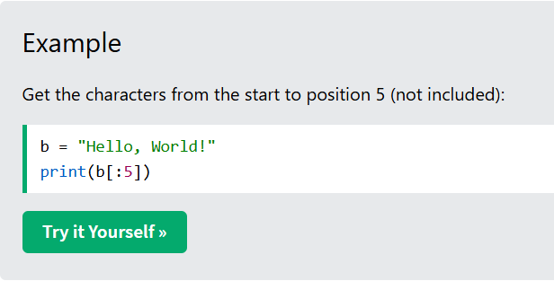
Slice To the End
By leaving out the end index, the range will go to the end:
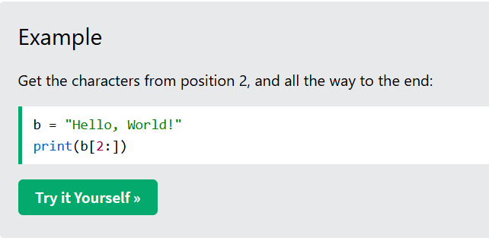
Negative Indexing
Use negative indexes to start the slice from the end of the string:
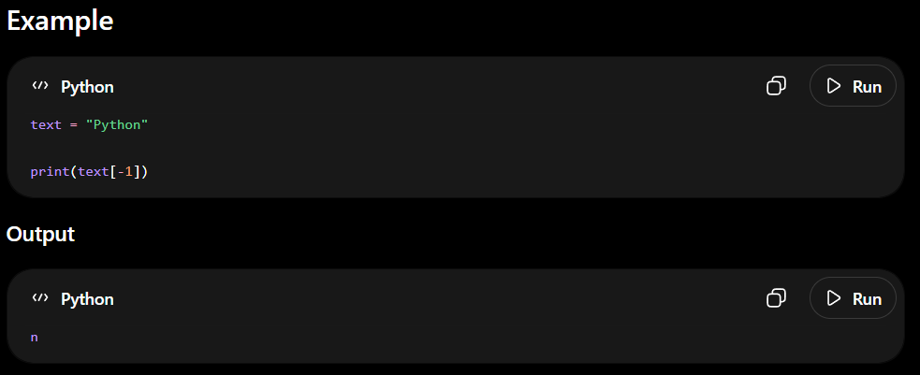
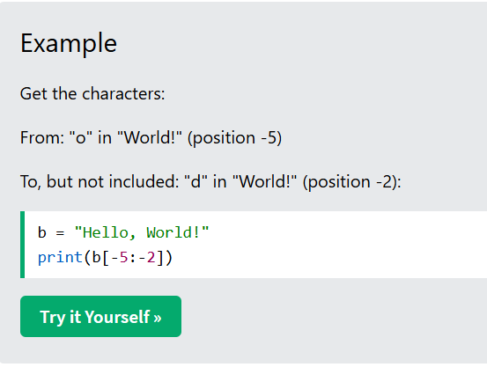
Python - Modify Strings
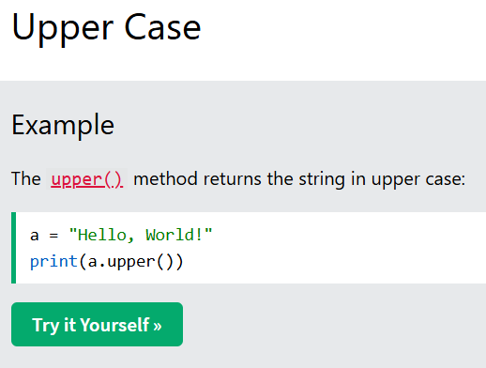
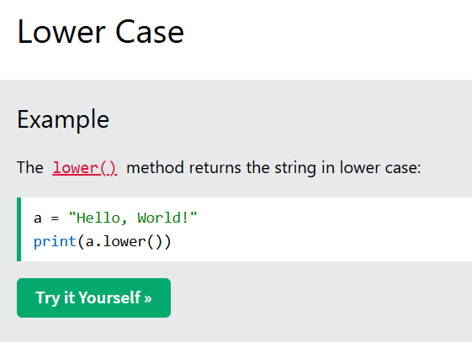
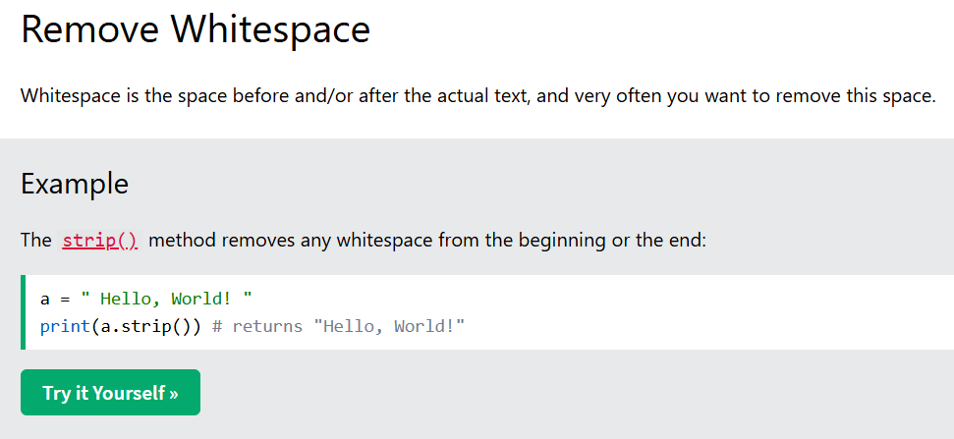
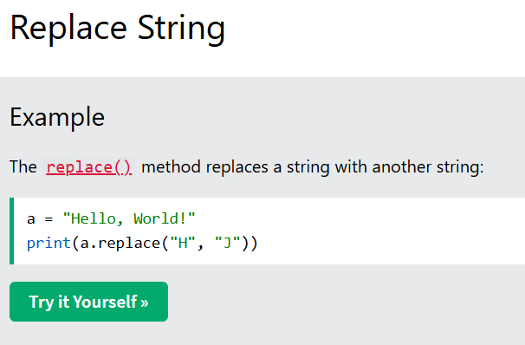
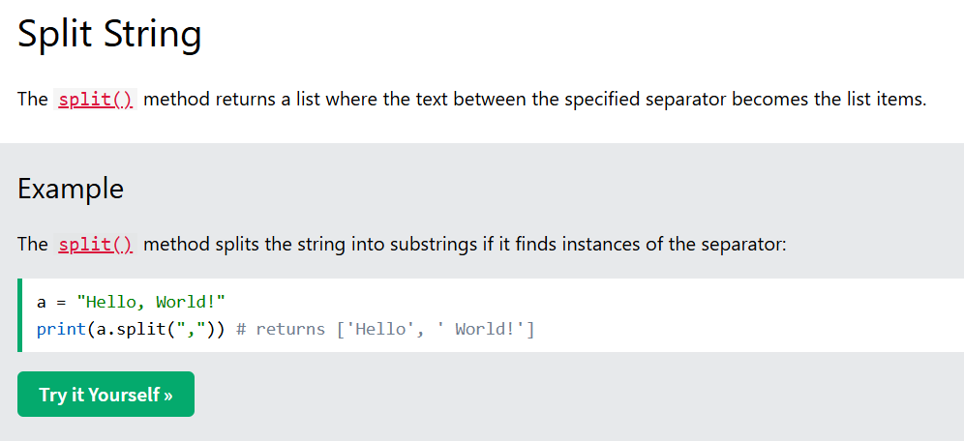
String Concatenation
To concatenate, or combine, two strings you can use the + operator.
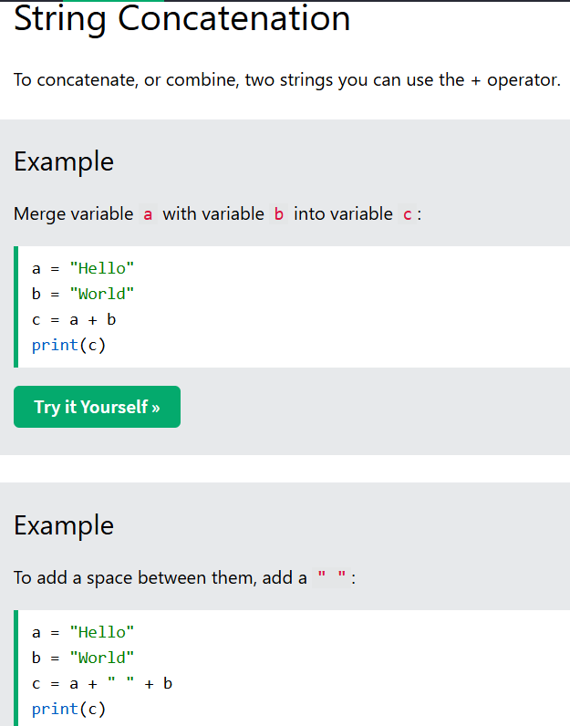
Python - Format Strings
String Format
As we learned in the Python Variables chapter, we cannot combine strings and numbers like this:
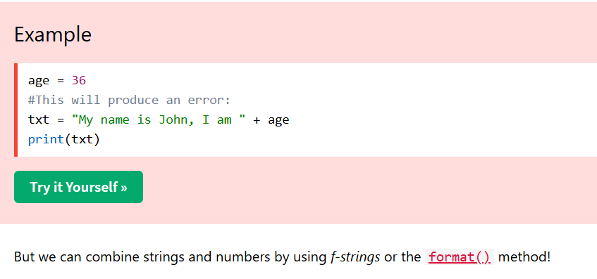
F-Strings
F-String was introduced in Python 3.6, and is now the preferred way of formatting strings.
To specify a string as an f-string, simply put an f in front of the string literal, and add curly brackets {} as placeholders for variables and other operations.
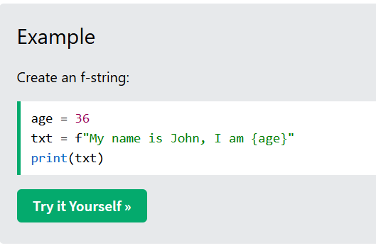
Placeholders and Modifiers
A placeholder can contain variables, operations, functions, and modifiers to format the value.
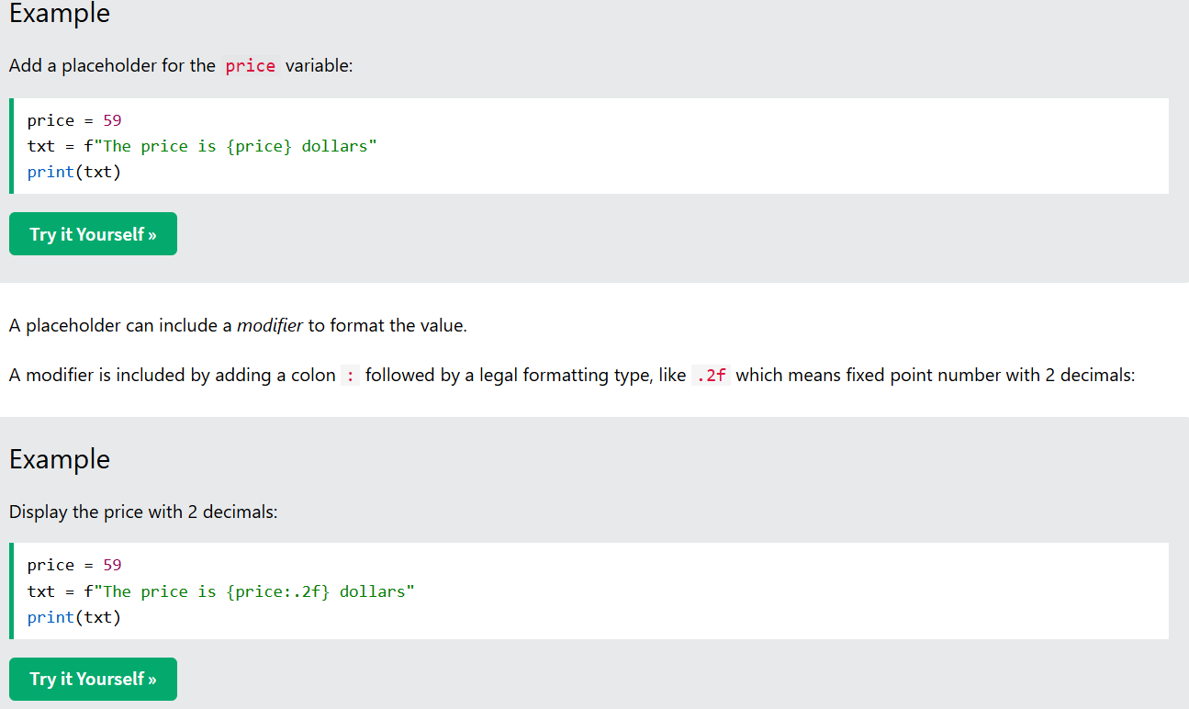
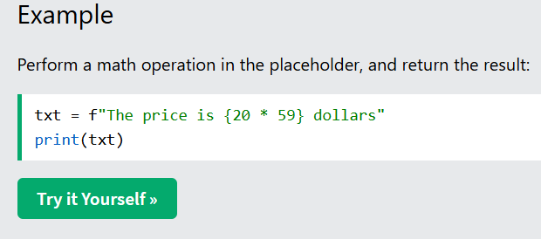
String Exercise
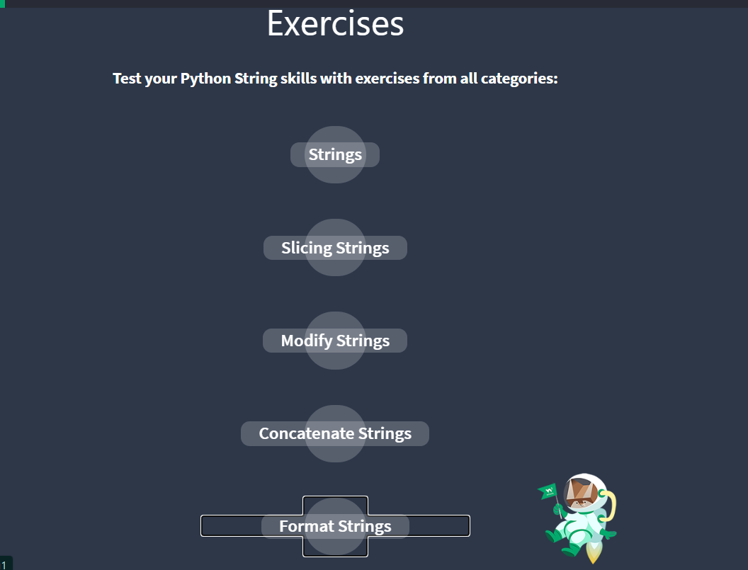
In strings
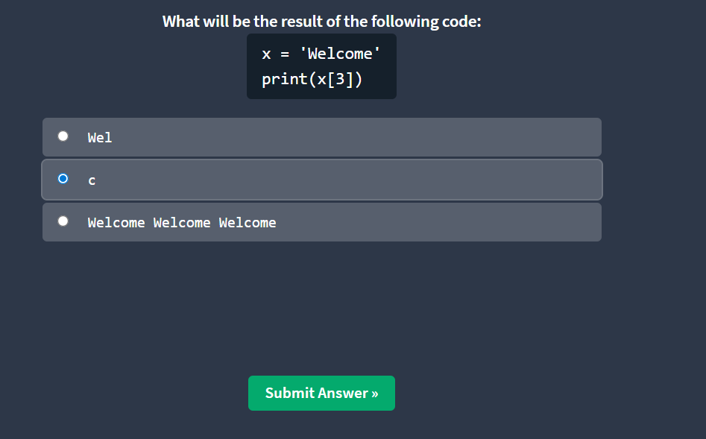
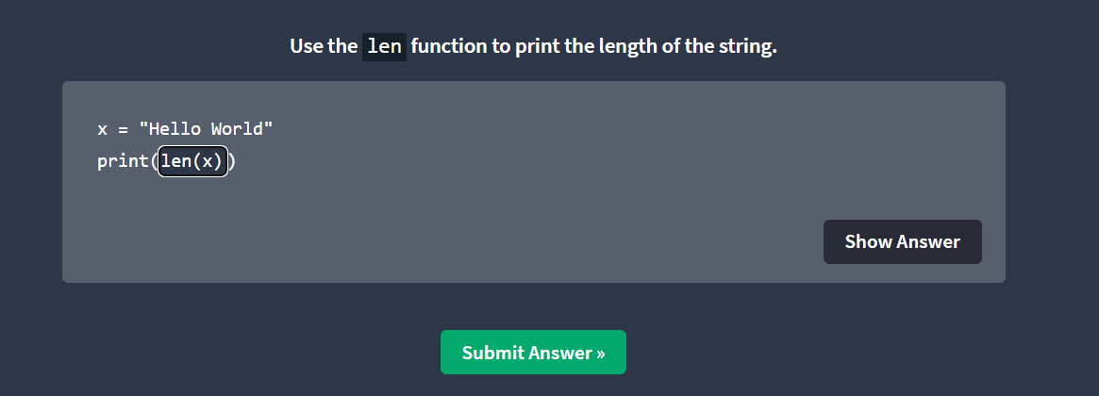
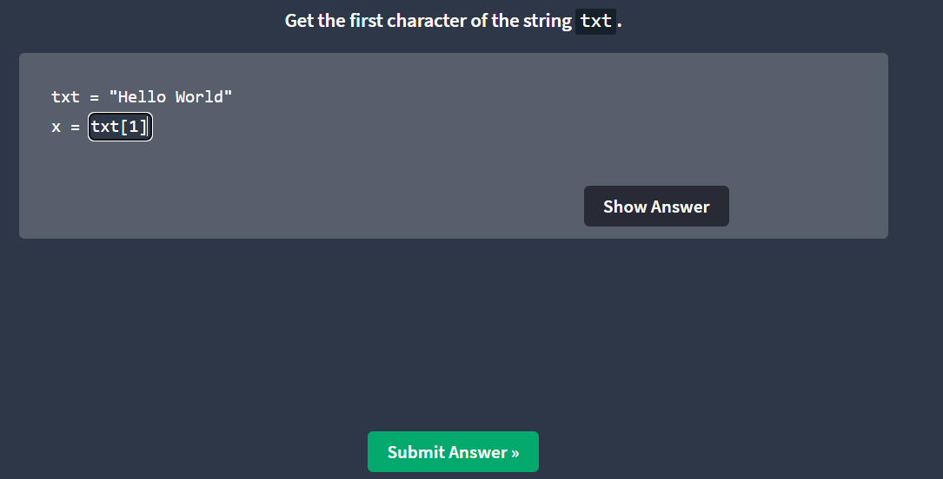
Slicing Strings
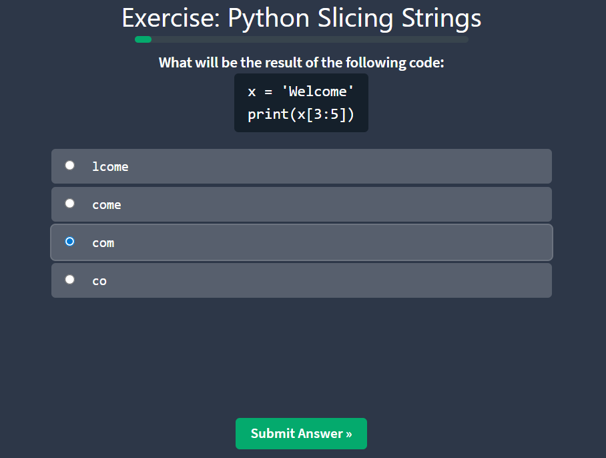
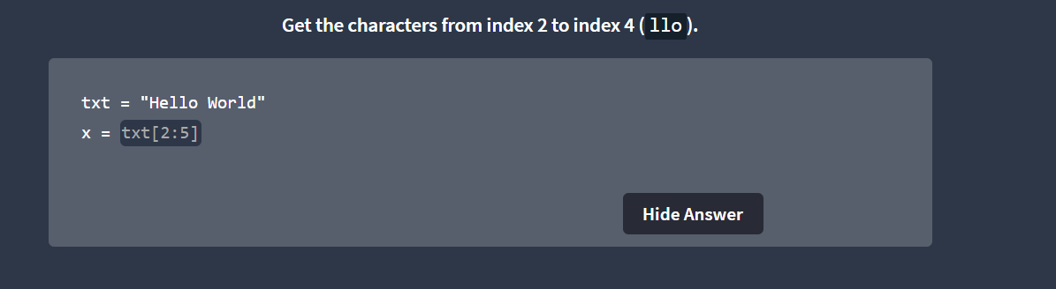
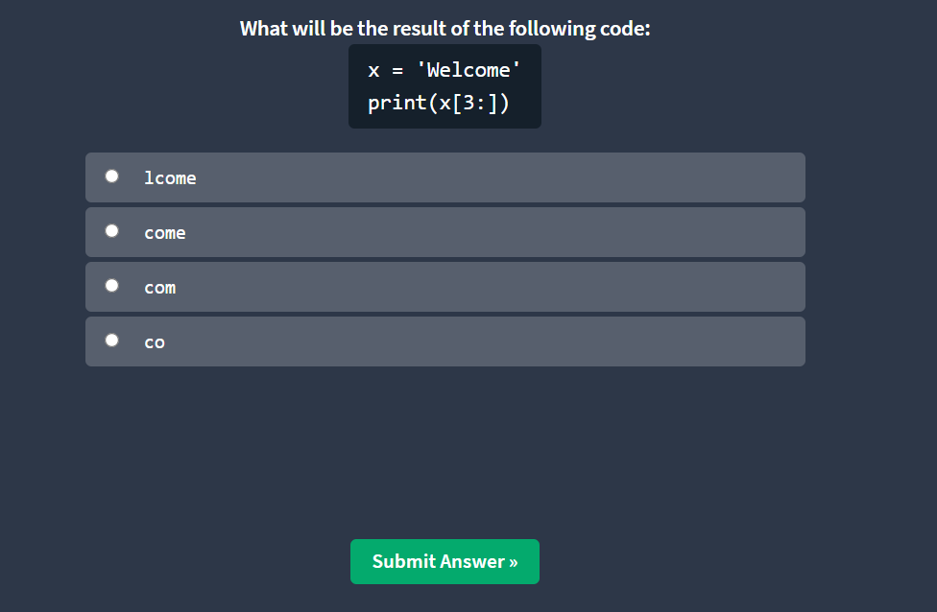
Strings Concatenate
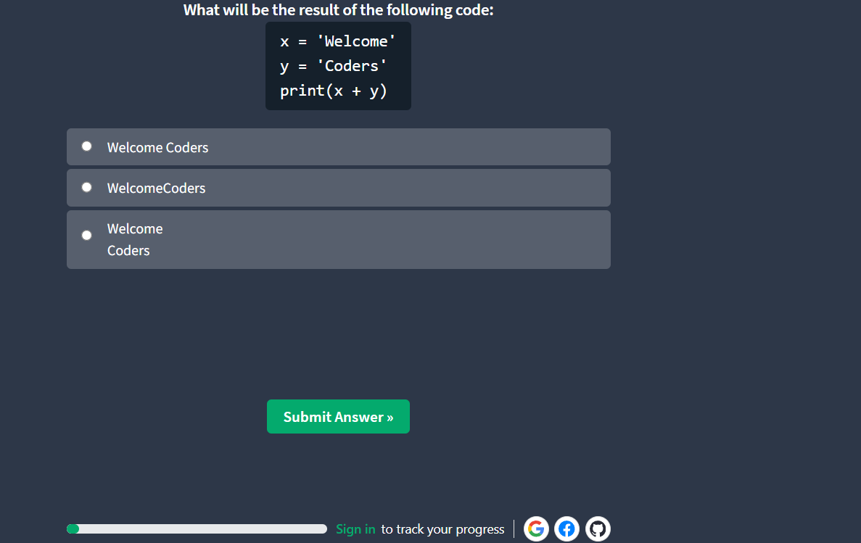
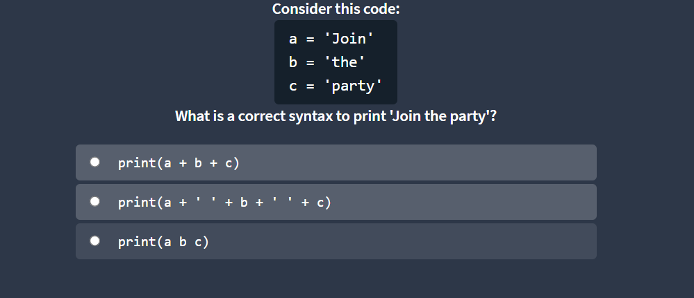
Format Strings
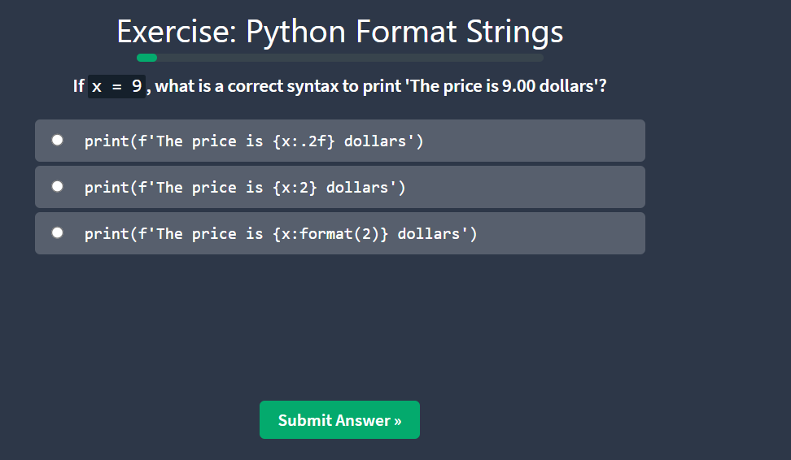
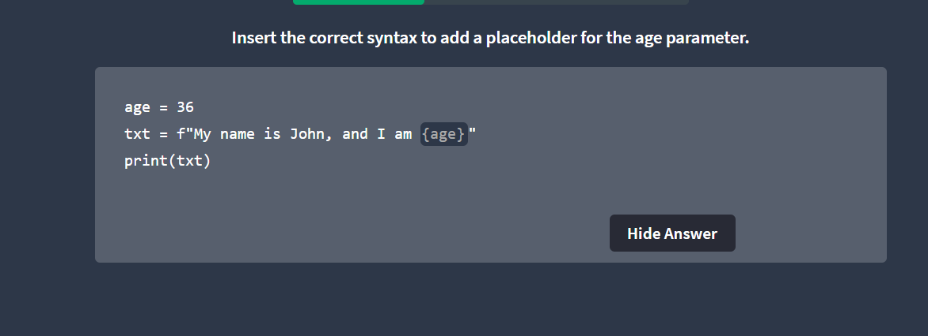
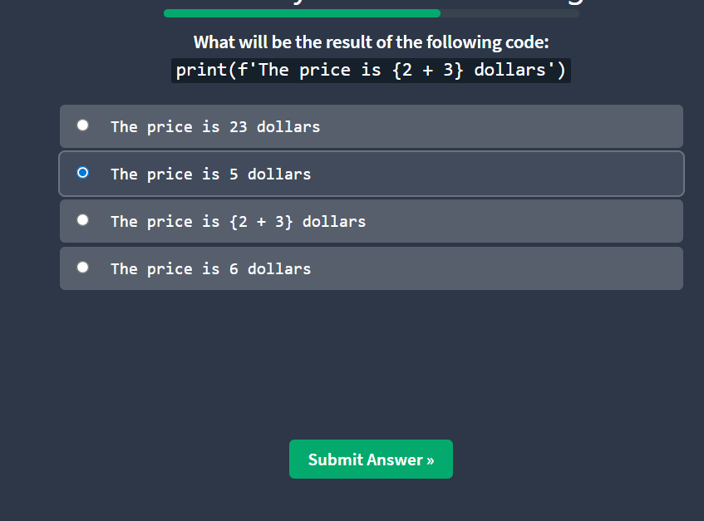
Python Booleans
Boolean Values
In programming you often need to know if an expression is True or False.
You can evaluate any expression in Python, and get one of two answers, True or False.
When you compare two values, the expression is evaluated and Python returns the Boolean answer:
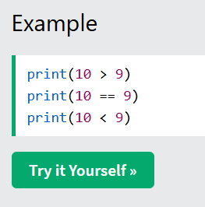
Evaluate Values and Variables
The bool() function allows you to evaluate any value, and give you True or False in return,
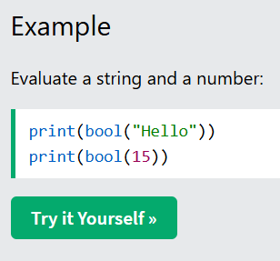
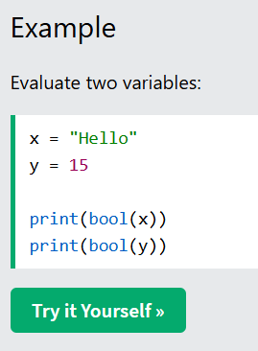
Python Casting – Data type Conversion
Specify a Variable Type
There may be times when you want to specify a type on to a variable. This can be done with casting. Python is an object-orientated language, and as such it uses classes to define data types, including its primitive types.
Casting in python is therefore done using constructor functions:
- int() - constructs an integer number from an integer literal, a float literal (by removing all decimals), or a string literal (providing the string represents a whole number)
- float() - constructs a float number from an integer literal, a float literal or a string literal (providing the string represents a float or an integer)
- str() - constructs a string from a wide variety of data types, including strings, integer literals and float literals
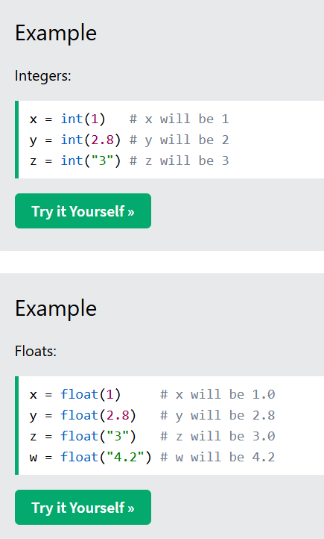
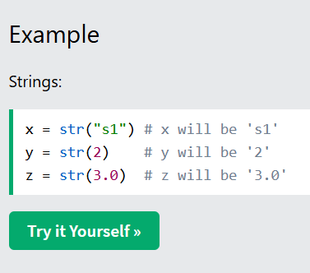

1.3 Data Structures
Data structures are used to store, organize, and manage data efficiently in Python. They help in accessing and processing data easily.
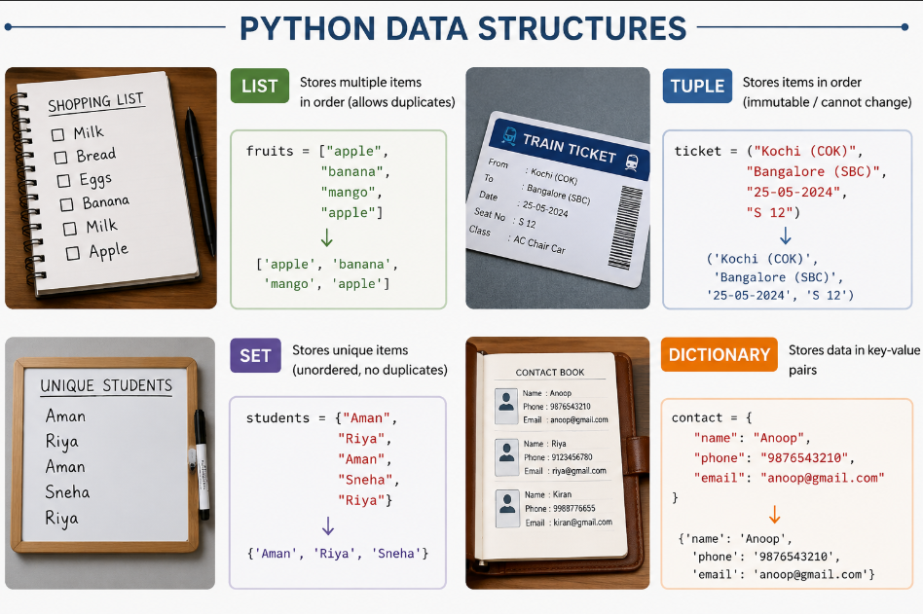

List
Lists are used to store multiple items in a single variable.
Lists are one of 4 built-in data types in Python used to store collections of data, the other 3 are Tuple, Set, and Dictionary, all with different qualities and usage.
Lists are created using square brackets:
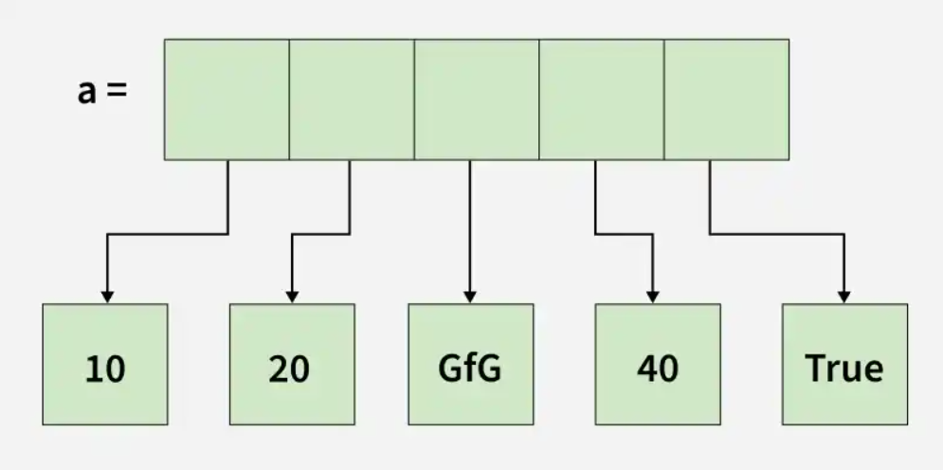
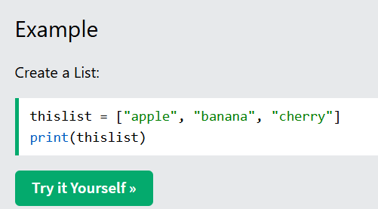
List Items
List items are ordered, changeable, and allow duplicate values.
List items are indexed, the first item has index [0], the second item has index [1] etc.
Ordered
When we say that lists are ordered, it means that the items have a defined order, and that order will not change.
If you add new items to a list, the new items will be placed at the end of the list.
Note: There are some list methods that will change the order, but in general: the order of the items will not change.
Changeable
The list is changeable, meaning that we can change, add, and remove items in a list after it has been created.
Allow Duplicates
Since lists are indexed, lists can have items with the same value:
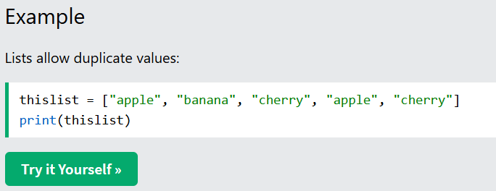
List Length
To determine how many items a list has, use the len() function:
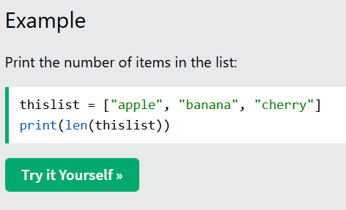
List Items - Data Types
List items can be of any data type:
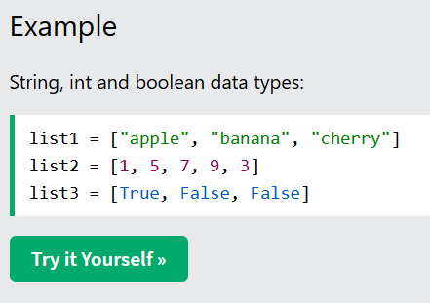
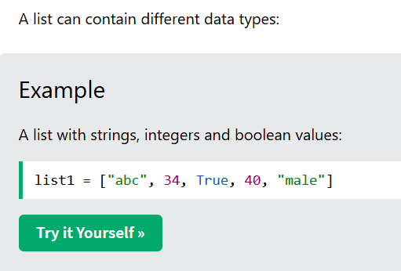
type ()
From Python's perspective, lists are defined as objects with the data type 'list':
<class 'list'>
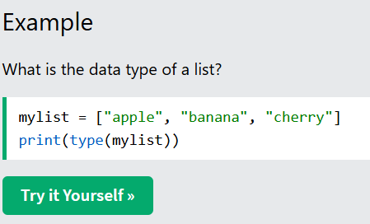
The list() Constructor
It is also possible to use the list() constructor when creating a new list.
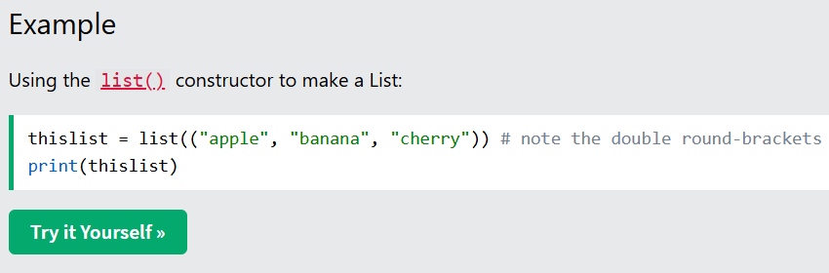
Access Items
List items are indexed and you can access them by referring to the index number:
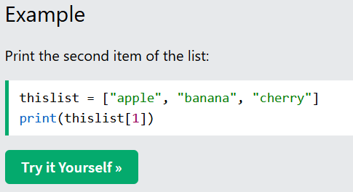
Note: The first item has index 0.
Negative Indexing
Negative indexing means start from the end
-1 refers to the last item, -2 refers to the second last item etc.
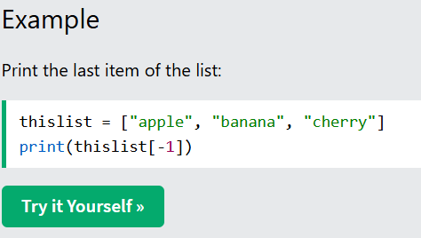
Range of Indexes
You can specify a range of indexes by specifying where to start and where to end the range.
When specifying a range, the return value will be a new list with the specified items.
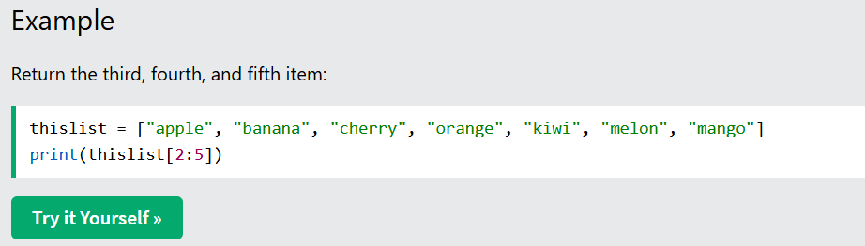
Note: The search will start at index 2 (included) and end at index 5 (not included).
Remember that the first item has index 0.
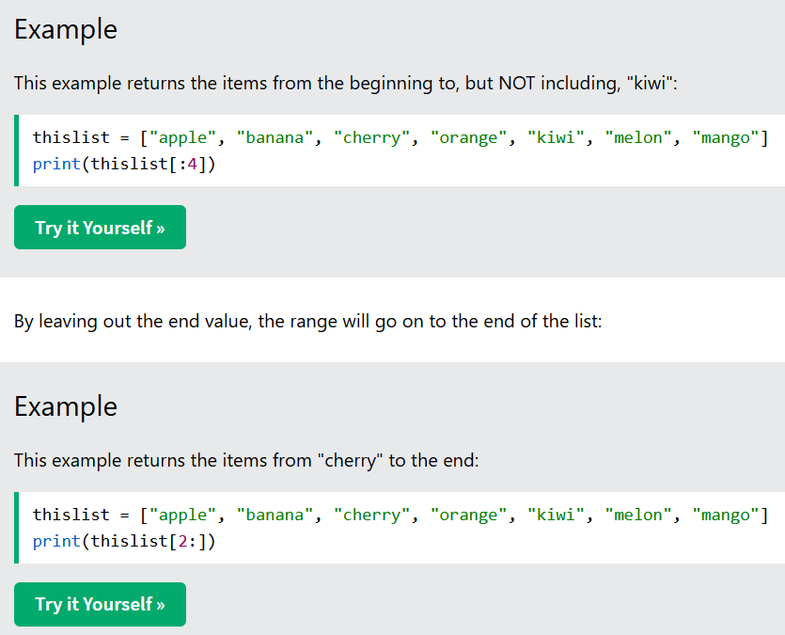
Change List Items
To change the value of a specific item, refer to the index number:
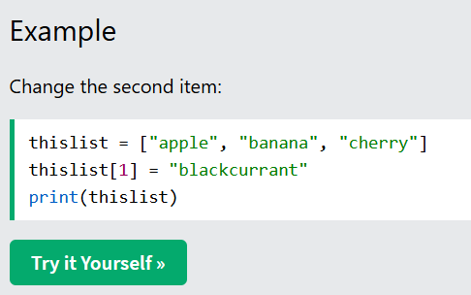
Change a Range of Item Values
To change the value of items within a specific range, define a list with the new values, and refer to the range of index numbers where you want to insert the new values:
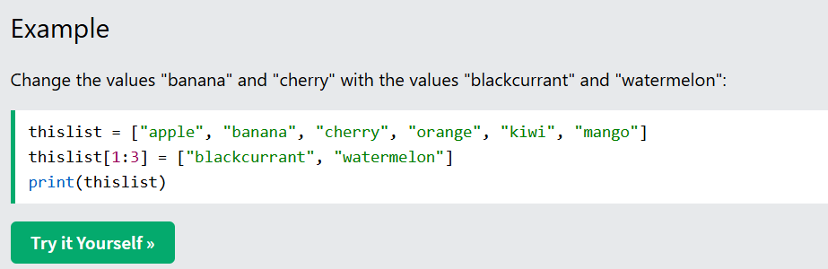
Note: The length of the list will change when the number of items inserted does not match the number of items replaced.
If you insert less items than you replace, the new items will be inserted where you specified, and the remaining items will move accordingly:
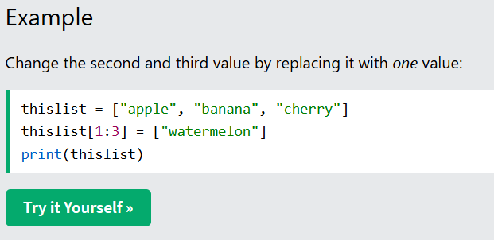
Insert Items
To insert a new list item, without replacing any of the existing values, we can use the insert() method.
The insert() method inserts an item at the specified index:
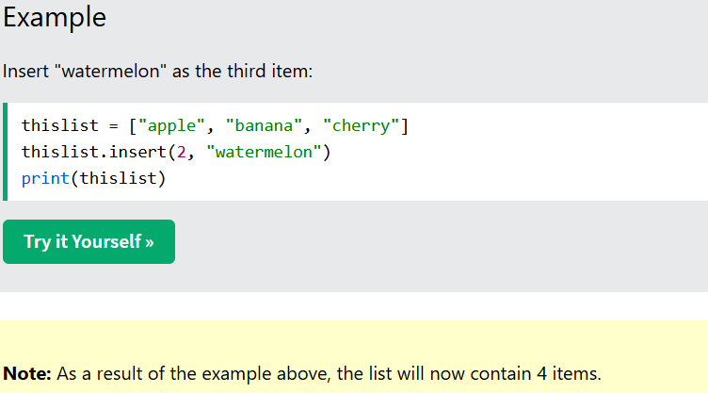
Add List Items
Append Items
To add an item to the end of the list, use the append() method:
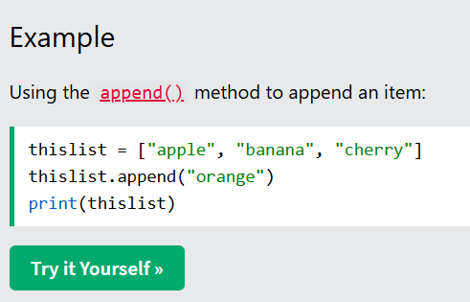
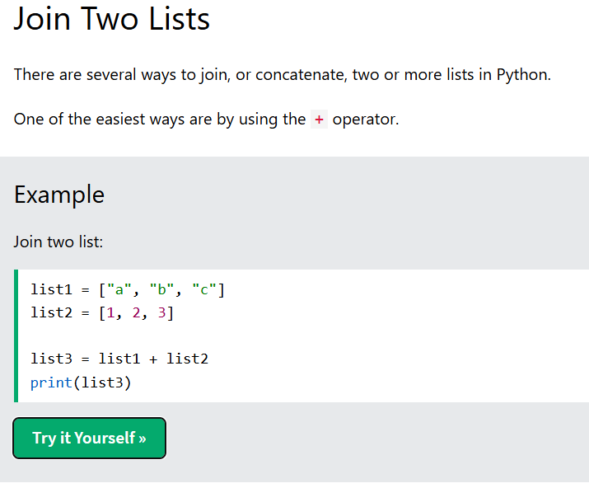
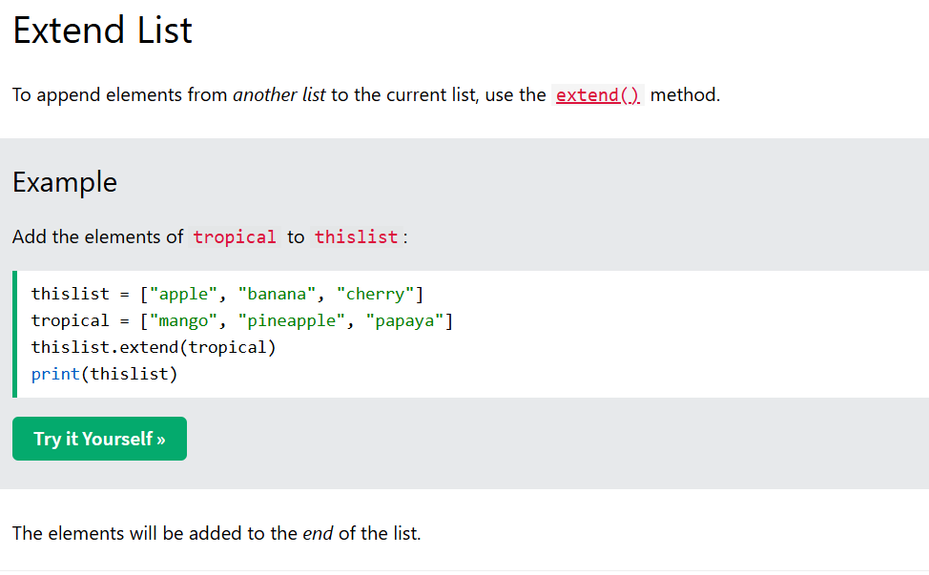
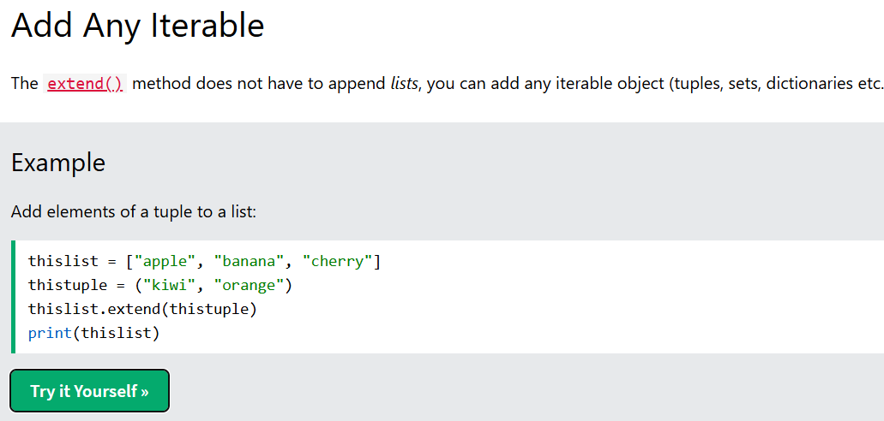
Remove List Items
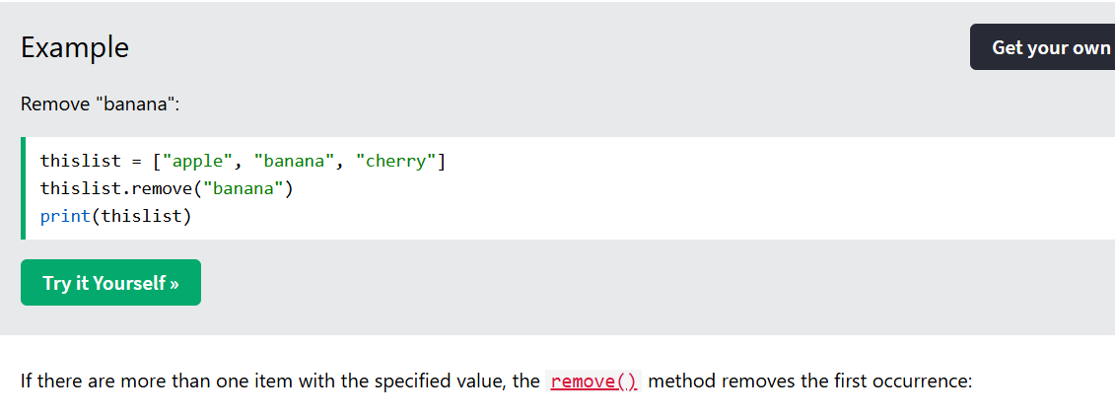
Remove Specified Index
The pop() method removes the specified index.
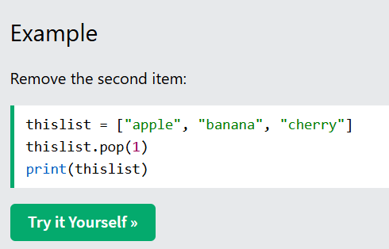
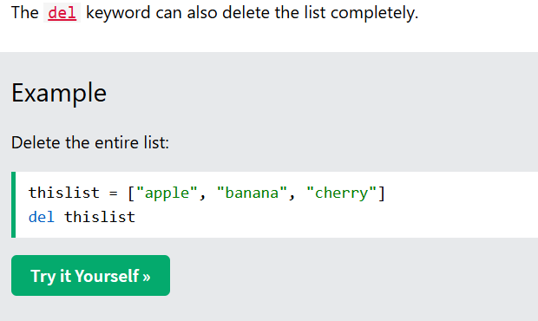
Clear the List
The clear() method empties the list.
The list still remains, but it has no content.
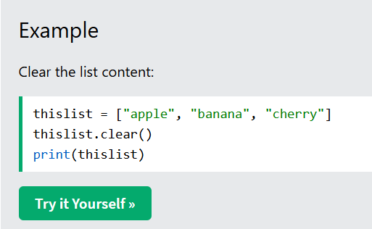
Python - Sort Lists
Sort List Alphanumerically
List objects have a sort() method that will sort the list alphanumerically, ascending, by default:
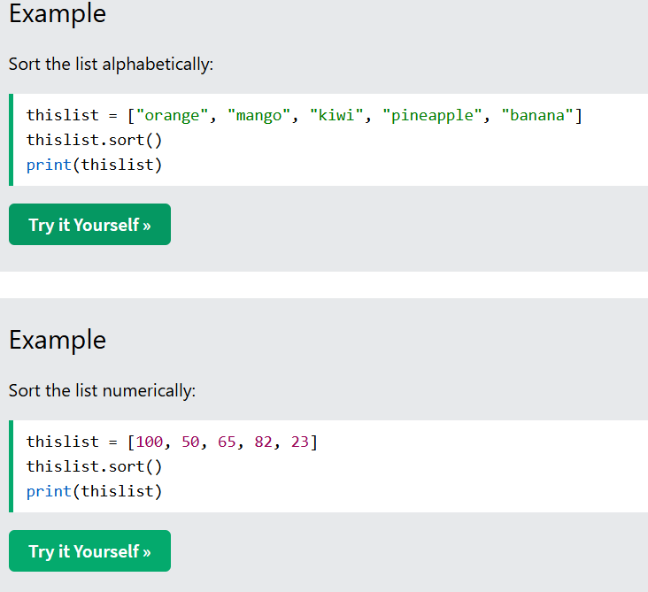
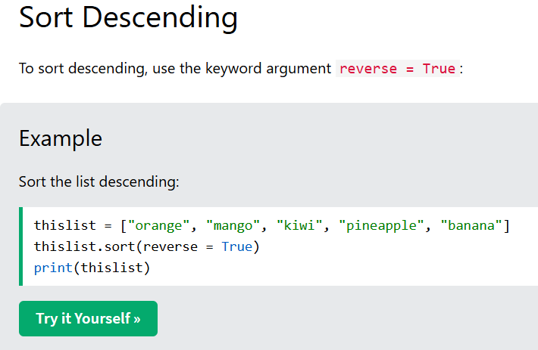
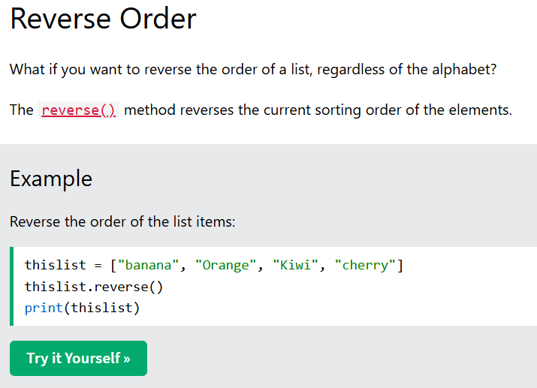
Copy a List
You cannot copy a list simply by typing list2 = list1, because: list2 will only be a reference to list1, and changes made in list1 will automatically also be made in list2.
Use the copy() method
You can use the built-in List method copy() to copy a list.
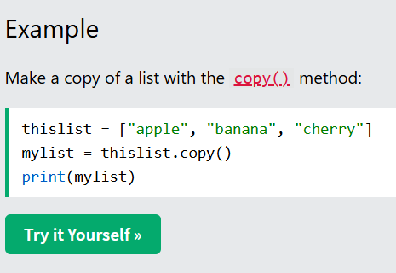
List Exercise
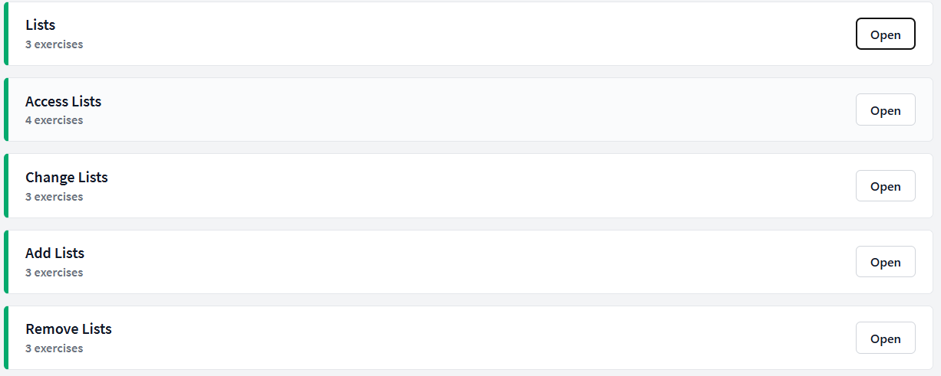
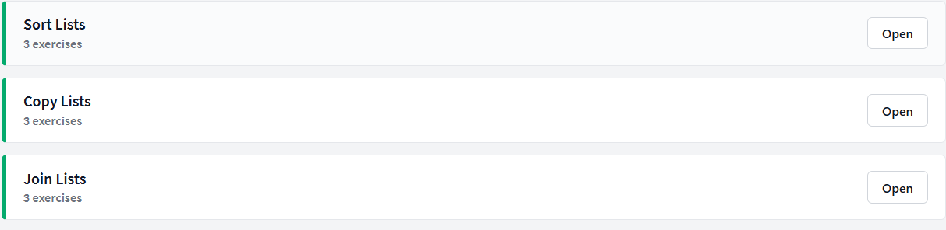
Lists
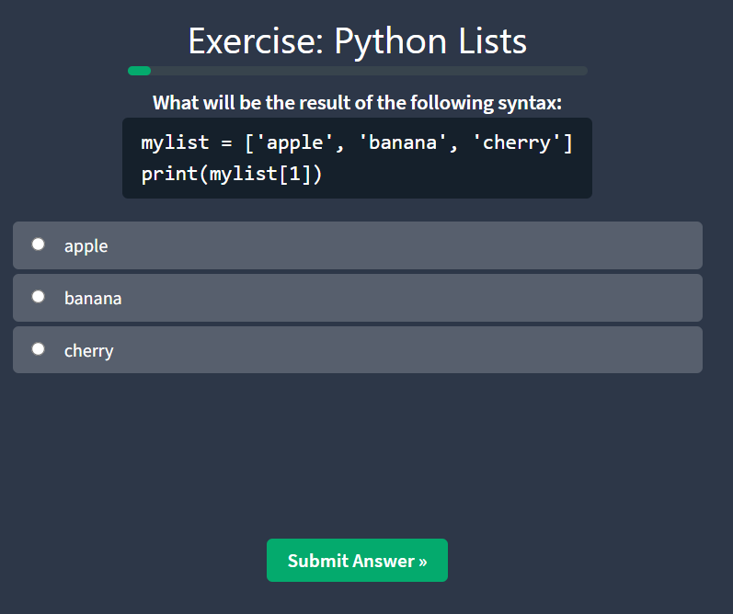
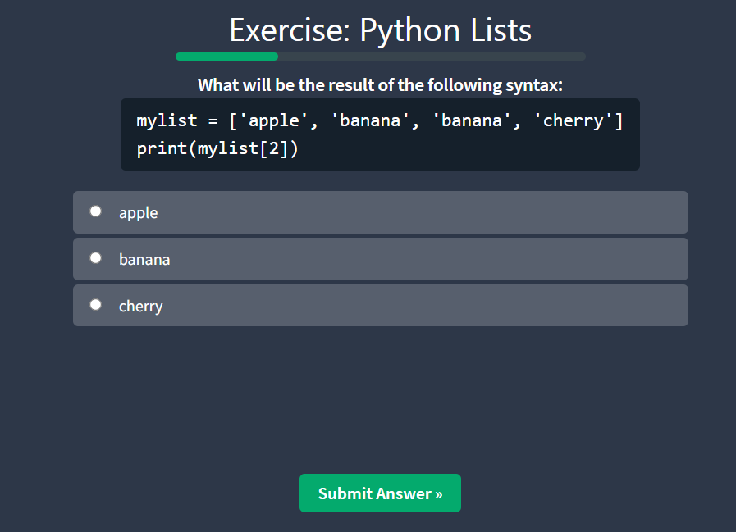
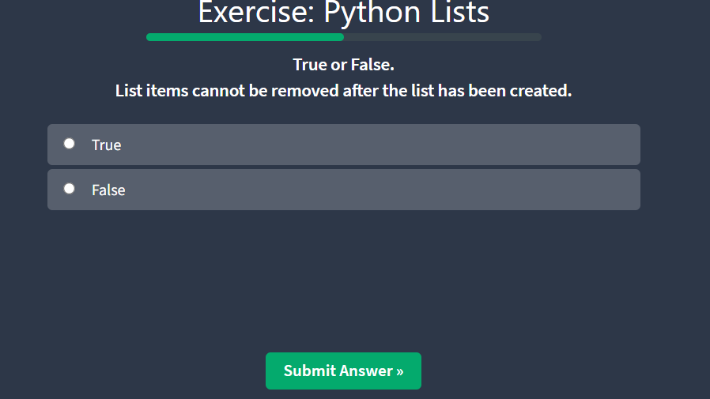
Access List
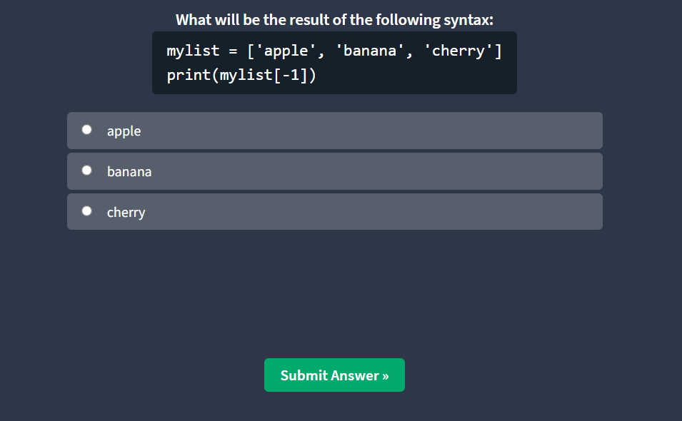
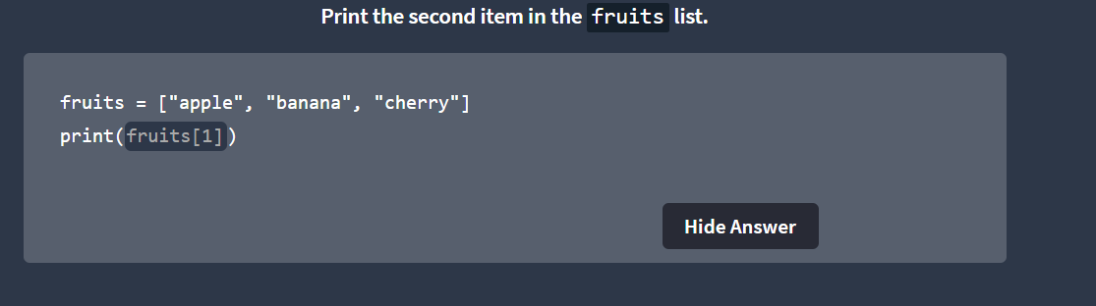
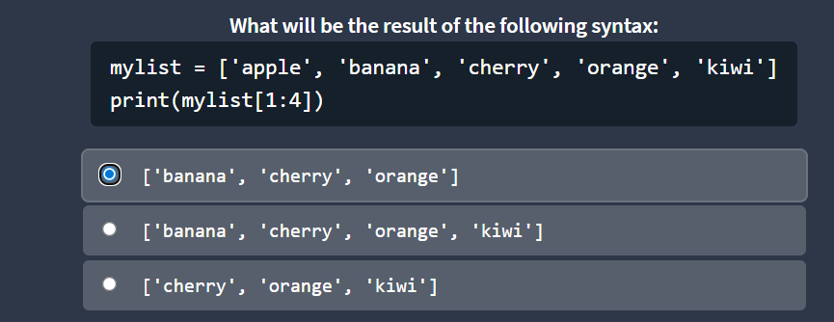
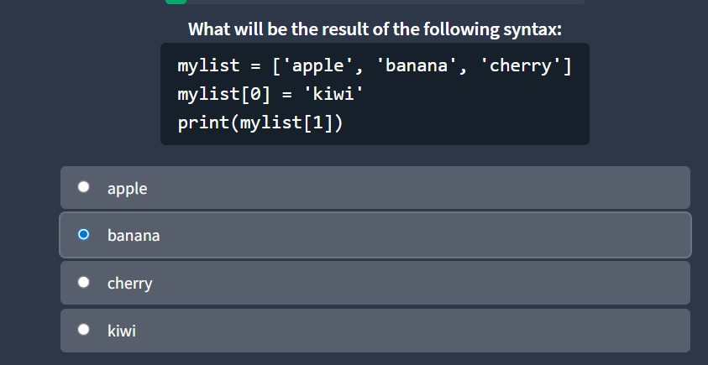
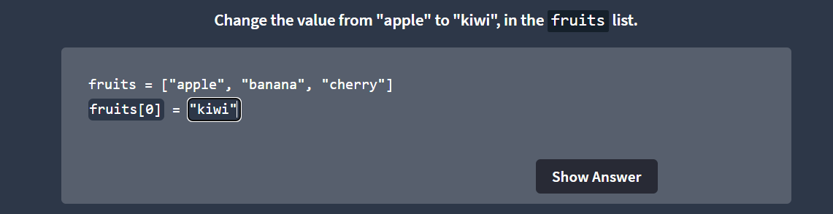
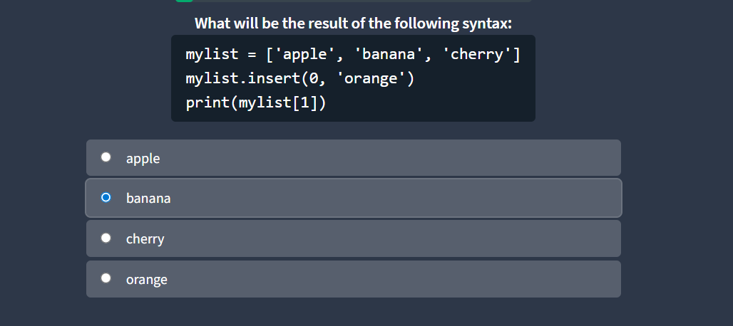
Add List Items

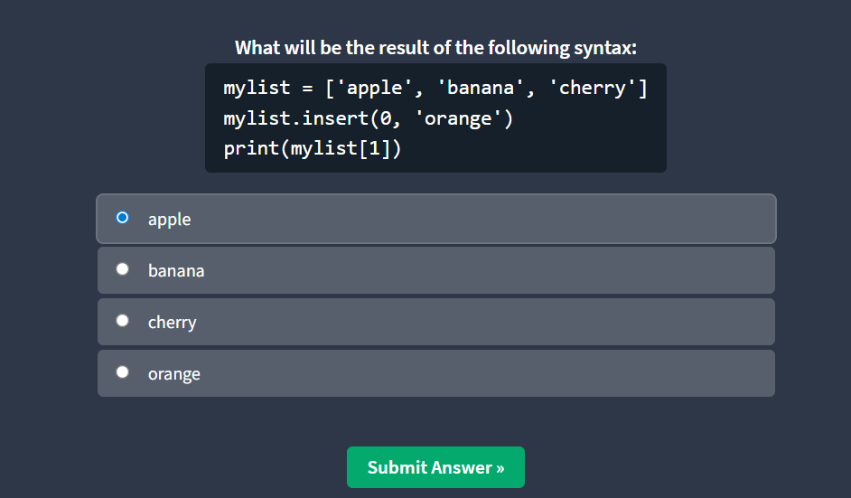
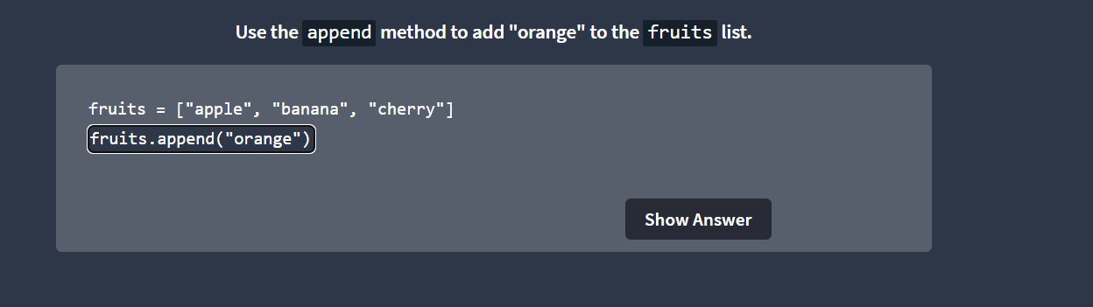
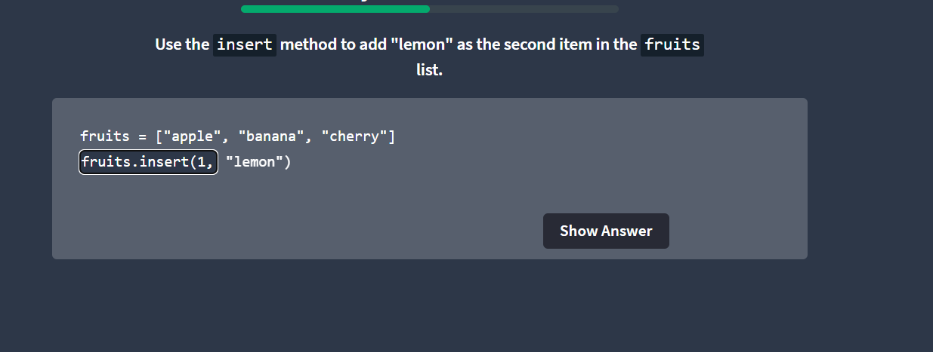
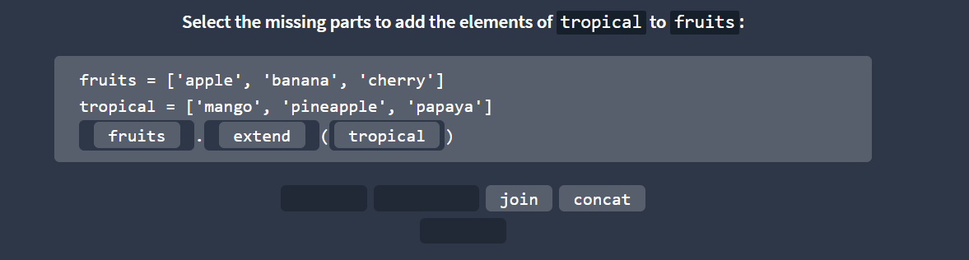
Remove List Items
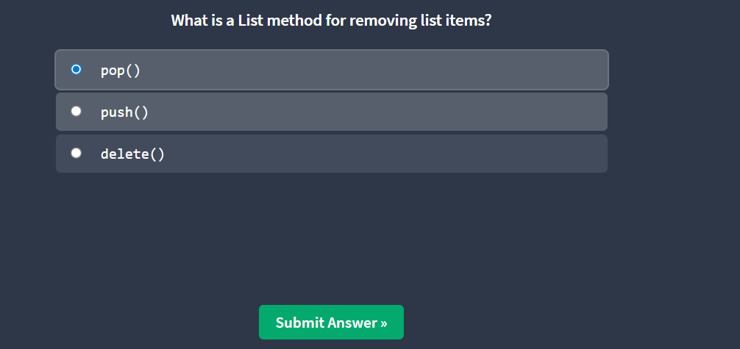
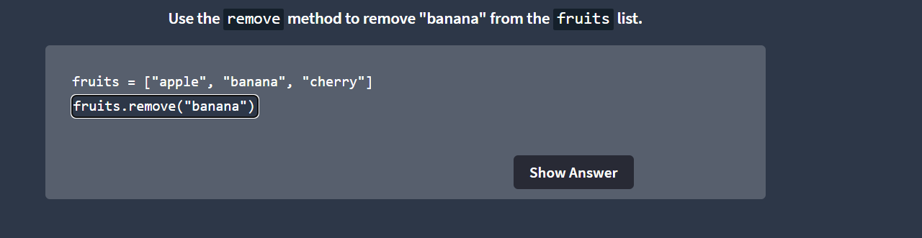
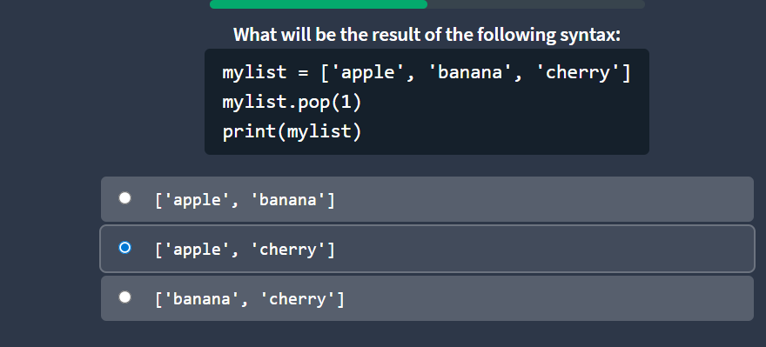
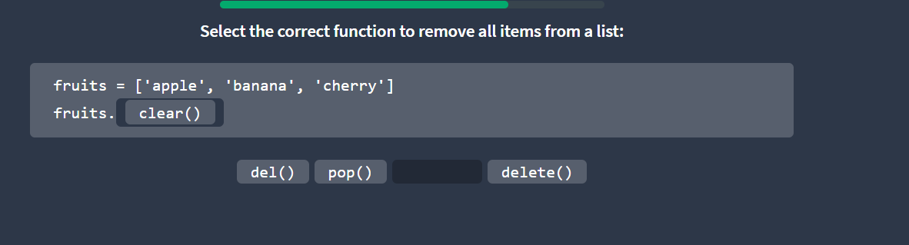
Python Sort Lists
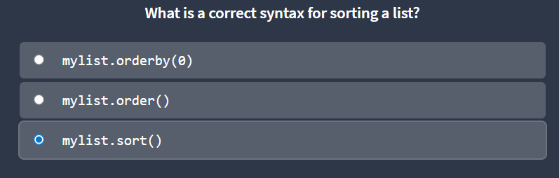
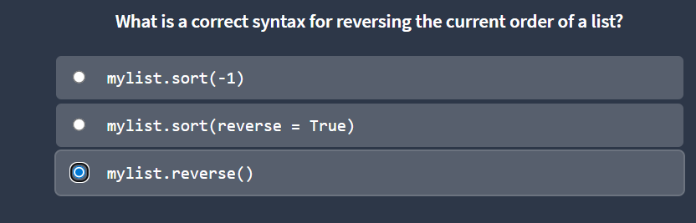
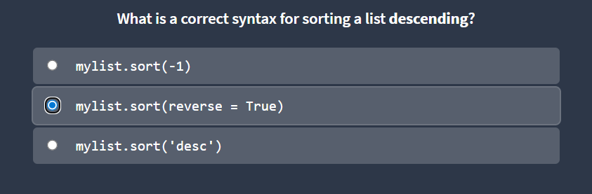
Python Join Lists

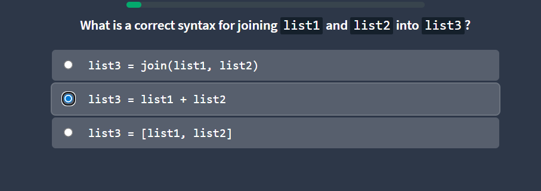
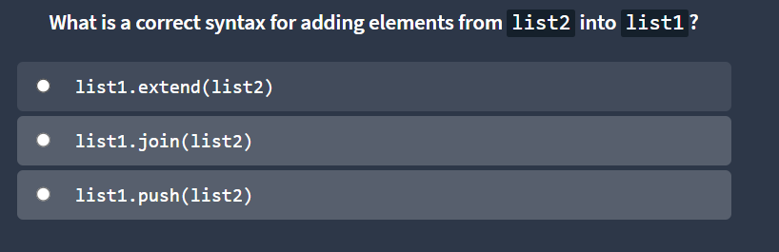
Python Tuples
Tuple
Tuples are used to store multiple items in a single variable.
Tuple is one of 4 built-in data types in Python used to store collections of data, the other 3 are List, Set, and Dictionary, all with different qualities and usage.
A tuple is a collection which is ordered and unchangeable.
Tuples are written with round brackets.

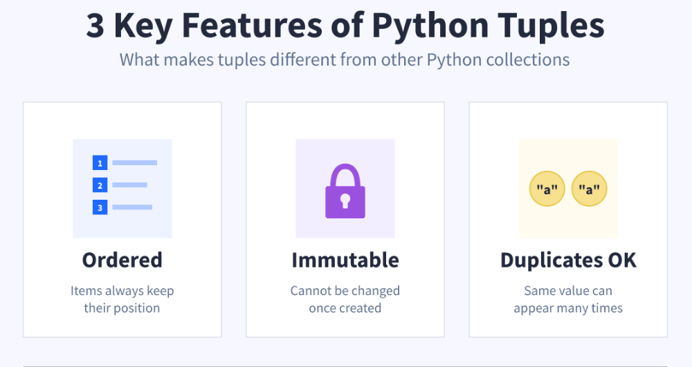
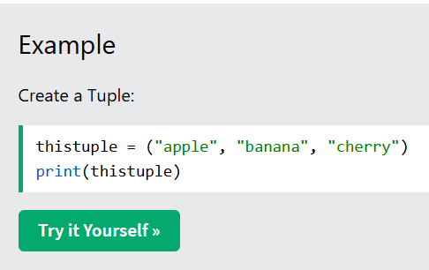
Tuple Items
Tuple items are ordered, unchangeable, and allow duplicate values.
Tuple items are indexed, the first item has index [0], the second item has index [1] etc.
Ordered
When we say that tuples are ordered, it means that the items have a defined order, and that order will not change.
Unchangeable
Tuples are unchangeable, meaning that we cannot change, add or remove items after the tuple has been created.
Allow Duplicates
Since tuples are indexed, they can have items with the same value:
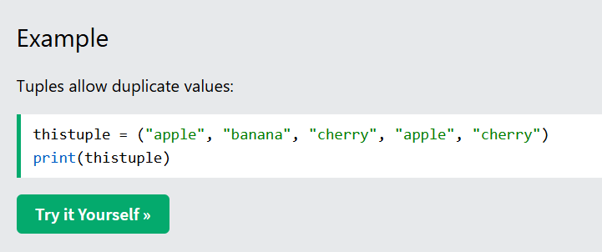
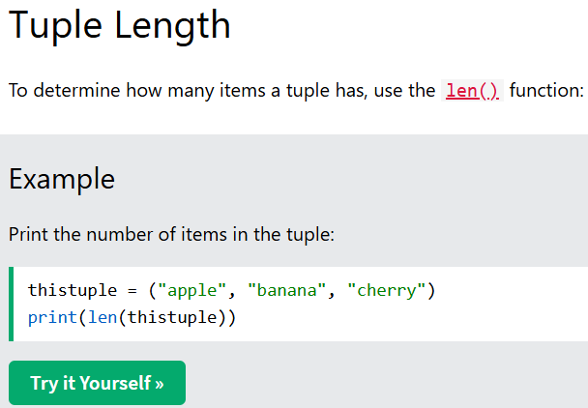
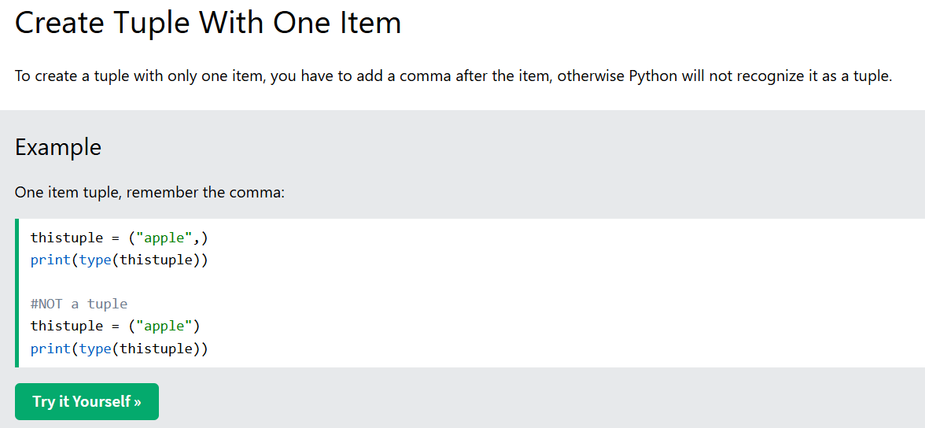
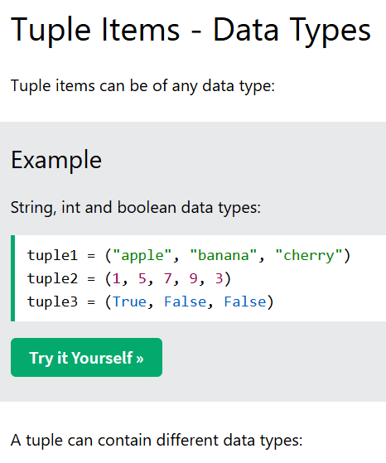
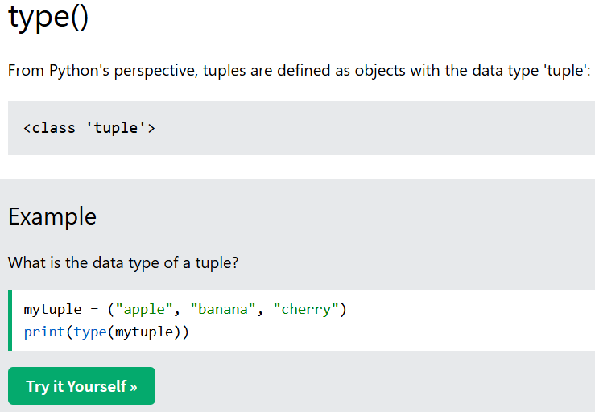
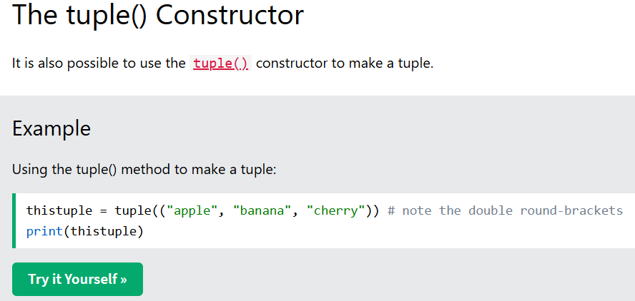
Python - Access Tuple Items
Access Tuple Items
You can access tuple items by referring to the index number, inside square brackets:
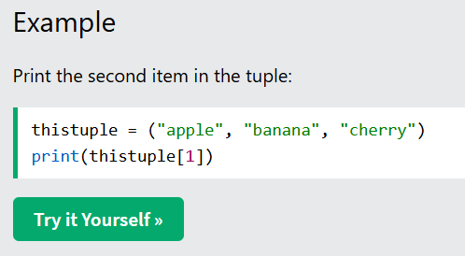
Note: The first item has index 0.
Negative Indexing
Negative indexing means start from the end.
-1 refers to the last item, -2 refers to the second last item etc.
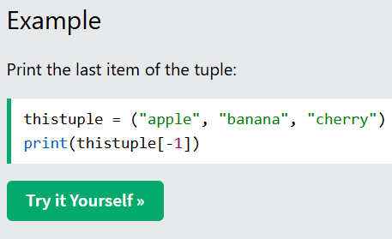
Range of Indexes
You can specify a range of indexes by specifying where to start and where to end the range.
When specifying a range, the return value will be a new tuple with the specified items.
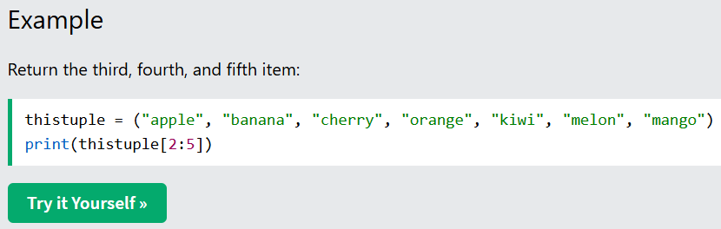
Note: The search will start at index 2 (included) and end at index 5 (not included).
Remember that the first item has index 0.
By leaving out the start value, the range will start at the first item:
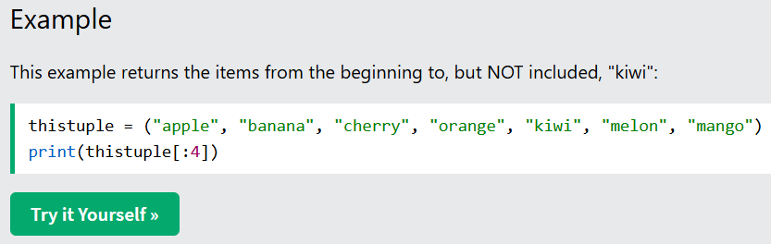
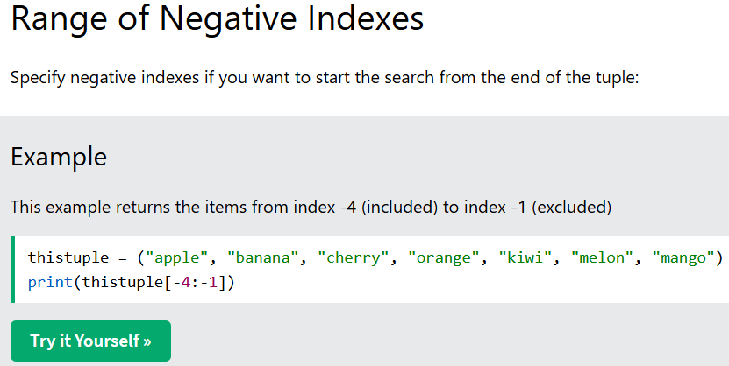
Update Tuples
Tuples are unchangeable, meaning that you cannot change, add, or remove items once the tuple is created.
But there are some workarounds.
Change Tuple Values
Once a tuple is created, you cannot change its values. Tuples are unchangeable, or immutable as it also is called.
But there is a workaround. You can convert the tuple into a list, change the list, and convert the list back into a tuple
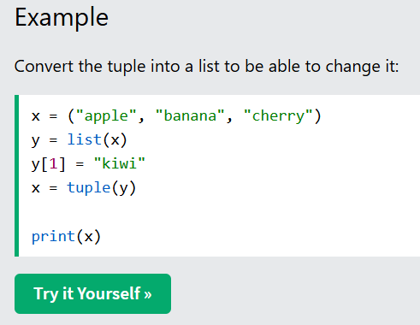
Add Items
Since tuples are immutable, they do not have a built-in append() method, but there are other ways to add items to a tuple.
Convert into a list: Just like the workaround for changing a tuple, you can convert it into a list, add your item(s), and convert it back into a tuple.
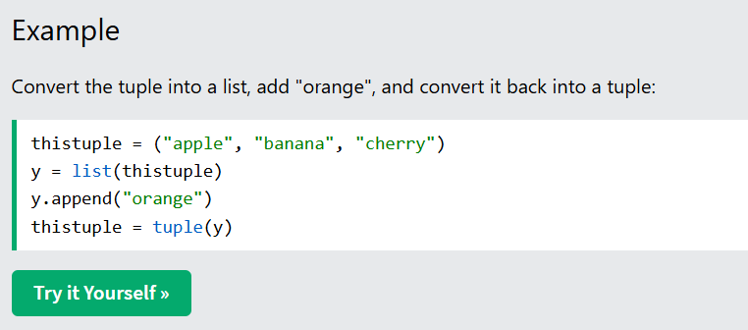
Add tuple to a tuple. You are allowed to add tuples to tuples, so if you want to add one item, (or many), create a new tuple with the item(s), and add it to the existing tuple:
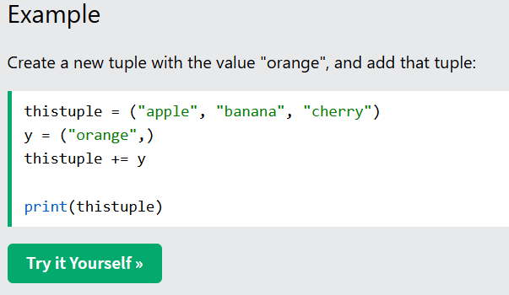
Note: When creating a tuple with only one item, remember to include a comma after the item, otherwise it will not be identified as a tuple.
Remove Items
Note: You cannot remove items in a tuple.
Tuples are unchangeable, so you cannot remove items from it, but you can use the same workaround as we used for changing and adding tuple items:
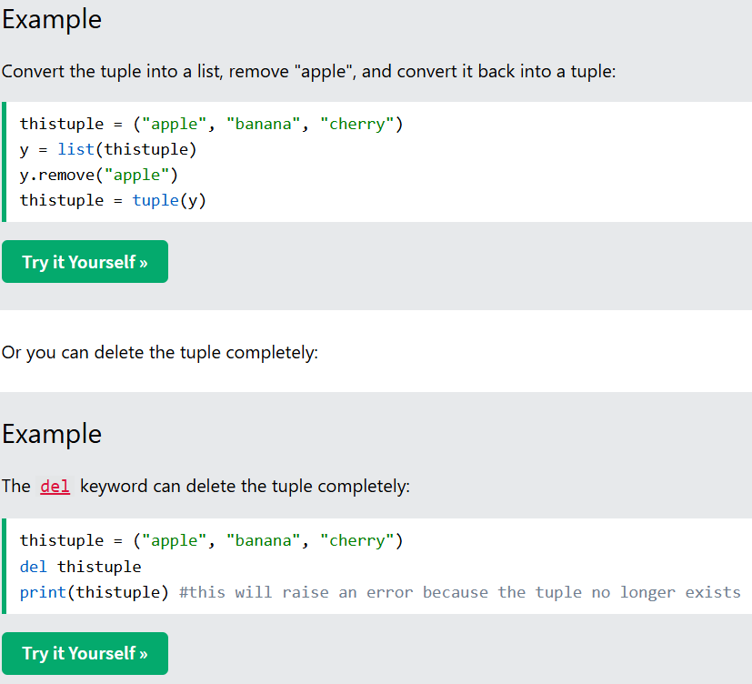
Unpack Tuples
When we create a tuple, we normally assign values to it. This is called "packing" a tuple:
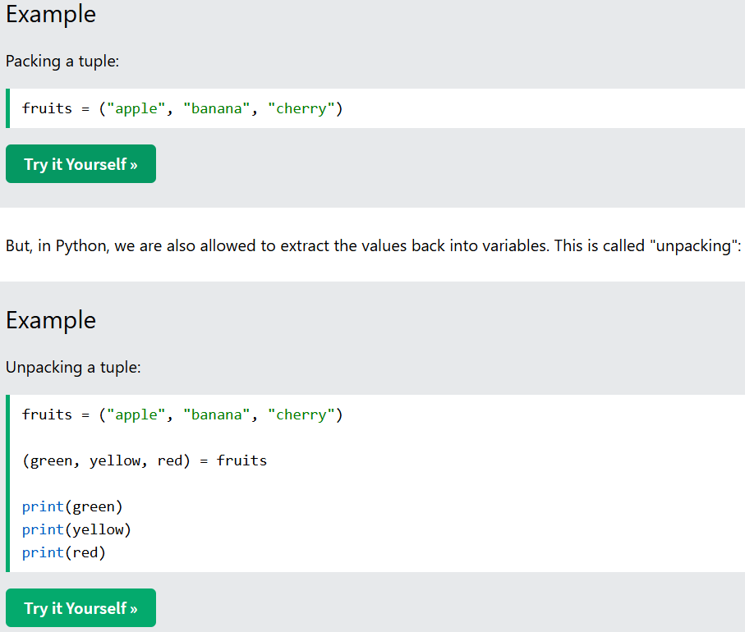
Note: The number of variables must match the number of values in the tuple, if not, you must use an asterisk to collect the remaining values as a list.
Using Asterisk*
If the number of variables is less than the number of values, you can add an * to the variable name and the values will be assigned to the variable as a list:
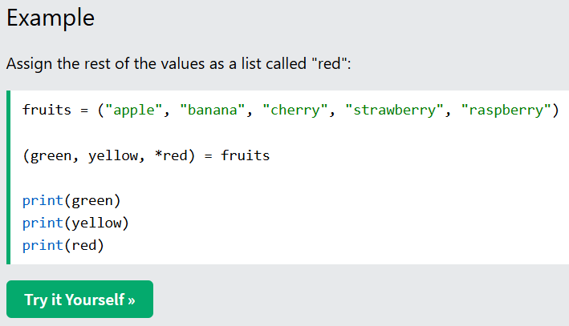
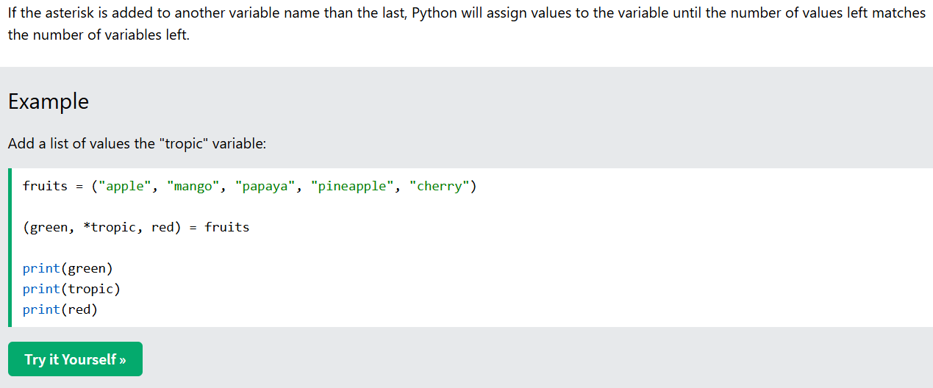
Python - Join Tuples
Join Two Tuples
To join two or more tuples you can use the + operator:
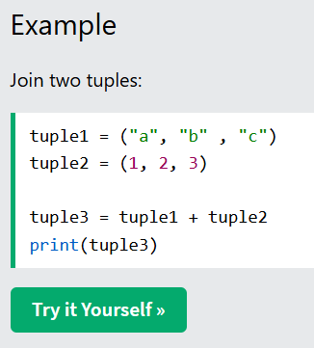
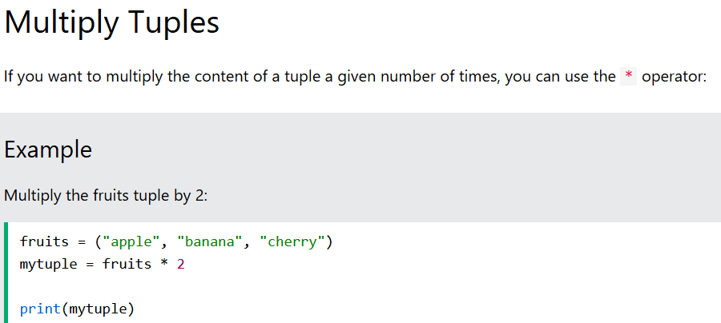

Tuple Exercise
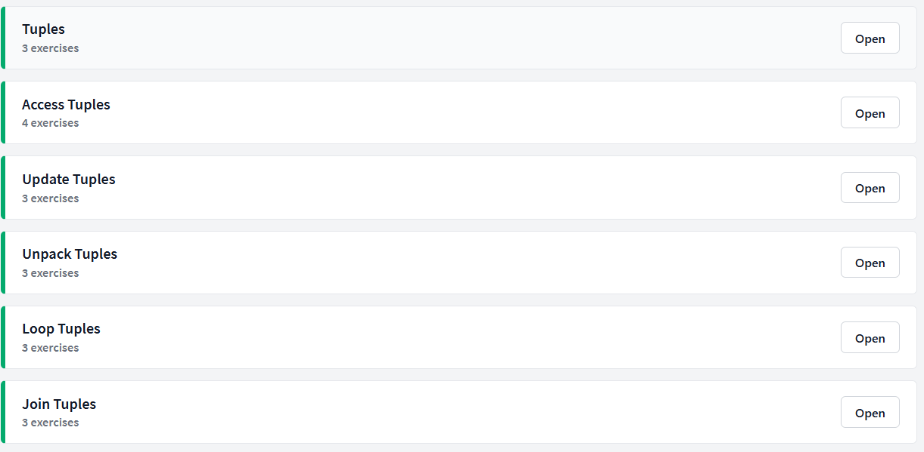
Tuples
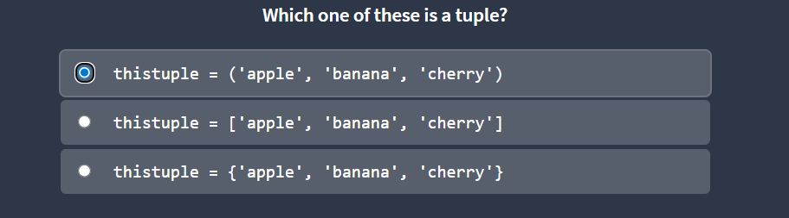
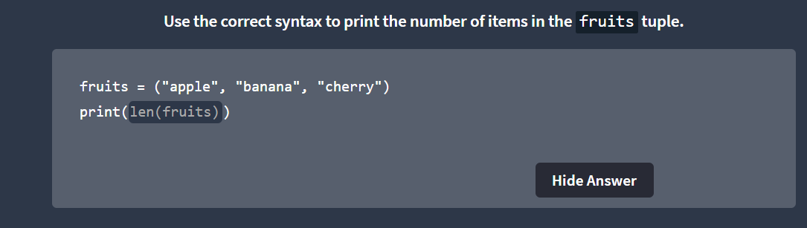
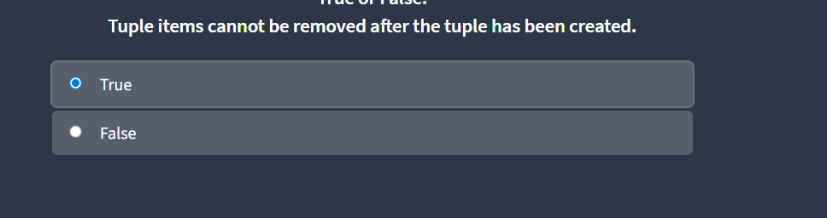
Python Access Tuples
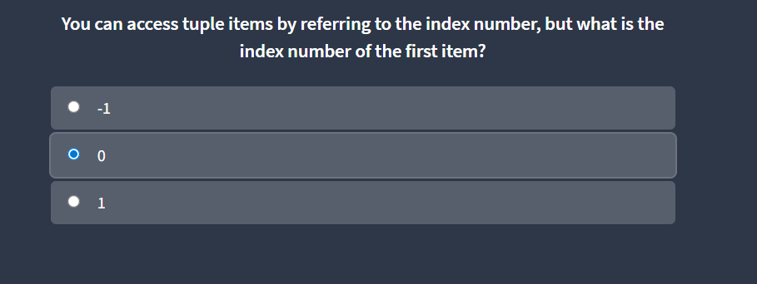
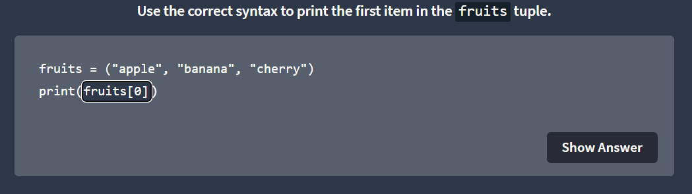
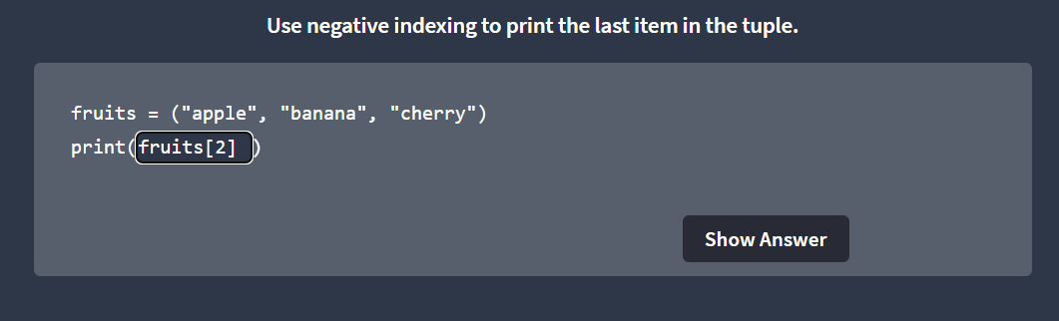
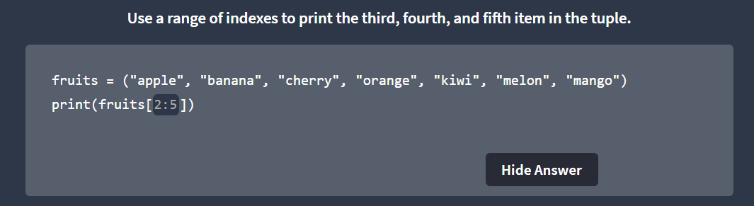
Python Update Tuples
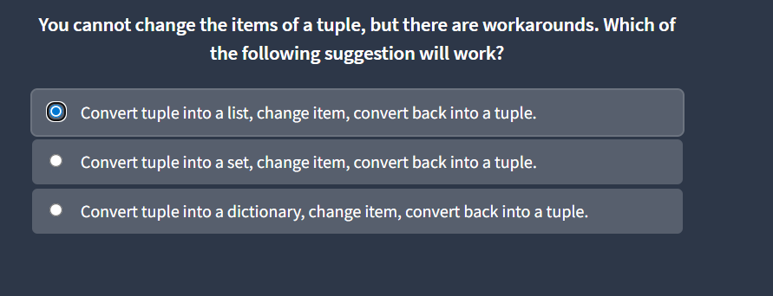
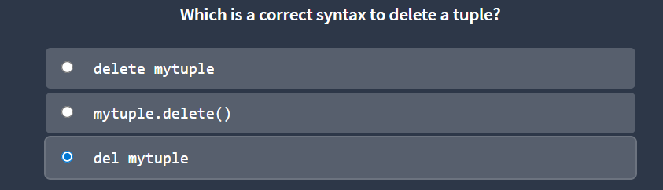
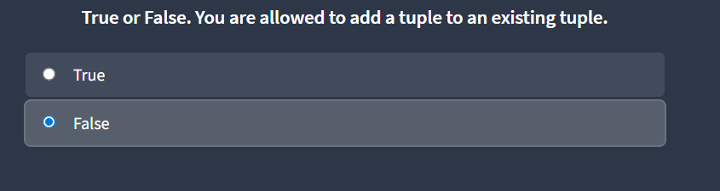
Unpack Tuples
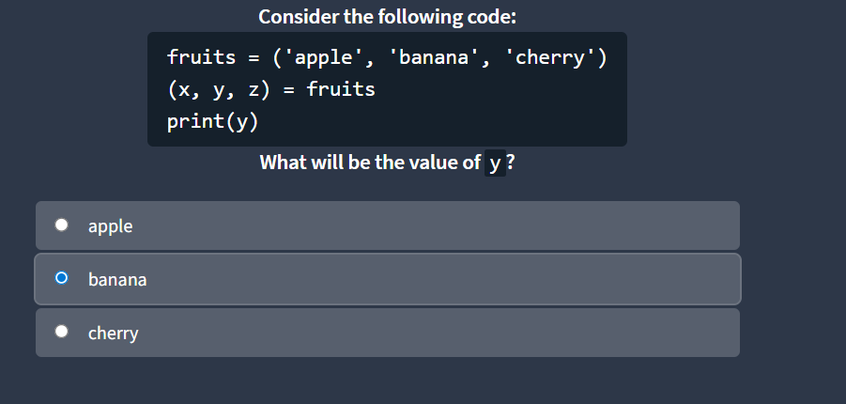
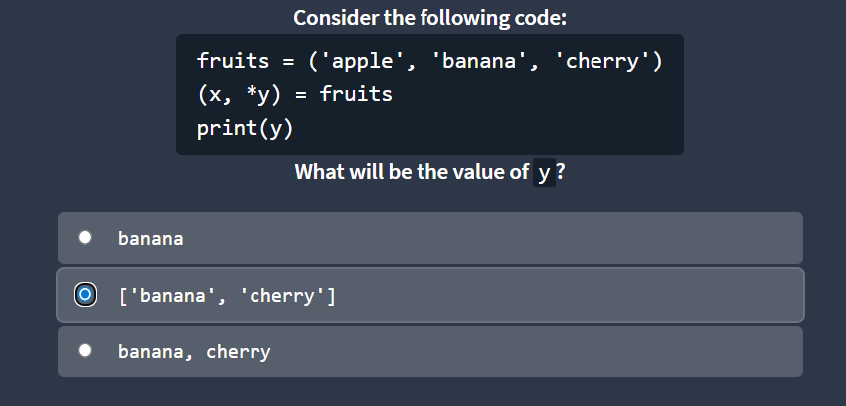
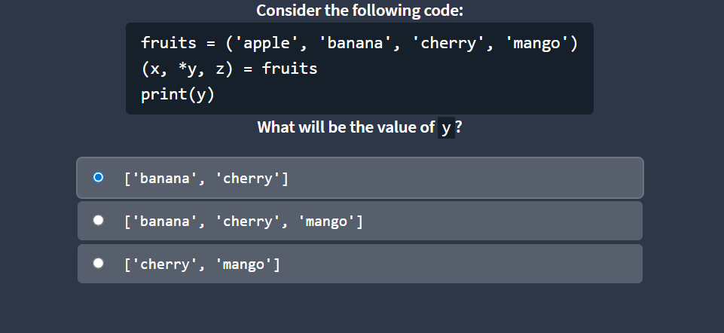
Python Join Tuples
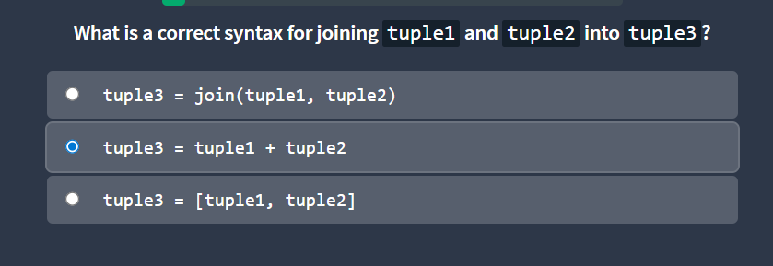
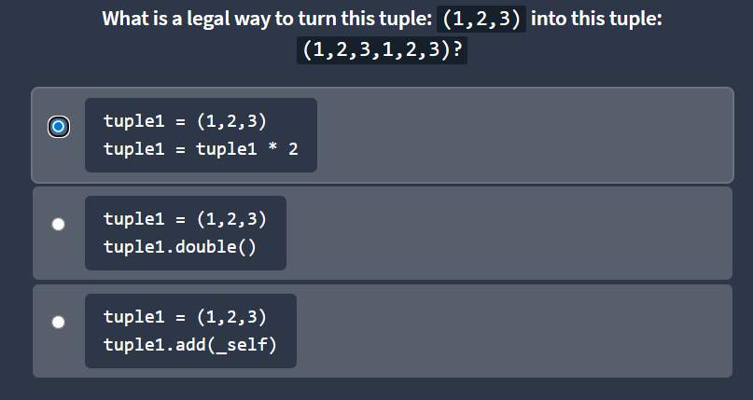
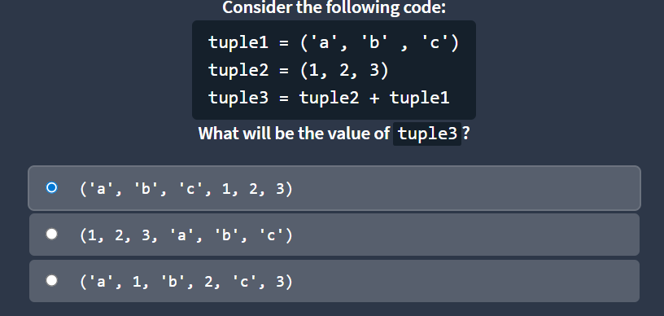
Python Sets
Set
Sets are used to store multiple items in a single variable.
Set is one of 4 built-in data types in Python used to store collections of data, the other 3 are List, Tuple, and Dictionary, all with different qualities and usage.
A set is a collection which is unordered, unchangeable*, and unindexed.
Note: Set items are unchangeable, but you can remove items and add new items.
Sets are written with curly brackets.

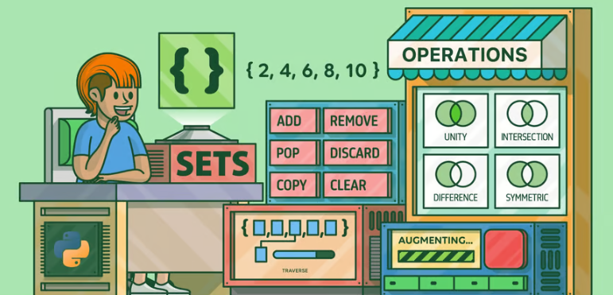
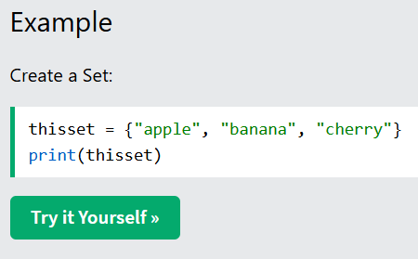
Note: Sets are unordered, so you cannot be sure in which order the items will appear.
Set Items
Set items are unordered, unchangeable, and do not allow duplicate values.
Unordered
Unordered means that the items in a set do not have a defined order.
Set items can appear in a different order every time you use them, and cannot be referred to by index or key.
Unchangeable
Set items are unchangeable, meaning that we cannot change the items after the set has been created.
Once a set is created, you cannot change its items, but you can remove items and add new items.
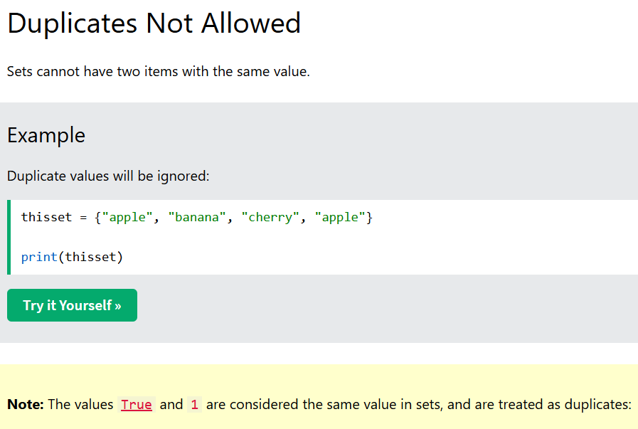
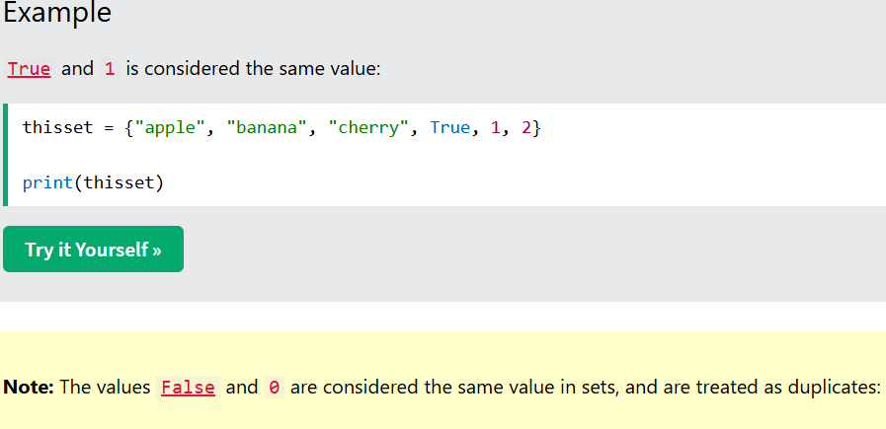
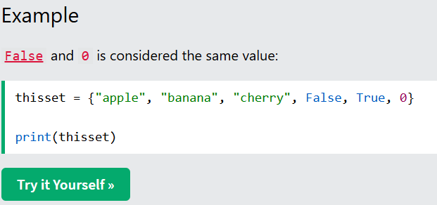
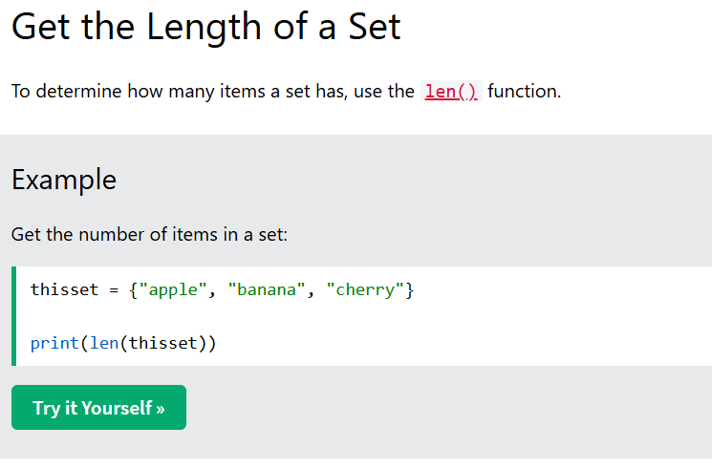
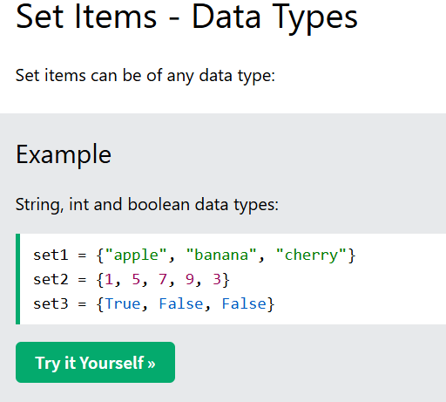
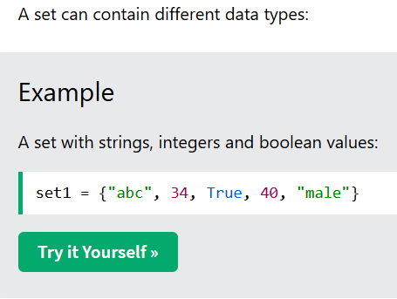
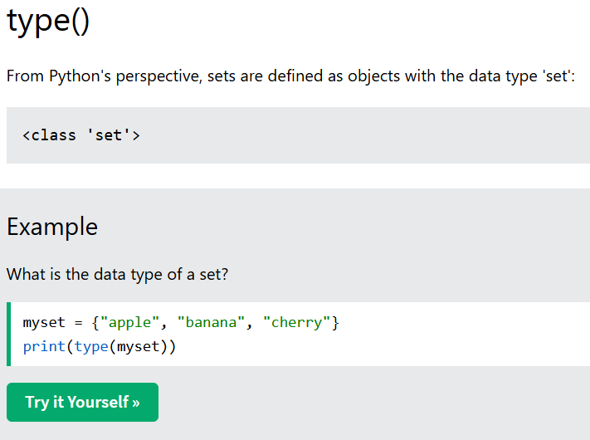
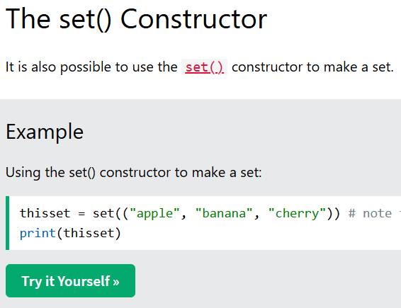
Add Set Items
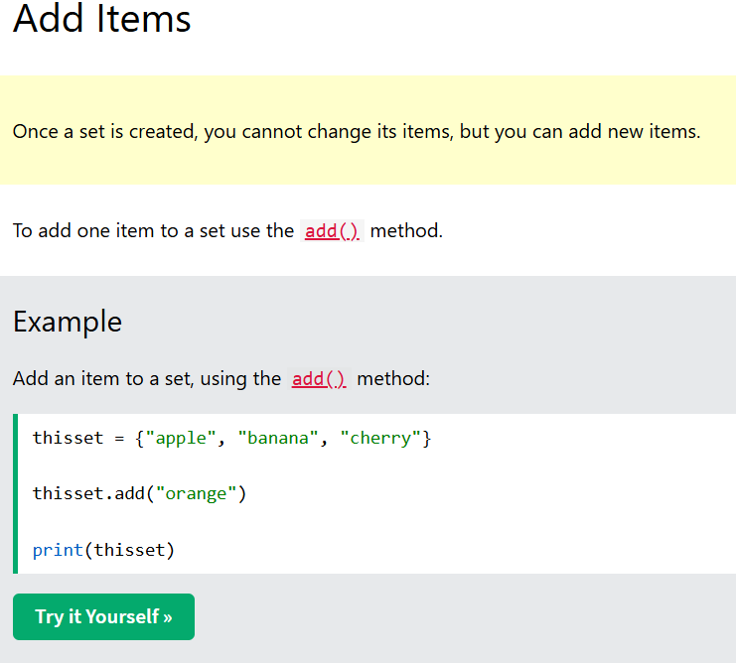
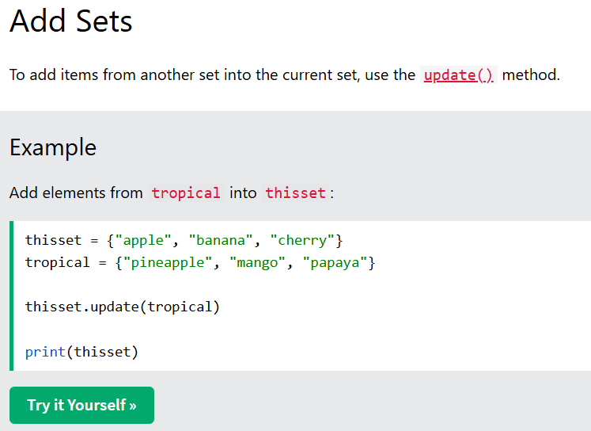
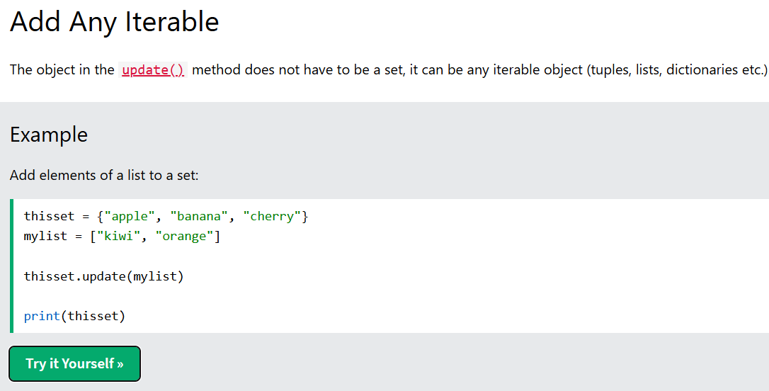
Python - Remove Set Items
Remove Item
To remove an item in a set, use the remove(), or the discard() method.
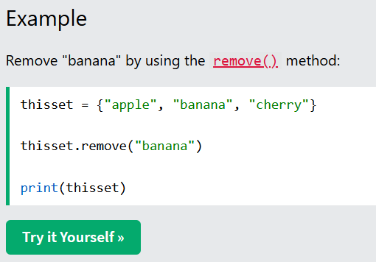
Note: If the item to remove does not exist, remove() will raise an error.
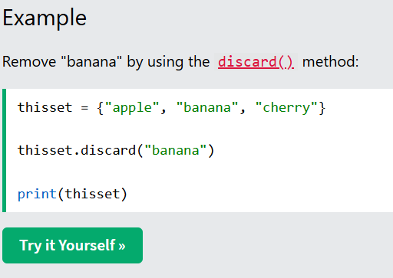
Note: If the item to remove does not exist, discard() will NOT raise an error.
You can also use the pop() method to remove an item, but this method will remove a random item, so you cannot be sure what item that gets removed.
The return value of the pop() method is the removed item.
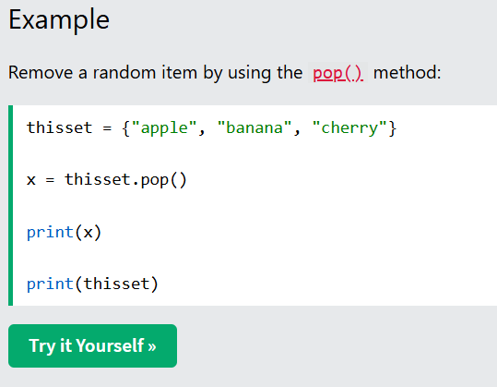
Note: Sets are unordered, so when using the pop() method, you do not know which item that gets removed.
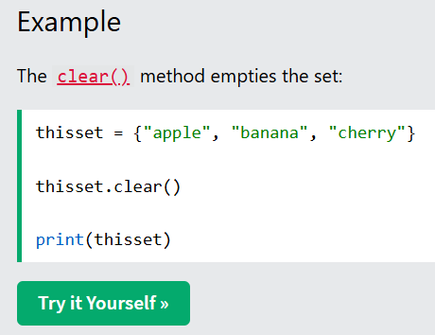
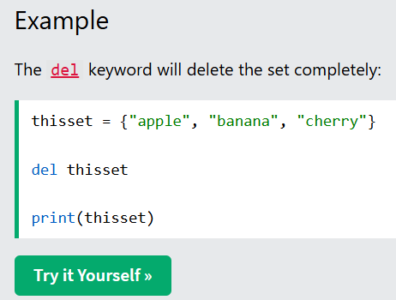
Python - Join Sets
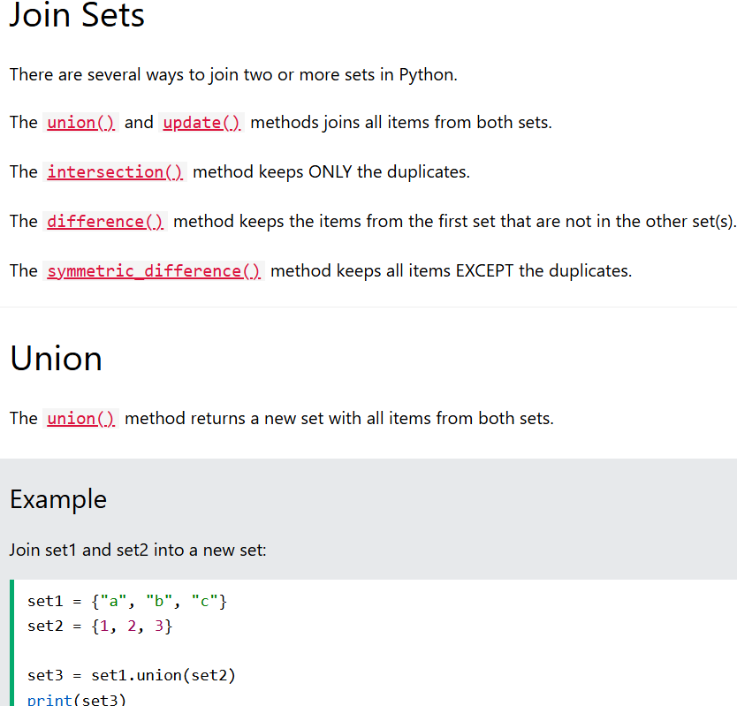
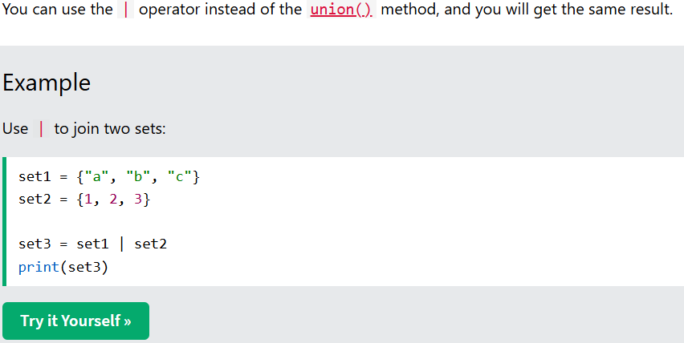
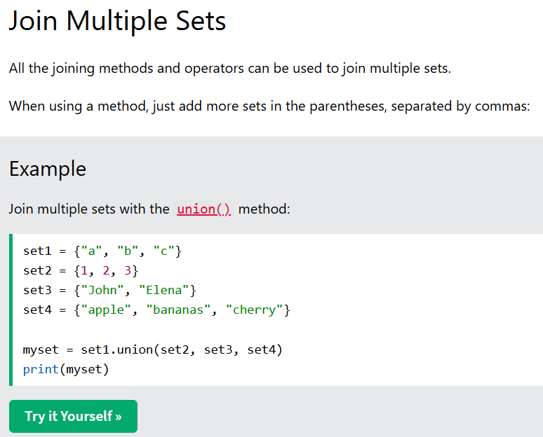
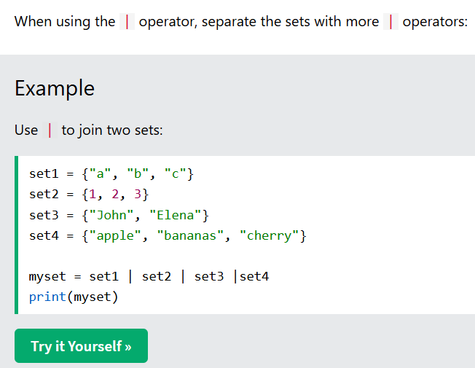
Join a Set and a Tuple
The union() method allows you to join a set with other data types, like lists or tuples.
The result will be a set.
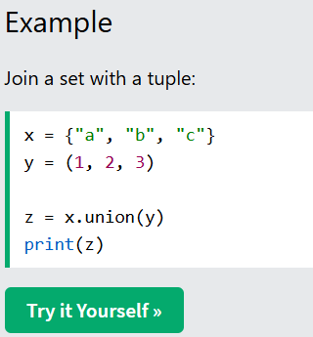
Note: The | operator only allows you to join sets with sets, and not with other data types like you can with the union() method.
Update
The update() method inserts all items from one set into another.
The update() changes the original set, and does not return a new set.
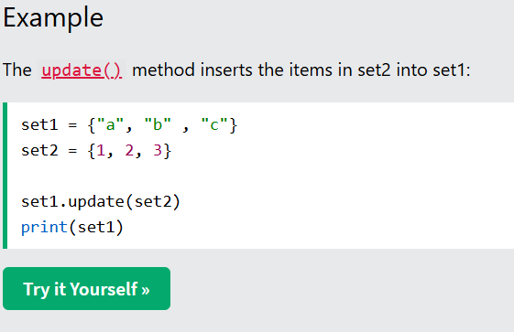
Note: Both union() and update() will exclude any duplicate items.
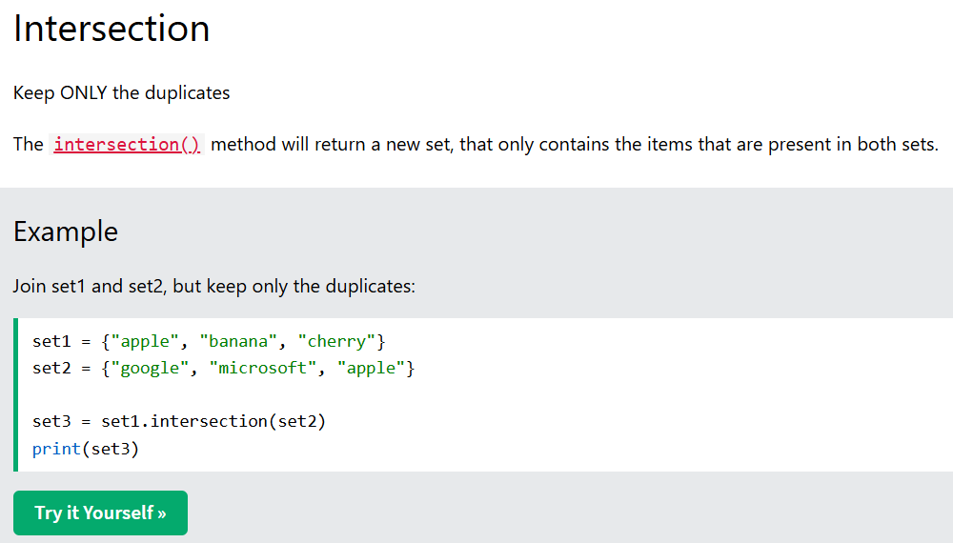
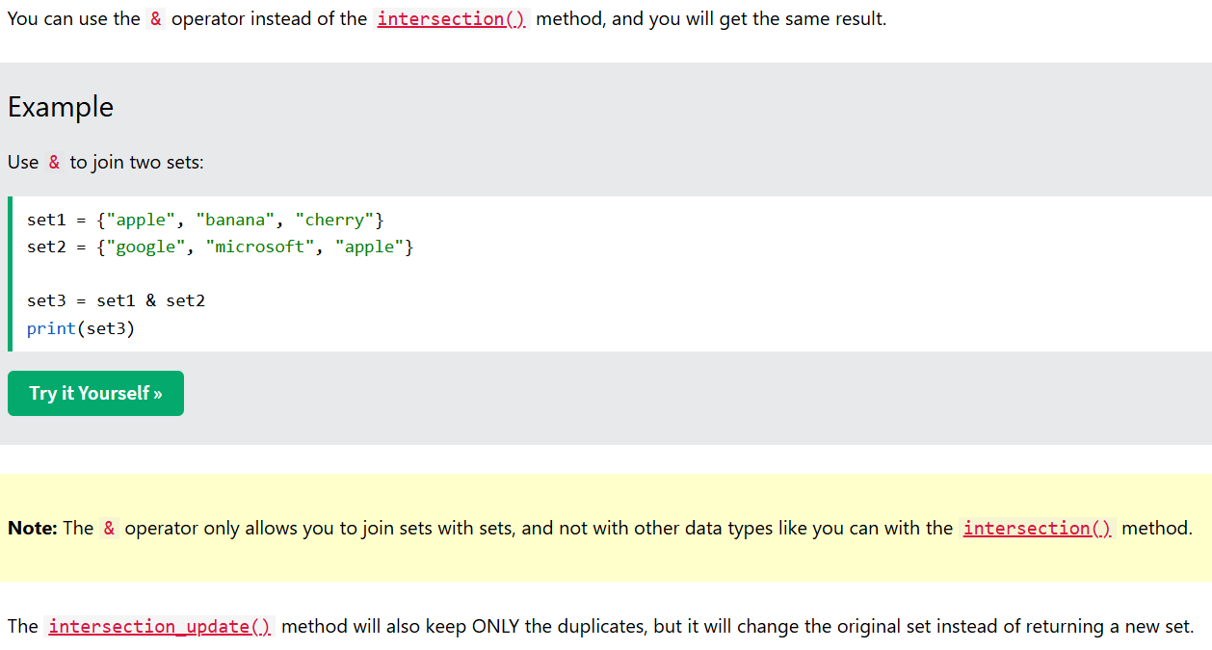
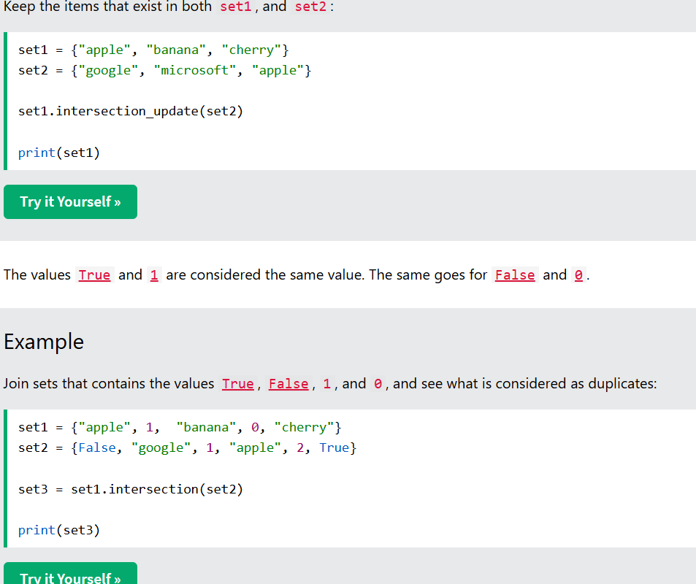
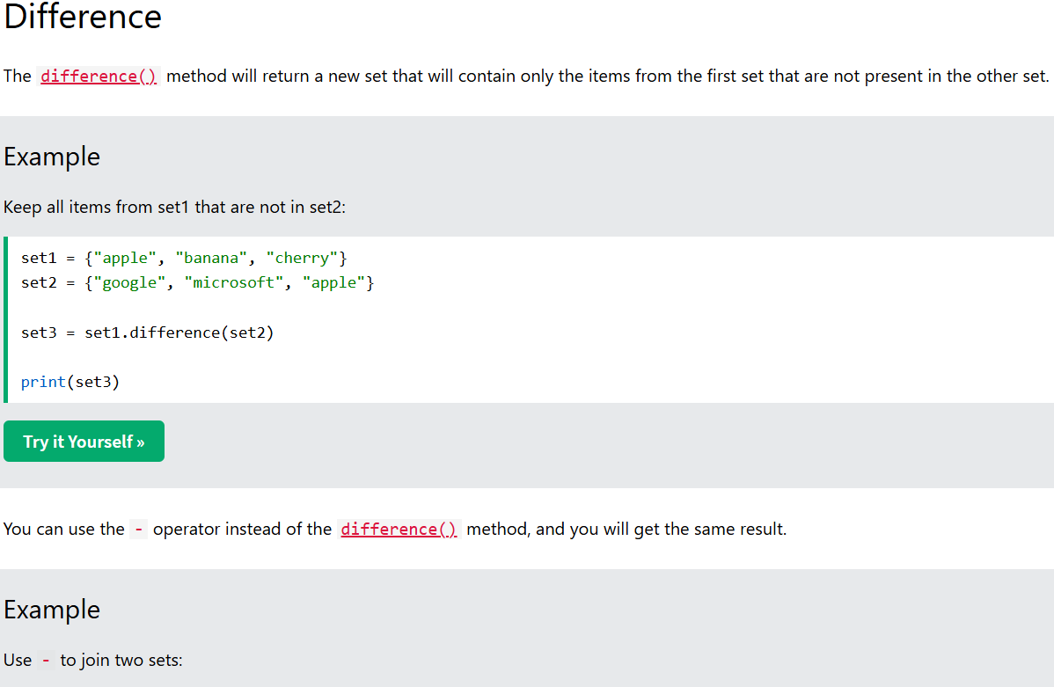
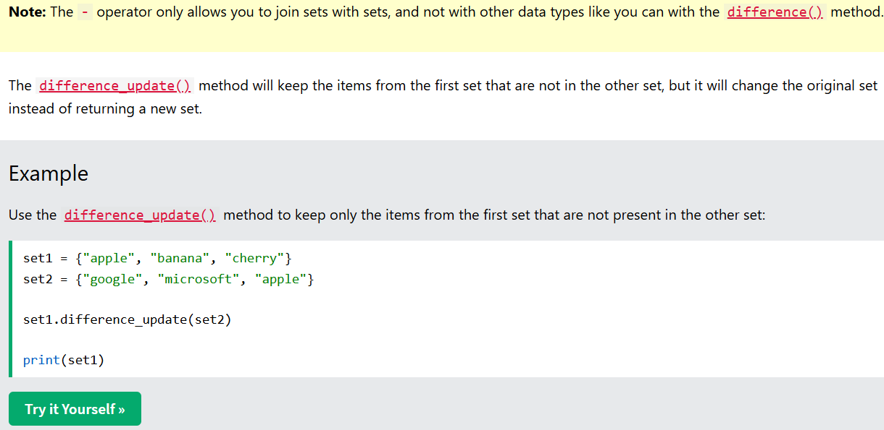
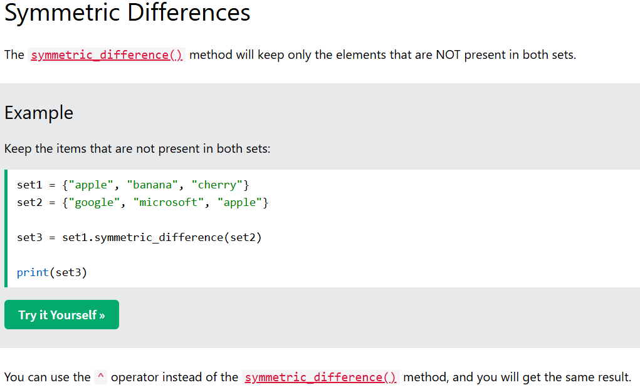
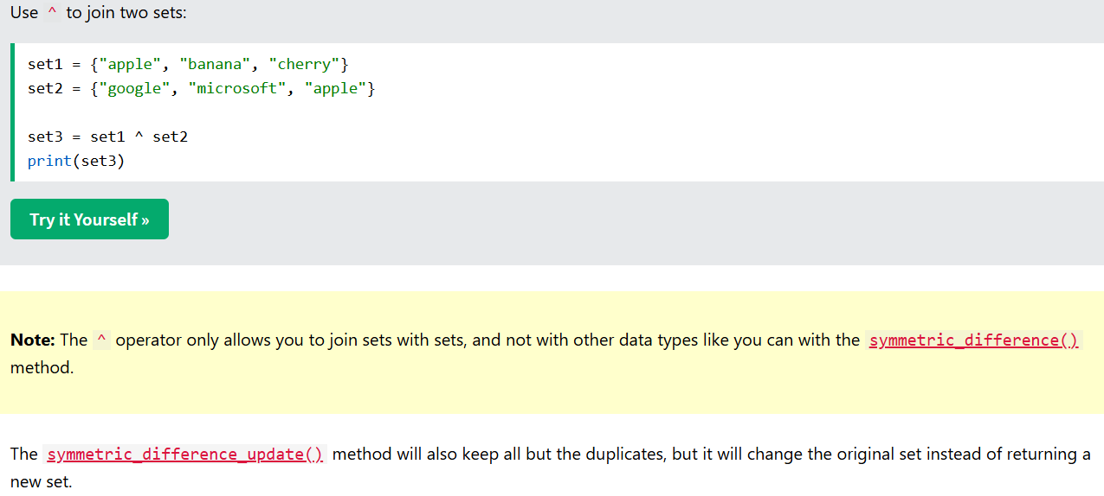
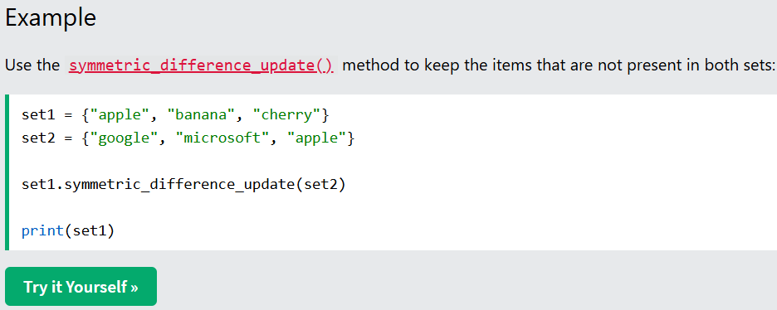
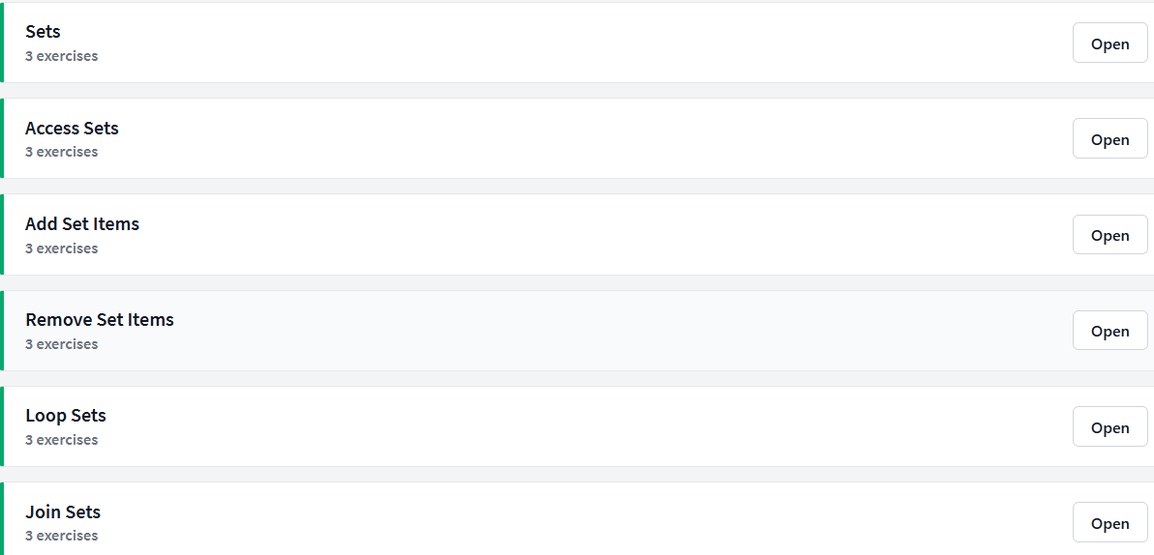

Sets
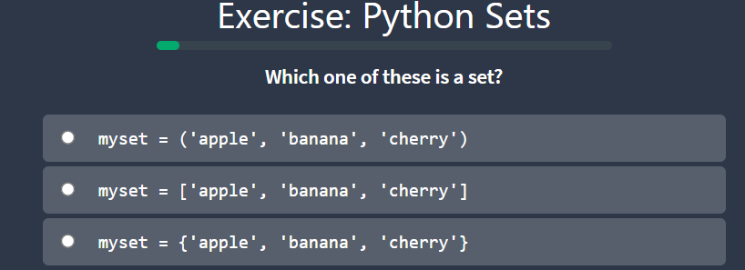
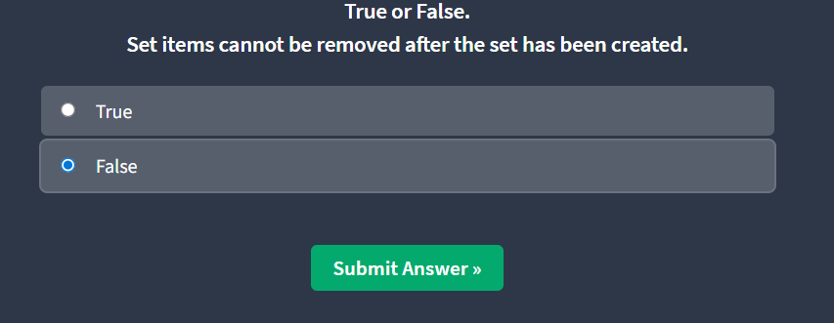
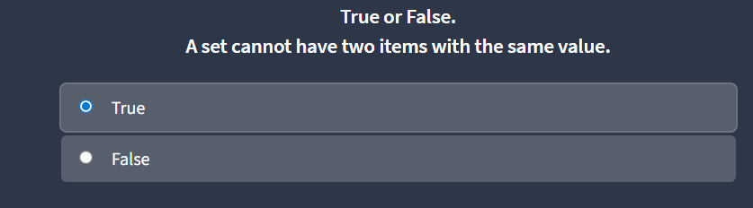
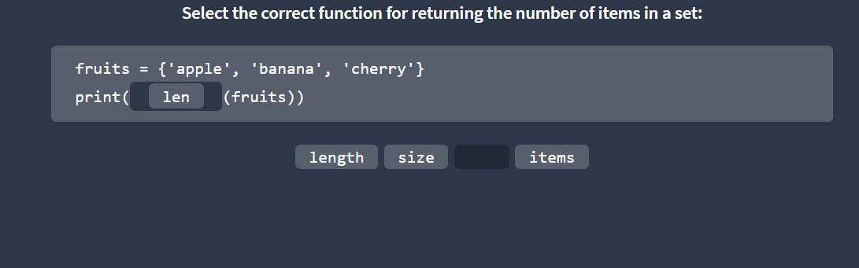
Add Set Items
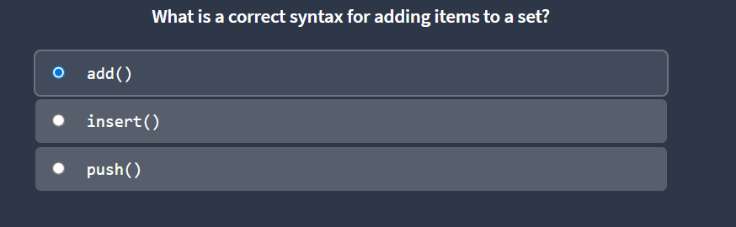
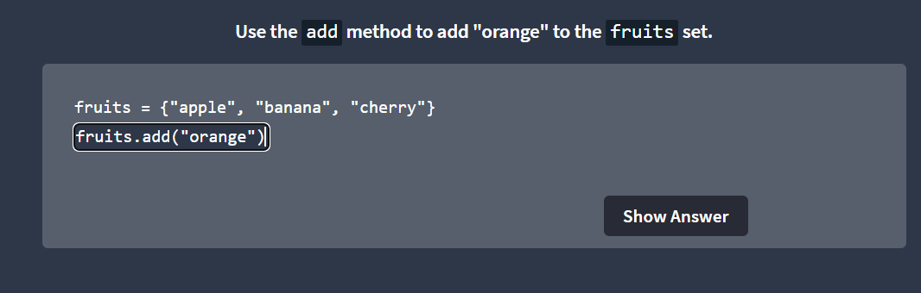
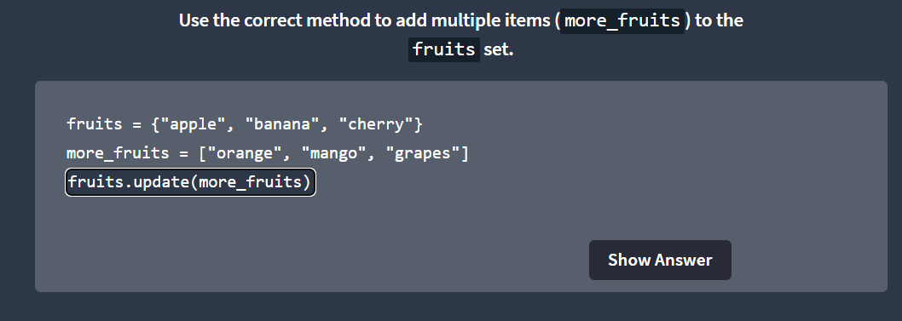
Remove Set items
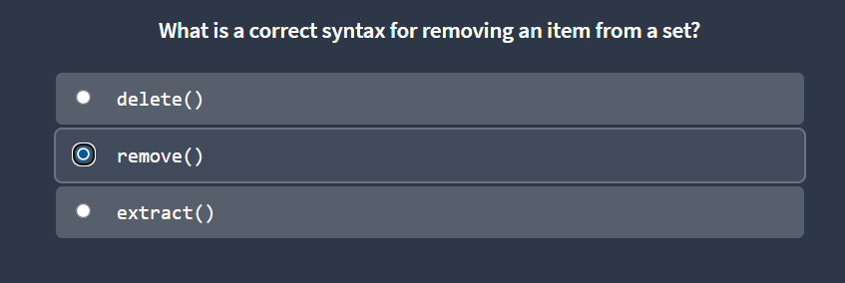
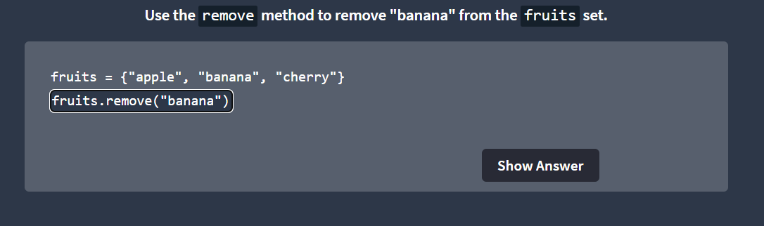
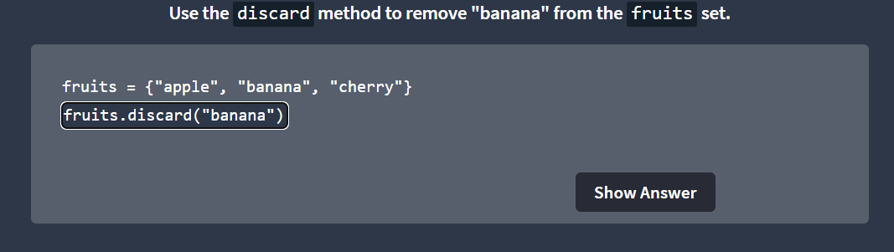
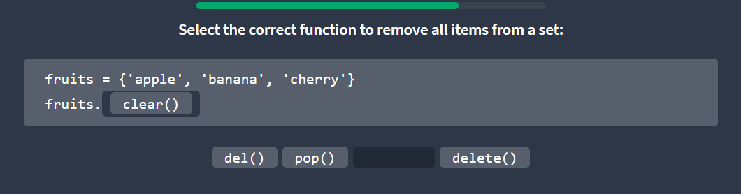
Joins Sets
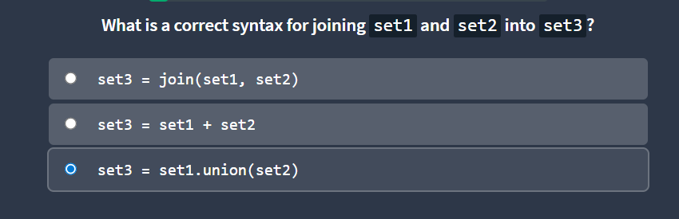
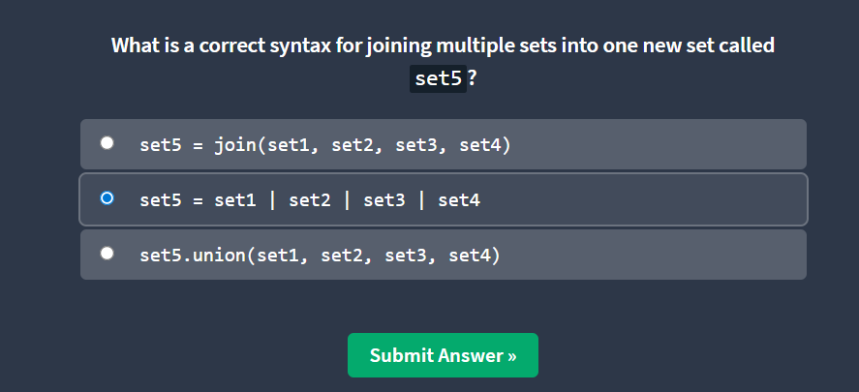
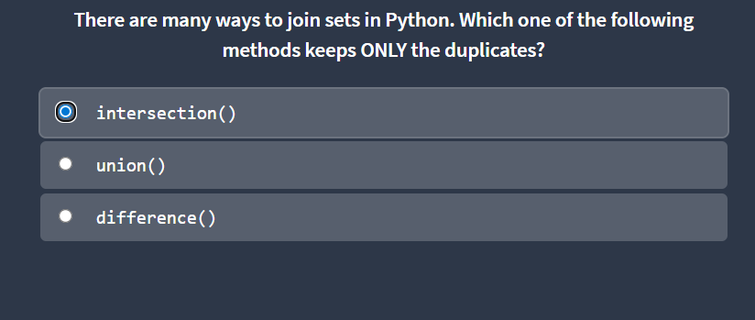
Python Dictionaries
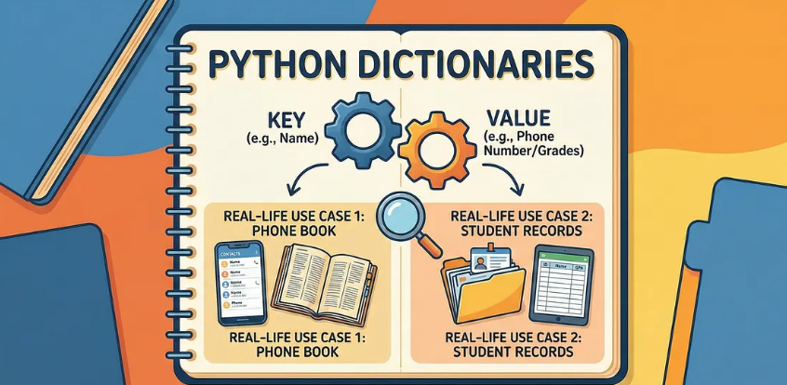
Dictionary
Dictionaries are used to store data values in key:value pairs.
A dictionary is a collection which is ordered*, changeable and do not allow duplicates.
As of Python version 3.7, dictionaries are ordered. In Python 3.6 and earlier, dictionaries are unordered.
Dictionaries are written with curly brackets, and have keys and values:
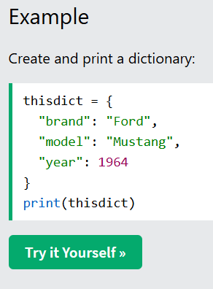
Dictionary Items
Dictionary items are ordered, changeable, and do not allow duplicates.
Dictionary items are presented in key:value pairs, and can be referred to by using the key name.
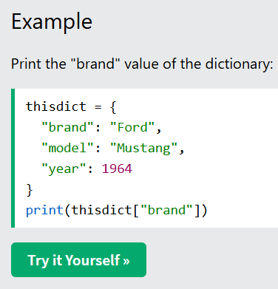
Ordered or Unordered?
As of Python version 3.7, dictionaries are ordered. In Python 3.6 and earlier, dictionaries are unordered.
When we say that dictionaries are ordered, it means that the items have a defined order, and that order will not change.
Unordered means that the items do not have a defined order, you cannot refer to an item by using an index.
Changeable
Dictionaries are changeable, meaning that we can change, add or remove items after the dictionary has been created.
Duplicates Not Allowed
Dictionaries cannot have two items with the same key:
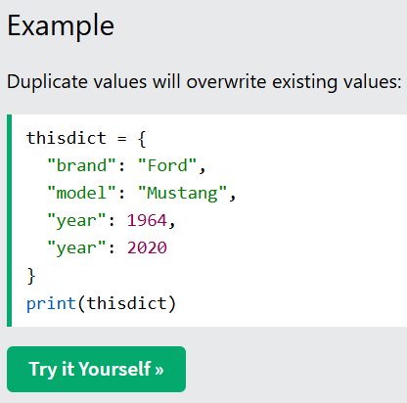
Dictionary Length
To determine how many items a dictionary has, use the len() function:
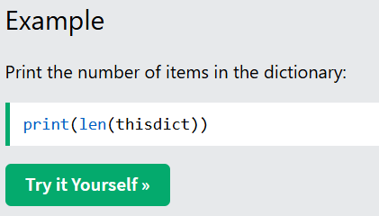
Dictionary Items - Data Types
The values in dictionary items can be of any data type:
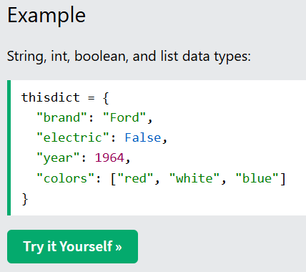
type()
From Python's perspective, dictionaries are defined as objects with the data type 'dict':
<class 'dict'>
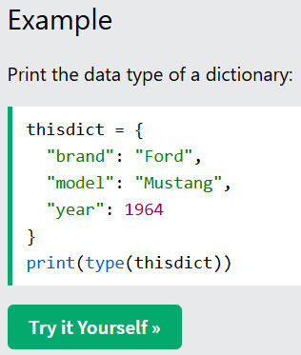
The dict() Constructor
It is also possible to use the dict() constructor to make a dictionary.
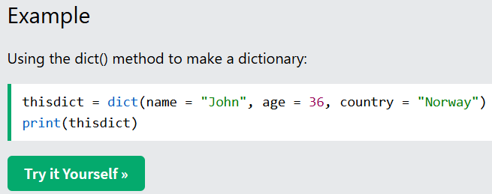
Python - Access Dictionary Items
Accessing Items
You can access the items of a dictionary by referring to its key name, inside square brackets:
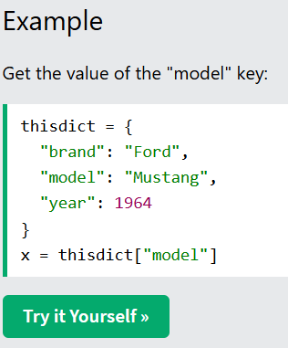
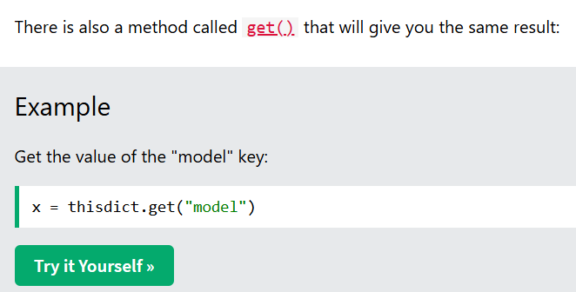
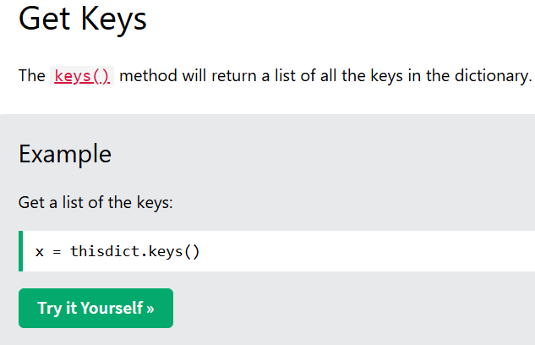
The list of the keys is a view of the dictionary, meaning that any changes done to the dictionary will be reflected in the keys list.
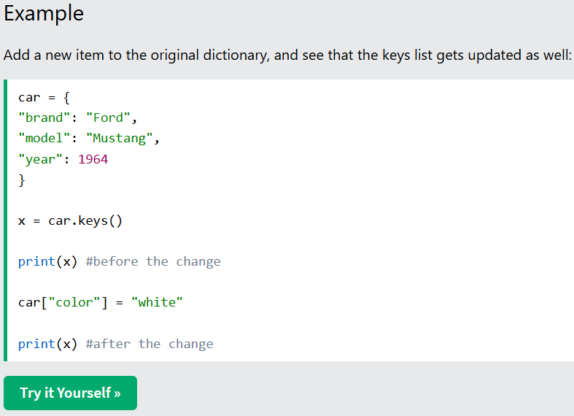
Get Values
The values() method will return a list of all the values in the dictionary.
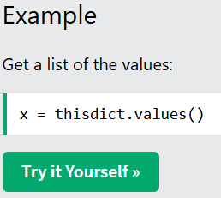
The list of the values is a view of the dictionary, meaning that any changes done to the dictionary will be reflected in the values list.
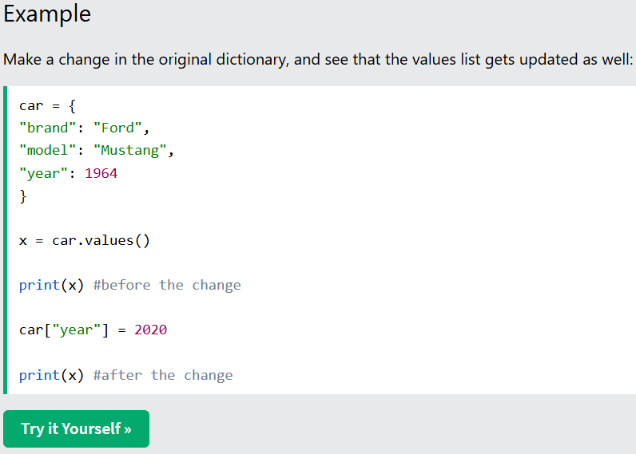
Get Items
The items() method will return each item in a dictionary, as tuples in a list.
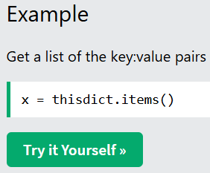
The returned list is a view of the items of the dictionary, meaning that any changes done to the dictionary will be reflected in the items list.
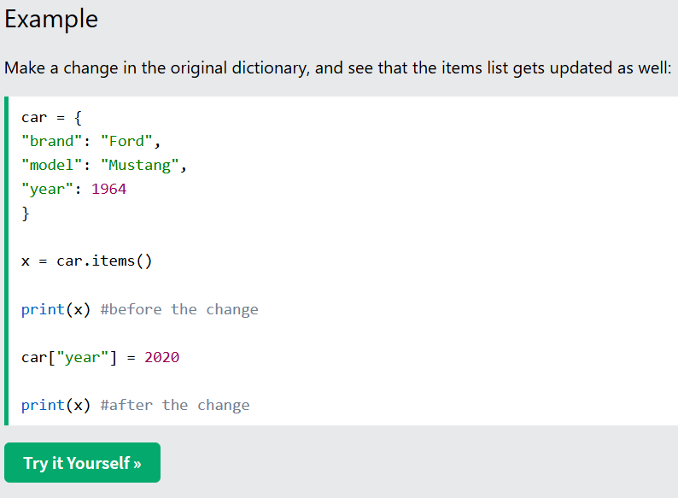
Python - Change Dictionary Items
Change Values
You can change the value of a specific item by referring to its key name:
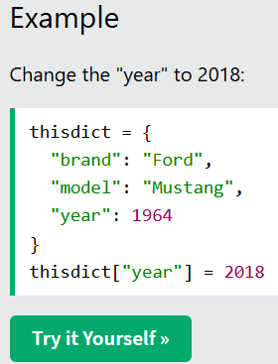
Update Dictionary
The update() method will update the dictionary with the items from the given argument.
The argument must be a dictionary, or an iterable object with key:value pairs.
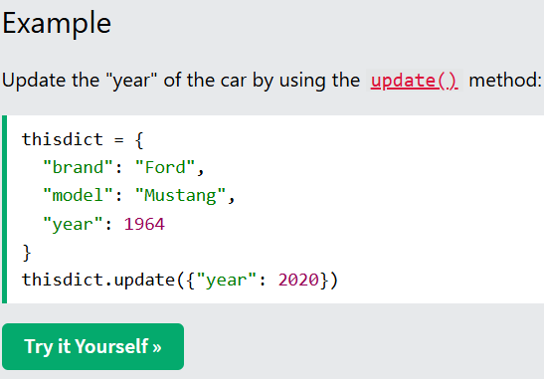
Python - Add Dictionary Items
Adding Items
Adding an item to the dictionary is done by using a new index key and assigning a value to it:
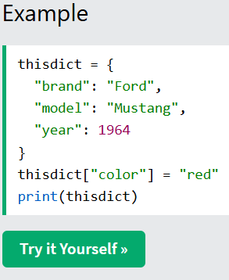
Update Dictionary
The update() method will update the dictionary with the items from a given argument. If the item does not exist, the item will be added.
The argument must be a dictionary, or an iterable object with key:value pairs.
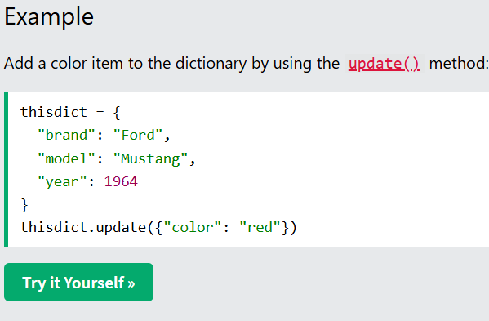
Python - Remove Dictionary Items
Removing Items
There are several methods to remove items from a dictionary:
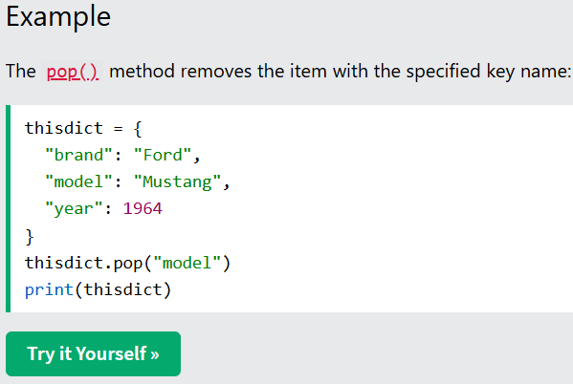
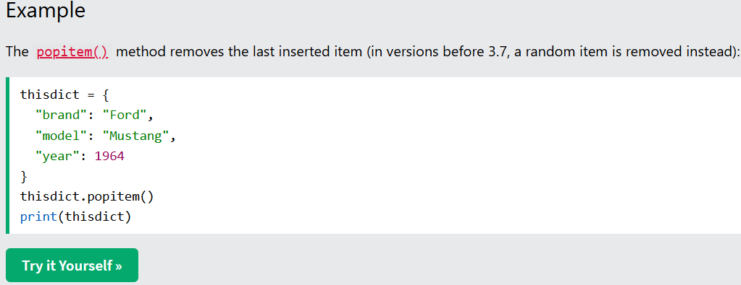
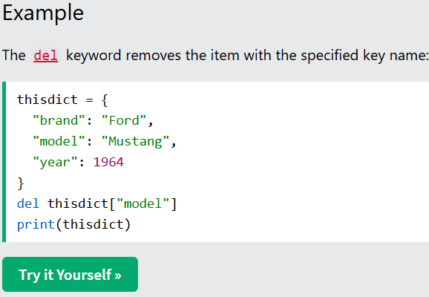
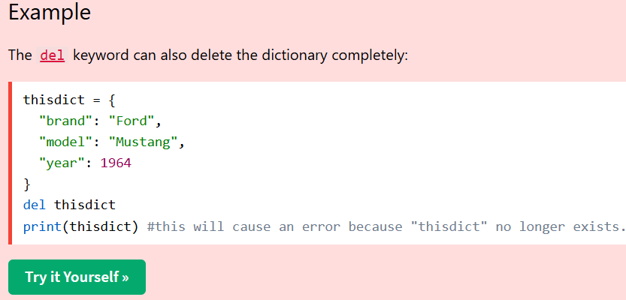
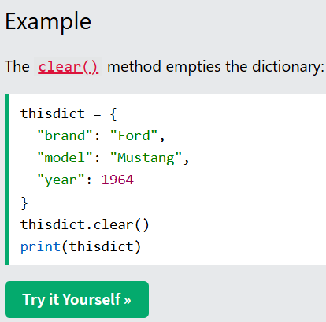
Python - Copy Dictionaries
Copy a Dictionary
You cannot copy a dictionary simply by typing dict2 = dict1, because: dict2 will only be a reference to dict1, and changes made in dict1 will automatically also be made in dict2.
There are ways to make a copy, one way is to use the built-in Dictionary method copy().
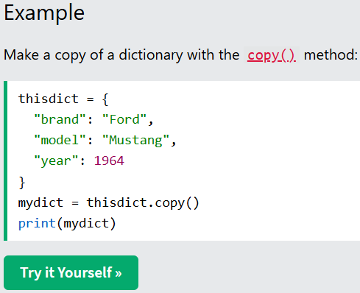
Another way to make a copy is to use the built-in function dict().
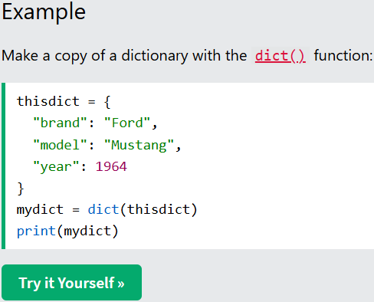
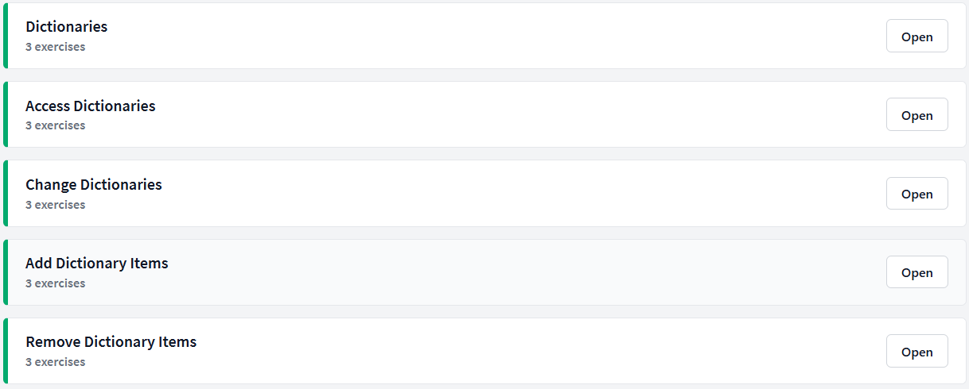
Python Dictionaries
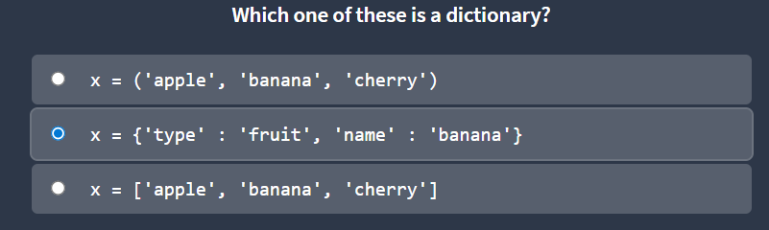
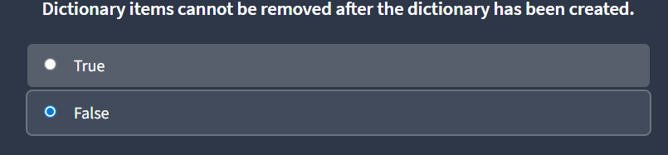
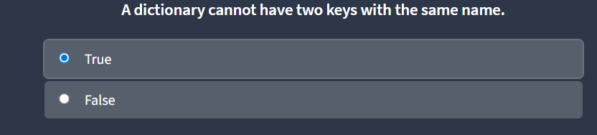
Python Access Dictionaries
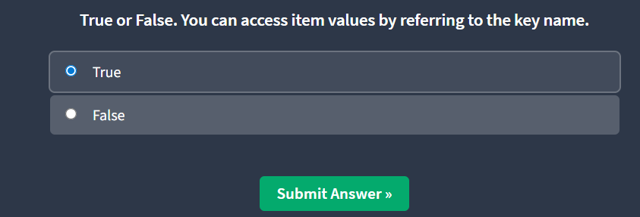
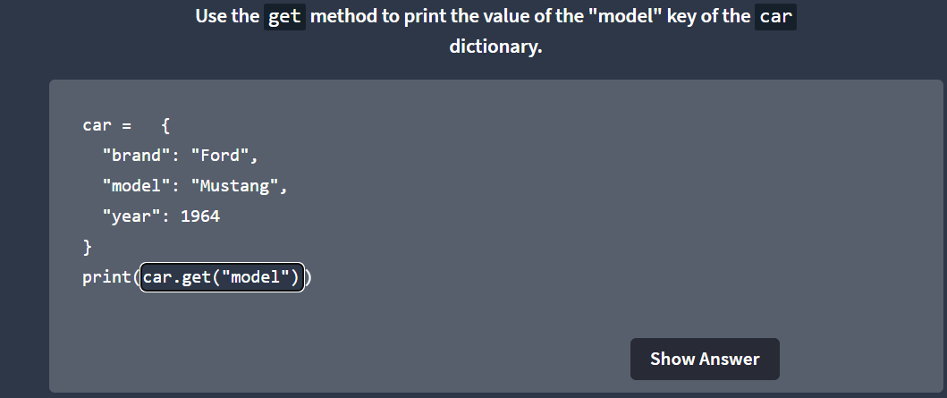
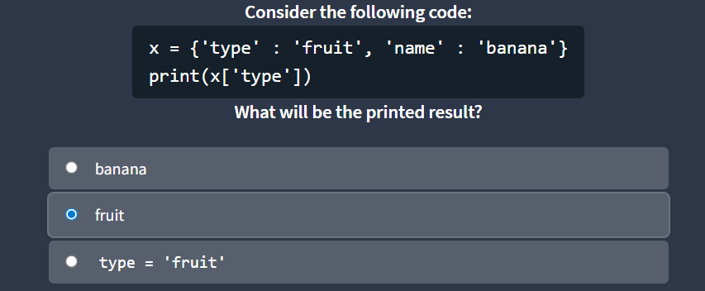
Python Change Dictionaries
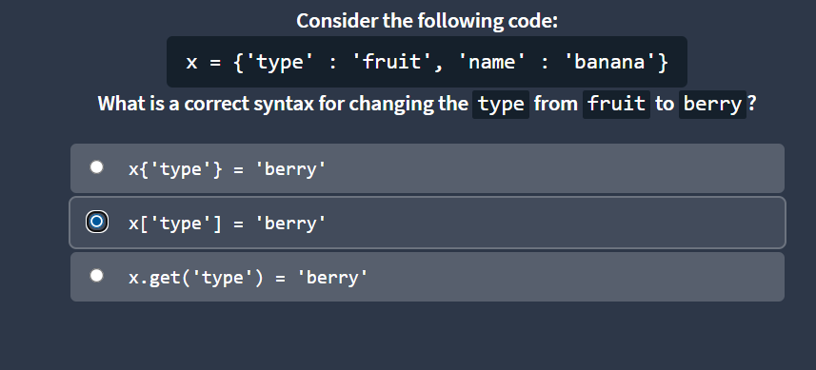
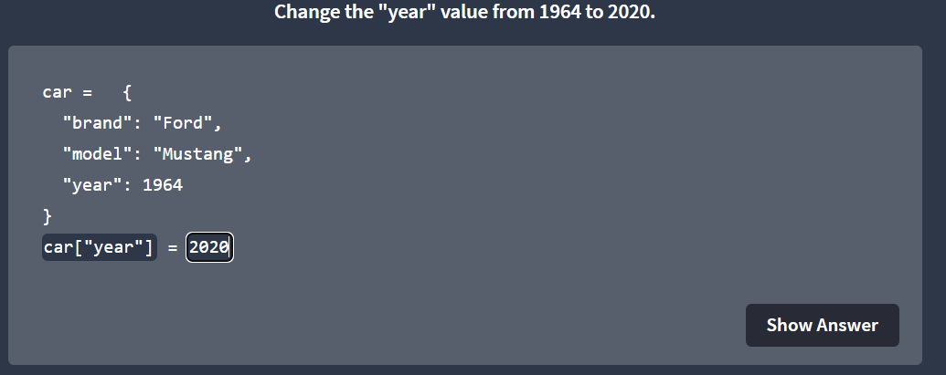
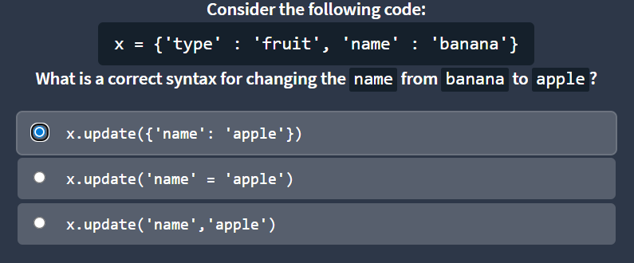
Python Add Dictionary Items
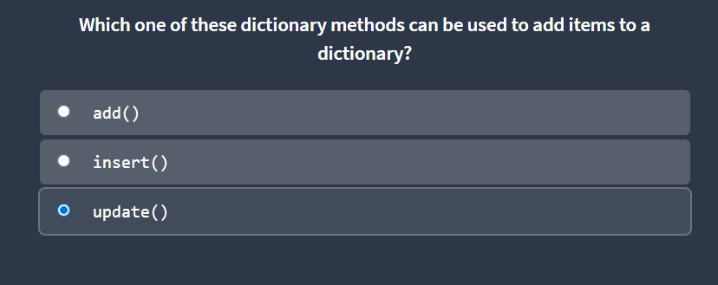
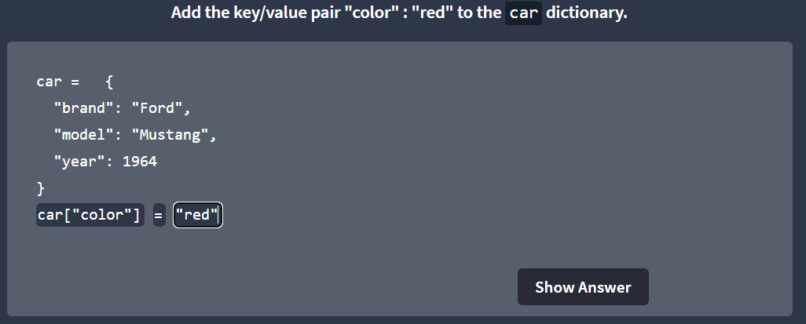
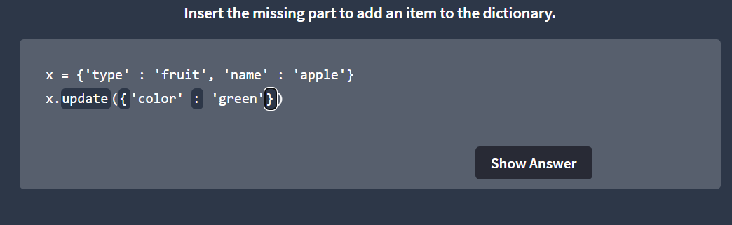
Remove Dictionary Items
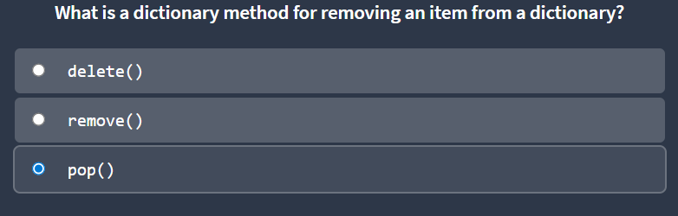
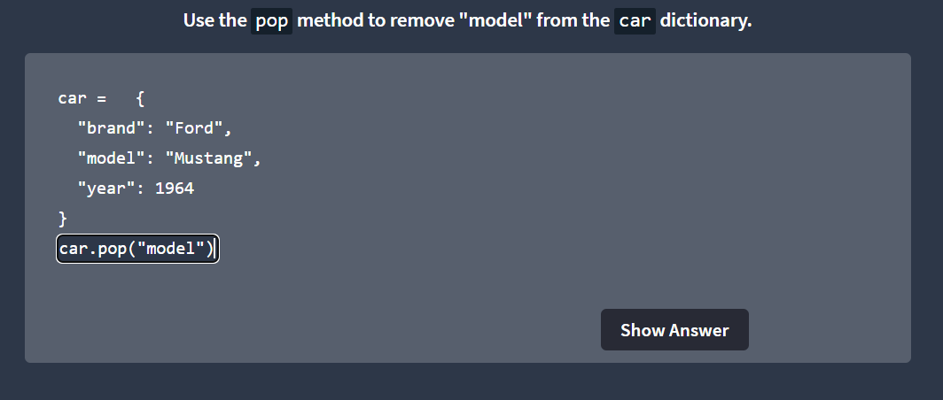
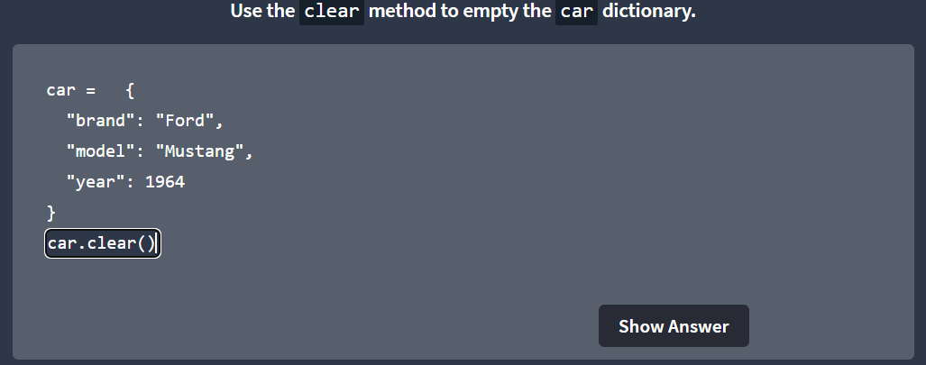
1.4 Python Operators
Operators are used to perform operations on variables and values.
In the example below, we use the + operator to add together two values:
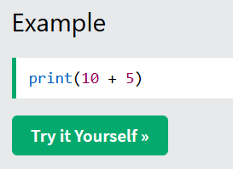
Although the + operator is often used to add together two values, like in the example above, it can also be used to add together a variable and a value, or two variables:
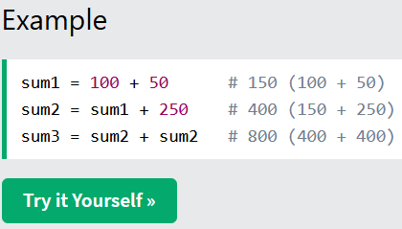
Python Arithmetic Operators
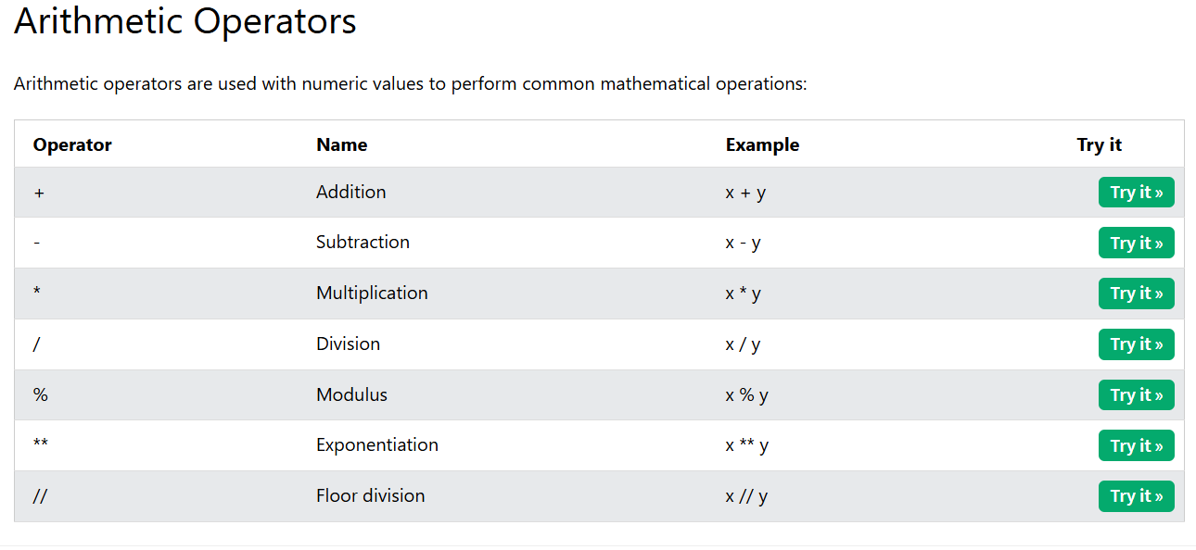
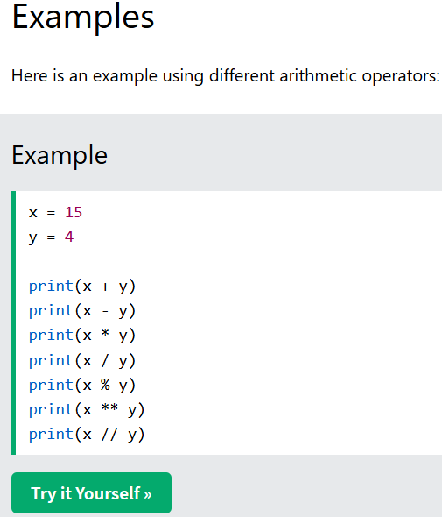
Assign Operators
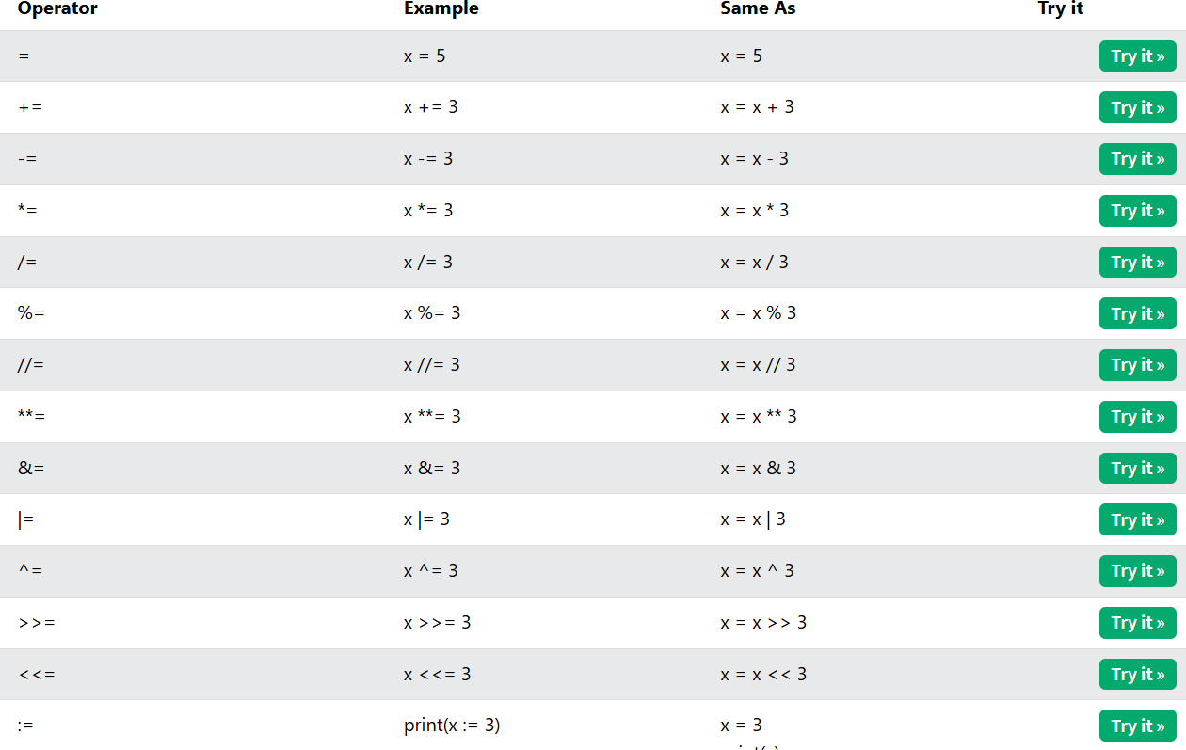
Comparison Operators
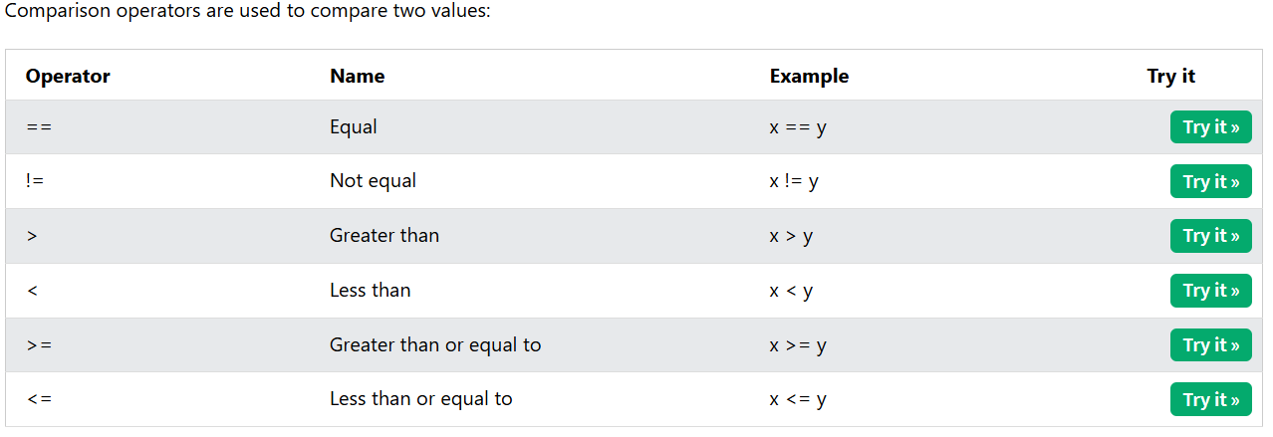
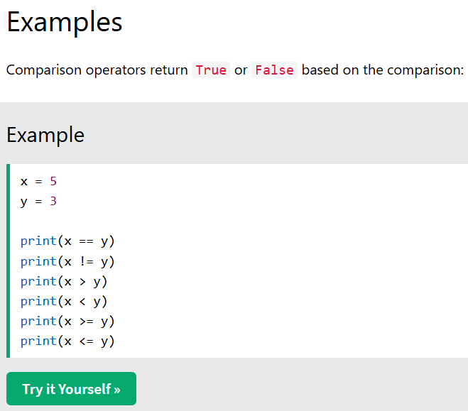
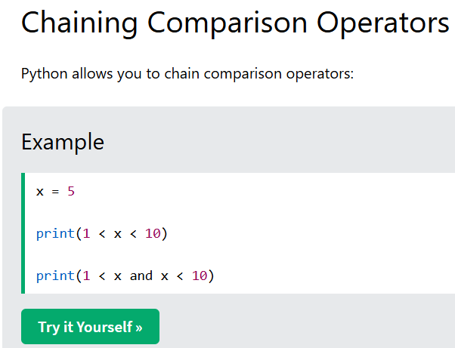
Logical Operators
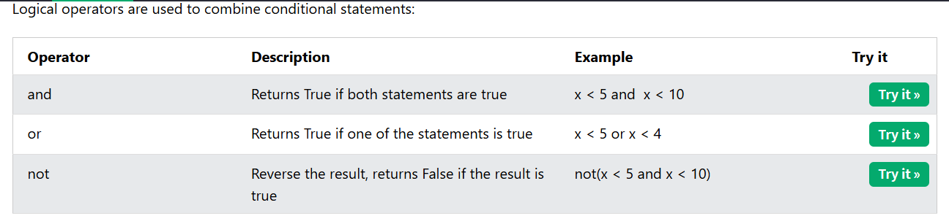
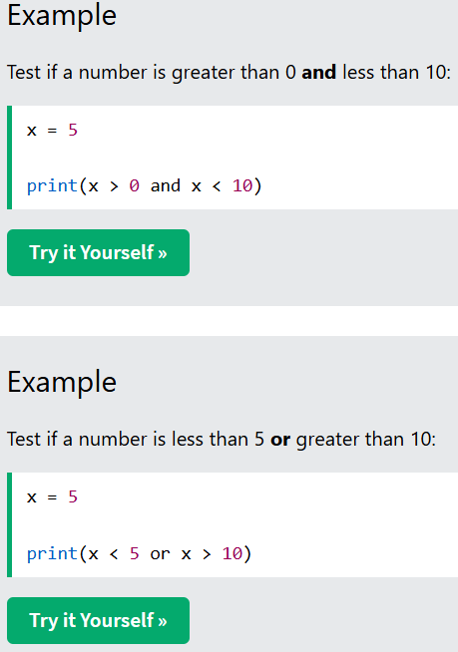
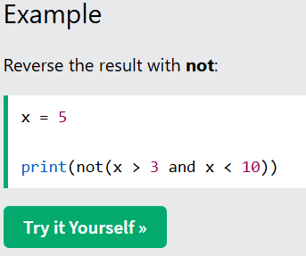
Python Identity Operators
Identity operators are used to compare the objects, not if they are equal, but if they are actually the same object, with the same memory location:
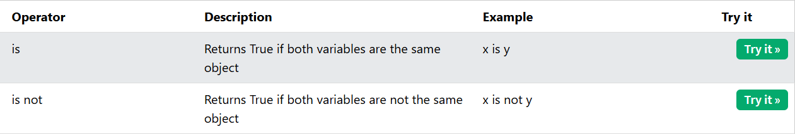
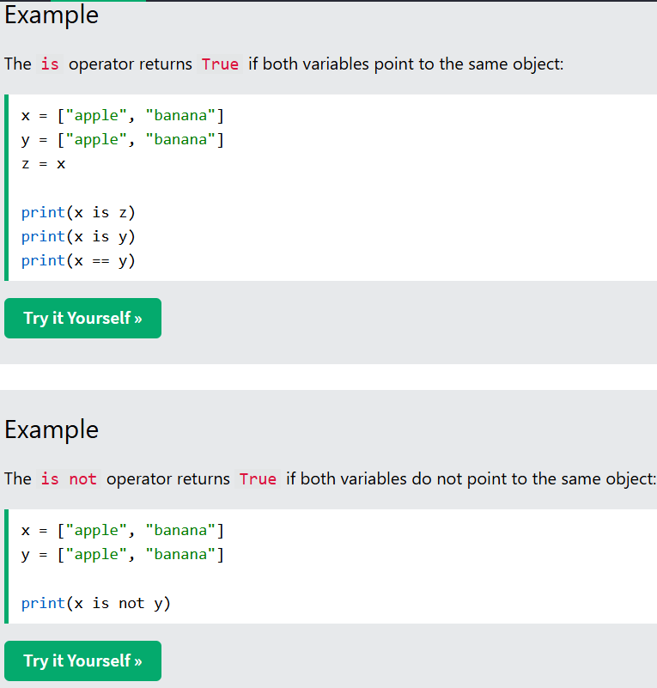
Python Membership Operators
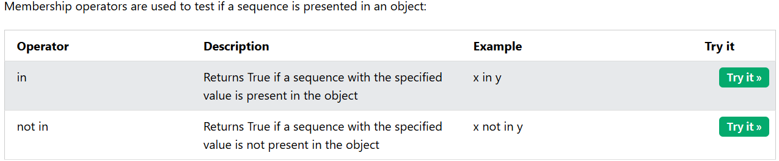
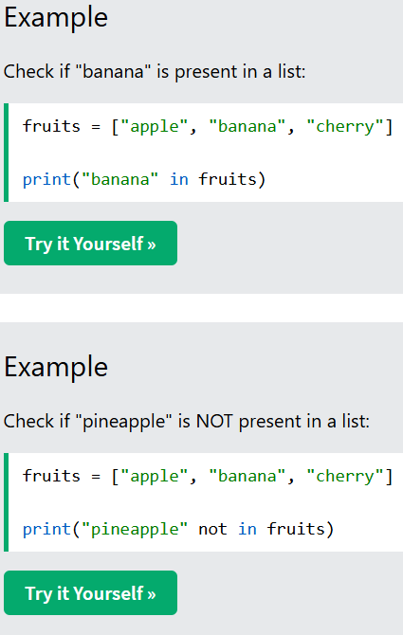
Code Challenge
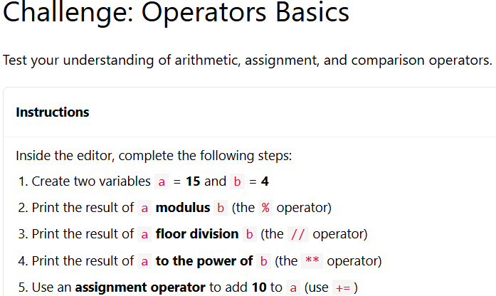
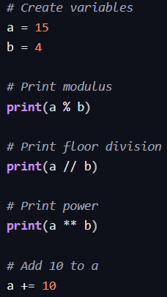
White Space
White space means the empty spaces used in a Python program to improve readability and code organization.
White space includes:
- spaces
- blank lines
- tabs
White space makes code cleaner and easier to understand.
White Space Around Operators
Spaces are commonly added around operators to improve readability.
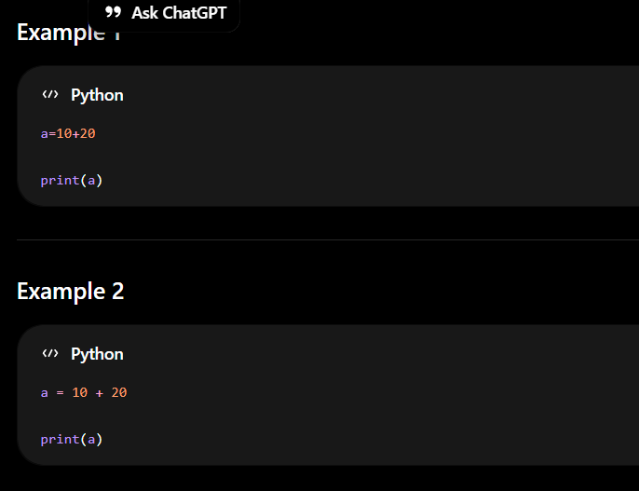
White Space in Variables and Datatypes
White space improves readability while working with variables and datatypes.
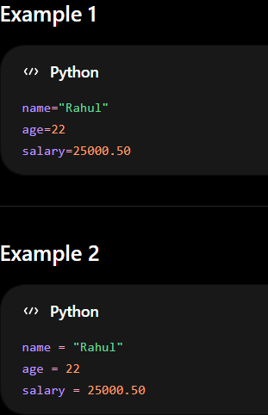
White Space in Data Structures
White space improves readability in lists and other data structures.
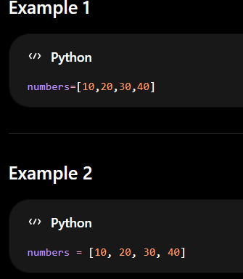
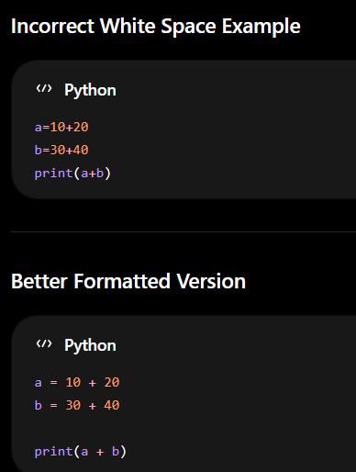

Module 2 - Flow Control with Decisions and Loops
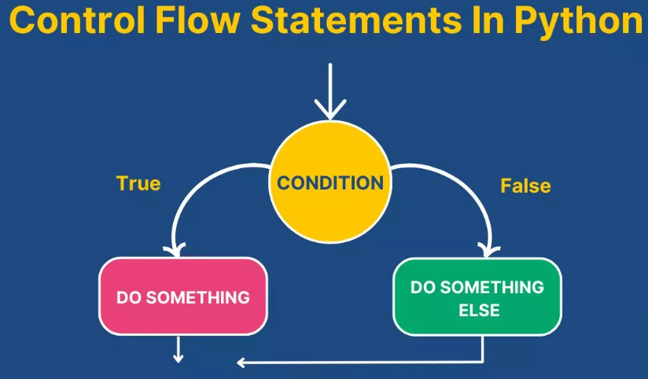
2.1 Python If_elif_else Statement
Python Conditions and If statements
Python supports the usual logical conditions from mathematics:
- Equals: a == b
- Not Equals: a != b
- Less than: a < b
- Less than or equal to: a <= b
- Greater than: a > b
- Greater than or equal to: a >= b
These conditions can be used in several ways, most commonly in "if statements" and loops.
An "if statement" is written by using the if keyword.
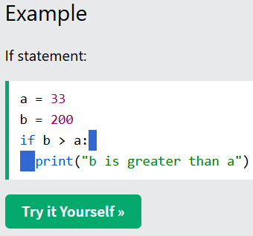
In this example we use two variables, a and b, which are used as part of the if statement to test whether b is greater than a. As a is 33, and b is 200, we know that 200 is greater than 33, and so we print to screen that "b is greater than a".
How If Statements Work
The if statement evaluates a condition (an expression that results in True or False). If the condition is true, the code block inside the if statement is executed. If the condition is false, the code block is skipped.
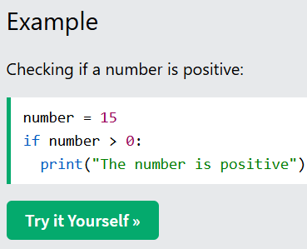
Indentation
Python relies on indentation (whitespace at the beginning of a line) to define scope in the code. Other programming languages often use curly-brackets for this purpose.
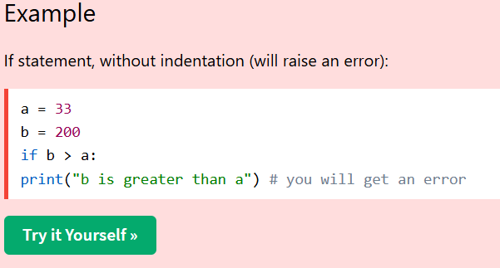
Note: You can use spaces or tabs for indentation, but you must use the same amount of indentation for all statements within the same code block.
Multiple Statements in If Block
You can have multiple statements inside an if block. All statements must be indented at the same level.
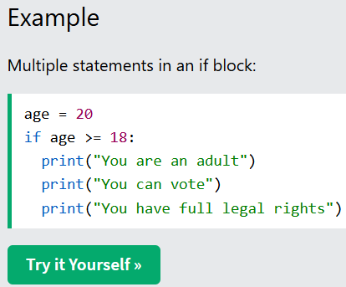
Using Variables in Conditions
Boolean variables can be used directly in if statements without comparison operators.
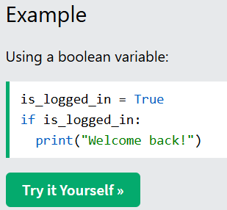
Python can evaluate many types of values as True or False in an if statement.
Zero (0), empty strings (""), None, and empty collections are treated as False. Everything else is treated as True.
This includes positive numbers (5), negative numbers (-3), and any non-empty string (even "False" is treated as True because it's a non-empty string).
Python Elif Statement
The Elif Keyword
The elif keyword is Python's way of saying "if the previous conditions were not true, then try this condition".
The elif keyword allows you to check multiple expressions for True and execute a block of code as soon as one of the conditions evaluates to True.
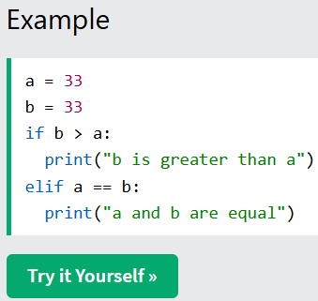
In this example a is equal to b, so the first condition is not true, but the elif condition is true, so we print to screen that "a and b are equal".
Multiple Elif Statements
You can have as many elif statements as you need. Python will check each condition in order and execute the first one that is true.
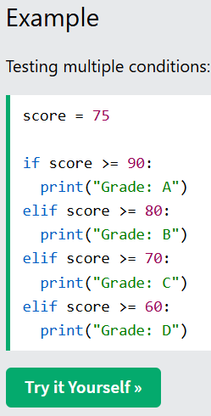
In this example, the program checks each condition in order. Since score is 75, it prints "Grade: C" (the first condition that evaluates to true).
How Elif Works
When you use elif, Python evaluates the conditions from top to bottom. As soon as it finds a condition that is true, it executes that block and skips all remaining conditions.
Important: Only the first true condition will be executed. Even if multiple conditions are true, Python stops after executing the first matching block.
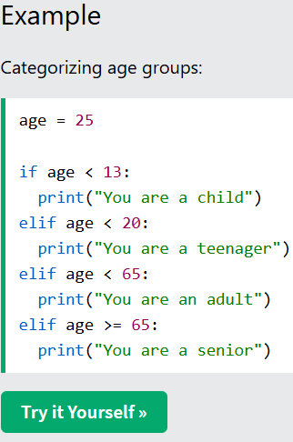
When to Use Elif
Use elif when you have multiple mutually exclusive conditions to check. This is more efficient than using multiple separate if statements because Python stops checking once it finds a true condition.
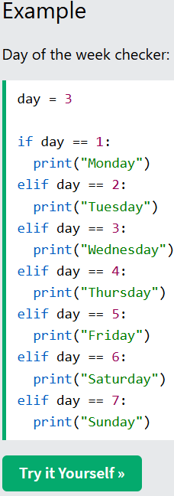
Python Else Statement
The Else Keyword
The else keyword catches anything which isn't caught by the preceding conditions.
The else statement is executed when the if condition (and any elif conditions) evaluate to False.
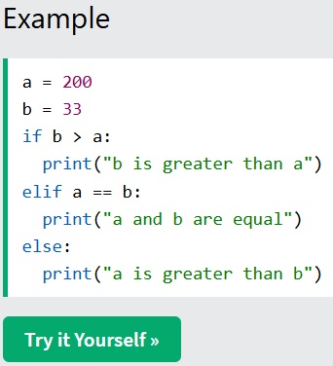
In this example a is greater than b, so the first condition is not true, also the elif condition is not true, so we go to the else condition and print to screen that "a is greater than b".
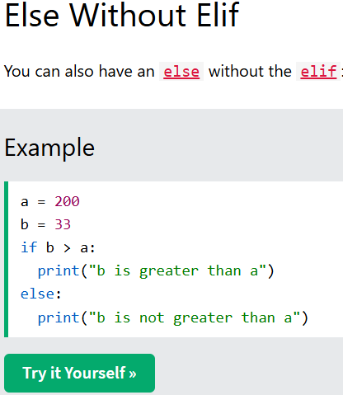
This creates a simple two-way choice: if the condition is true, execute one block; otherwise, execute the else block.
How Else Works
The else statement provides a default action when none of the previous conditions are true. Think of it as a "catch-all" for any scenario not covered by your if and elif statements.
Note: The else statement must come last. You cannot have an elif after an else.
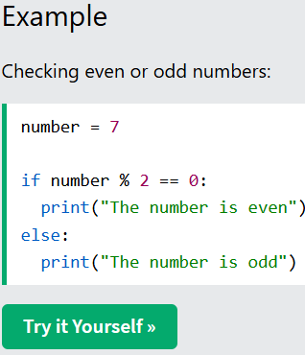
Complete If-Elif-Else Chain
You can combine if, elif, and else to create a comprehensive decision-making structure.
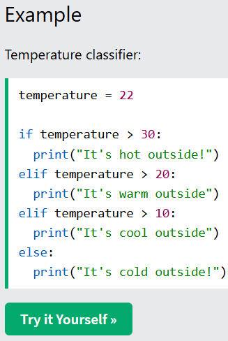
Else as Fallback
The else statement acts as a fallback that executes when none of the preceding conditions are true. This makes it useful for error handling, validation, and providing default values.
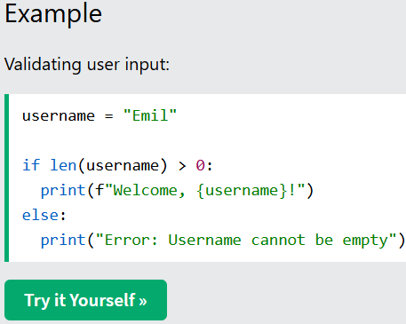
Python Shorthand If
Shorthand If
If you have only one statement to execute, you can put it on the same line as the if statement.
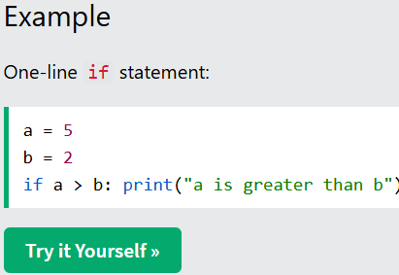
Note: You still need the colon : after the condition.
Short Hand If ... Else
If you have one statement for if and one for else, you can put them on the same line using a conditional expression:
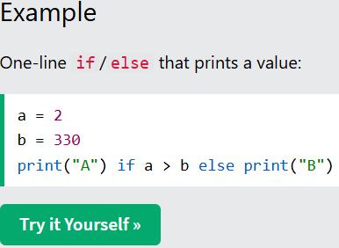
This is called a conditional expression (sometimes known as a "ternary operator").
Assign a Value With If ... Else
You can also use a one-line if/else to choose a value and assign it to a variable:
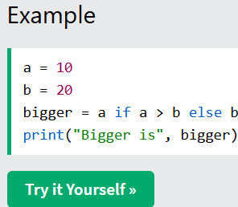
The syntax follows this pattern:
variable = value_if_true if condition else value_if_false
Multiple Conditions on One Line
You can chain conditional expressions, but keep it short so it stays readable:
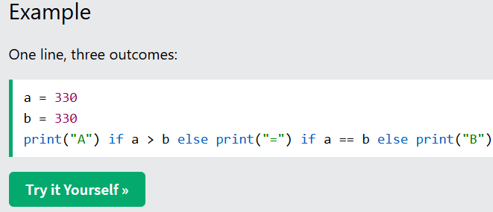
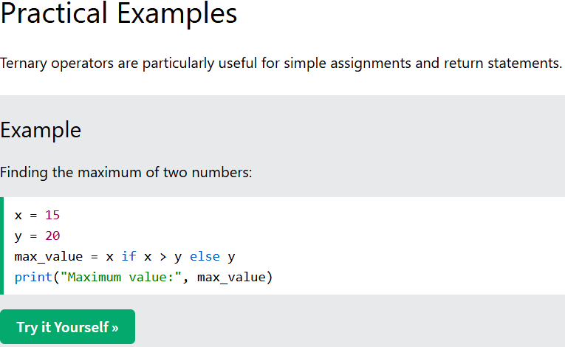
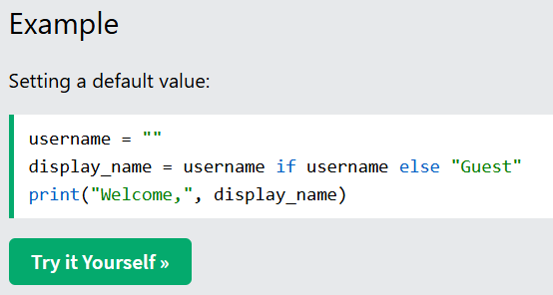
When to Use Shorthand If
Shorthand if statements and ternary operators should be used when:
- The condition and actions are simple
- It improves code readability
- You want to make a quick assignment based on a condition
Important: While shorthand if statements can make code more concise, avoid overusing them for complex conditions. For readability, use regular if-else statements when dealing with multiple lines of code or complex logic.
Python Logical Operators
Logical operators are used to combine conditional statements. Python has three logical operators:
- and - Returns True if both statements are true
- or - Returns True if one of the statements is true
- not - Reverses the result, returns False if the result is true
The and Operator
The and keyword is a logical operator, and is used to combine conditional statements. Both conditions must be true for the entire expression to be true.
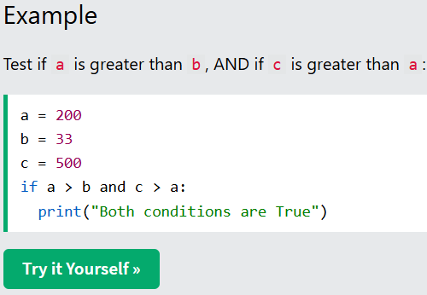
The or Operator
The or keyword is a logical operator, and is used to combine conditional statements. At least one condition must be true for the entire expression to be true.
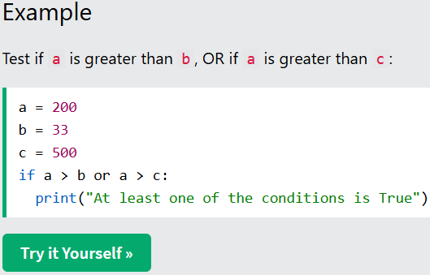
The not Operator
The not keyword is a logical operator, and is used to reverse the result of the conditional statement.
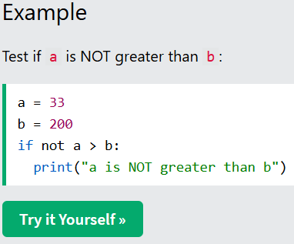
Combining Multiple Operators
You can combine multiple logical operators in a single expression. Python evaluates not first, then and, then or.
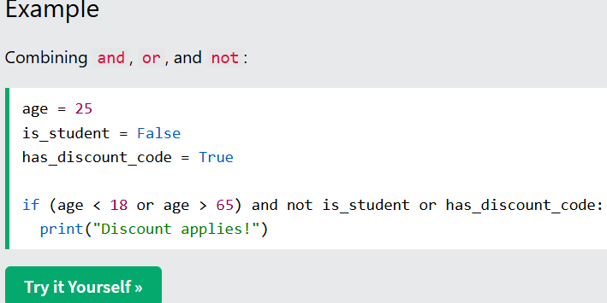
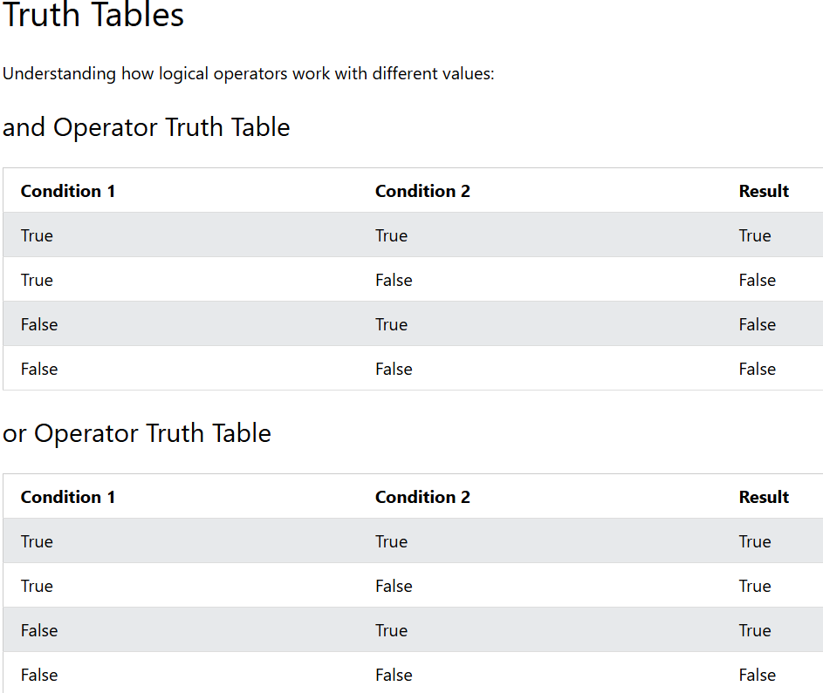
Using Parentheses for Clarity
When combining multiple logical operators, use parentheses to make your intentions clear and control the order of evaluation.
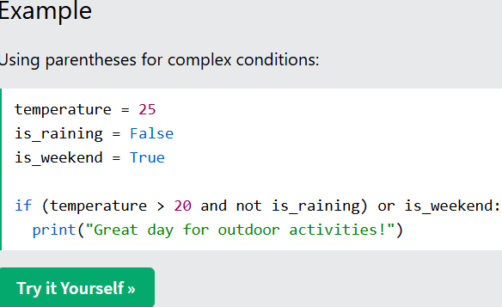
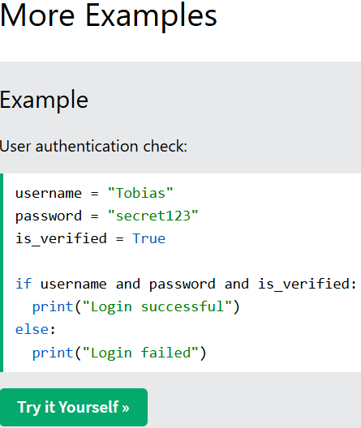
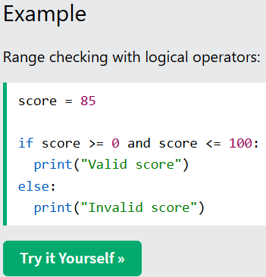
Python Nested If
Nested If Statements
You can have if statements inside if statements. This is called nested if statements.
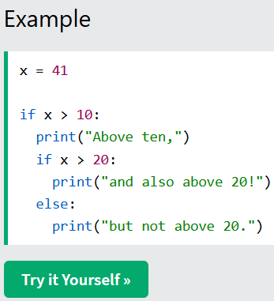
In this example, the inner if statement only runs if the outer condition (x > 10) is true.
How Nested If Works
Each level of nesting creates a deeper level of decision-making. The code evaluates from the outermost condition inward.
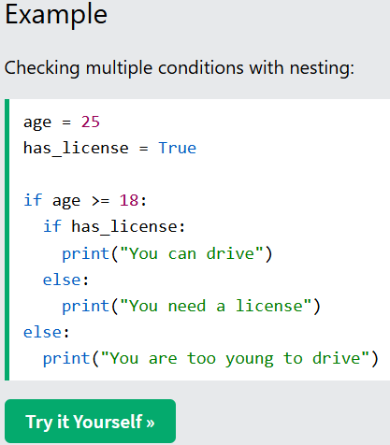
Multiple Levels of Nesting
You can nest as many levels deep as needed, but keep in mind that too many levels can make code harder to read.
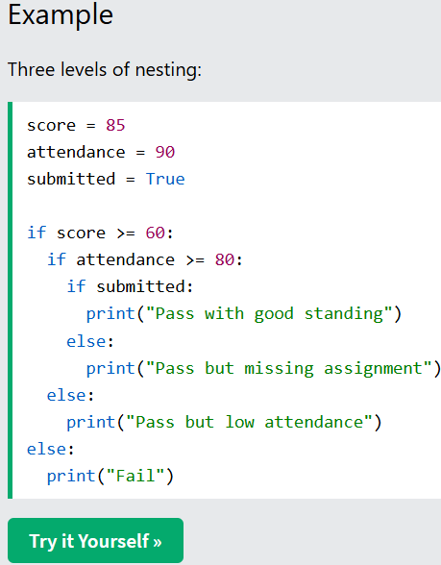
Nested If vs Logical Operators
Sometimes nested if statements can be simplified using logical operators like and. The choice depends on your logic.
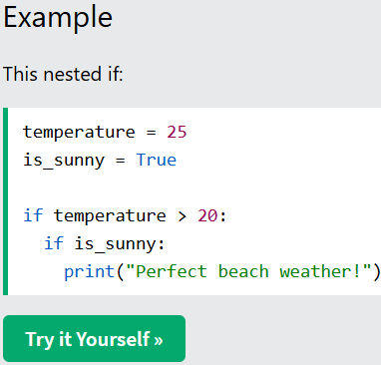
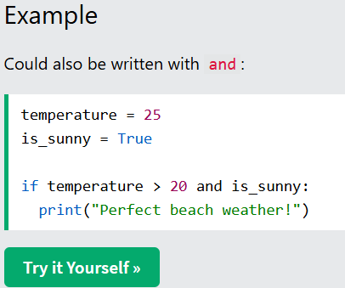
Both approaches produce the same result. Use nested if statements when the inner logic is complex or depends on the outer condition. Use and when both conditions are simple and equally important.

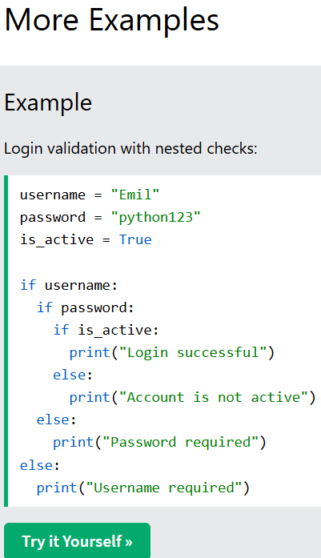
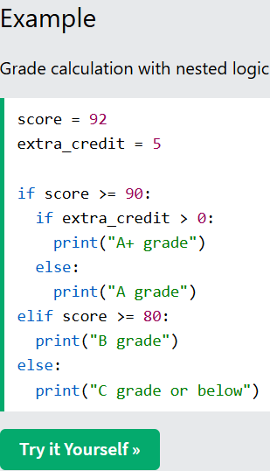
Python Pass Statement
The pass Statement
if statements cannot be empty, but if you for some reason have an if statement with no content, put in the pass statement to avoid getting an error.
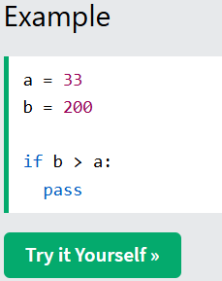
The pass statement is a null operation - nothing happens when it executes. It serves as a placeholder.
Why Use pass?
The pass statement is useful in several situations:
- When you're creating code structure but haven't implemented the logic yet
- When a statement is required syntactically but no action is needed
- As a placeholder for future code during development
- In empty functions or classes that you plan to implement later
pass in Development
During development, you might want to sketch out your program structure before implementing the details. The pass statement allows you to do this without syntax errors.
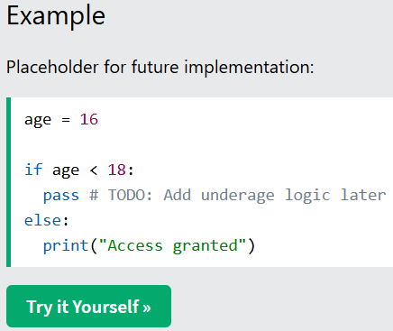
pass vs Comments
A comment is ignored by Python, but pass is an actual statement that gets executed (though it does nothing). You need pass where Python expects a statement, not just a comment.
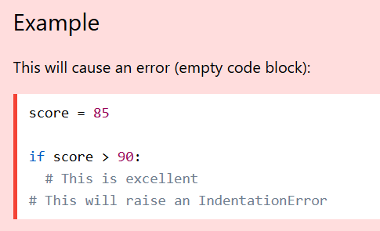
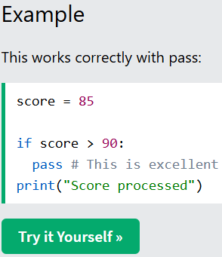
pass with Multiple Conditions
You can use pass in any branch of an if-elif-else statement.
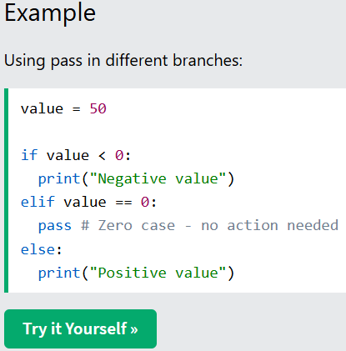
Python If...Else Code Challenge
Challenge: If...Else Basics
Test your understanding of if, elif, else, and shorthand if statements.
Instructions
Inside the editor, complete the following steps:
- Create a variable age with the value 20
- Write an if statement that prints "Child" if age is less than 13
- Add an elif that prints "Teenager" if age is less than 18
- Add an else that prints "Adult"
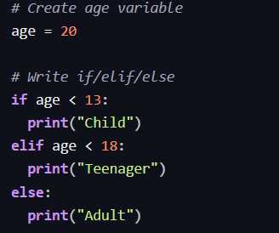
Python Loops
Python has two primitive loop commands:
- For loops
- While loops

2.2 Python For Loops
A for loop is used for iterating over a sequence (that is either a list, a tuple, a dictionary, a set, or a string).
This is less like the for keyword in other programming languages, and works more like an iterator method as found in other object-orientated programming languages.
With the for loop we can execute a set of statements, once for each item in a list, tuple, set etc.
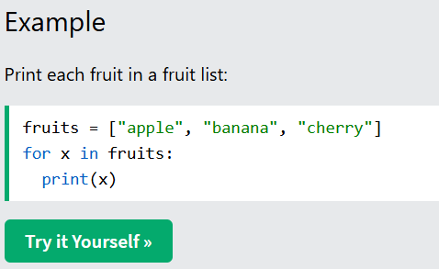
The for loop does not require an indexing variable to set beforehand.
Looping Through a String
Even strings are iterable objects, they contain a sequence of characters:
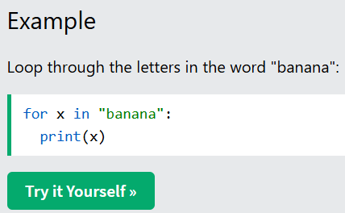
The break Statement
With the break statement we can stop the loop before it has looped through all the items:
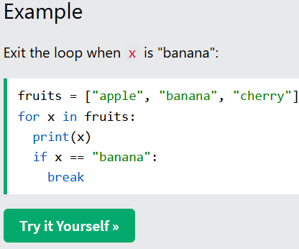
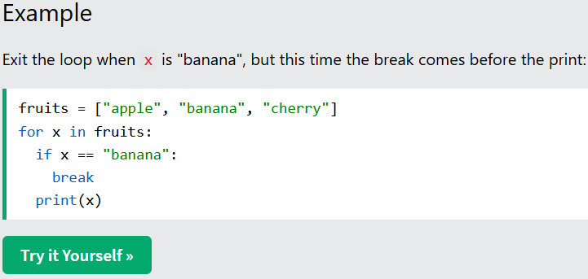
The continue Statement
With the continue statement we can stop the current iteration of the loop, and continue with the next:
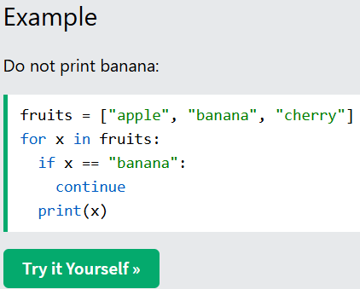
The range() Function
To loop through a set of code a specified number of times, we can use the range() function,
The range() function returns a sequence of numbers, starting from 0 by default, and increments by 1 (by default), and ends at a specified number.
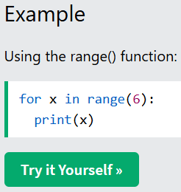
Note that range(6) is not the values of 0 to 6, but the values 0 to 5.
The range() function defaults to 0 as a starting value, however it is possible to specify the starting value by adding a parameter: range(2, 6), which means values from 2 to 6 (but not including 6):
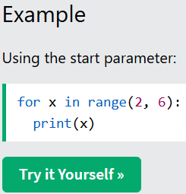
The range() function defaults to increment the sequence by 1, however it is possible to specify the increment value by adding a third parameter: range(2, 30, 3):
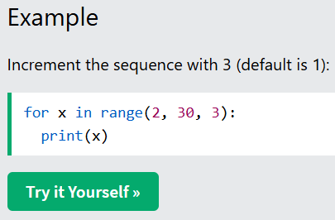
Else in For Loop
The else keyword in a for loop specifies a block of code to be executed when the loop is finished:
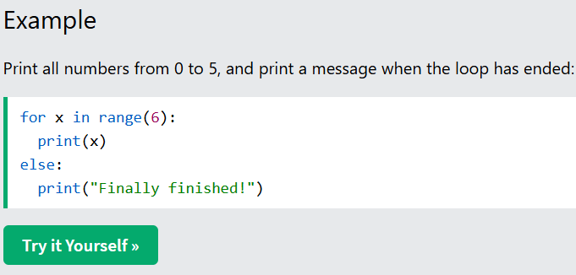
Note: The else block will NOT be executed if the loop is stopped by a break statement.
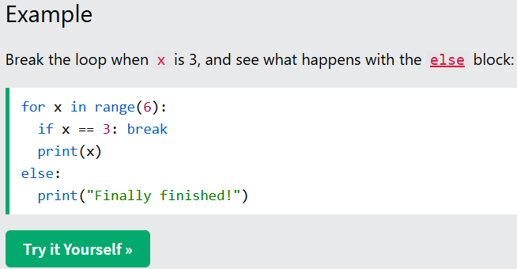
Nested Loops
A nested loop is a loop inside a loop.
The "inner loop" will be executed one time for each iteration of the "outer loop":
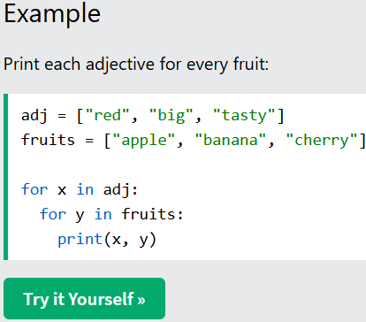
The pass Statement
for loops cannot be empty, but if you for some reason have a for loop with no content, put in the pass statement to avoid getting an error.
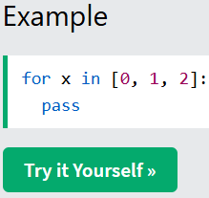
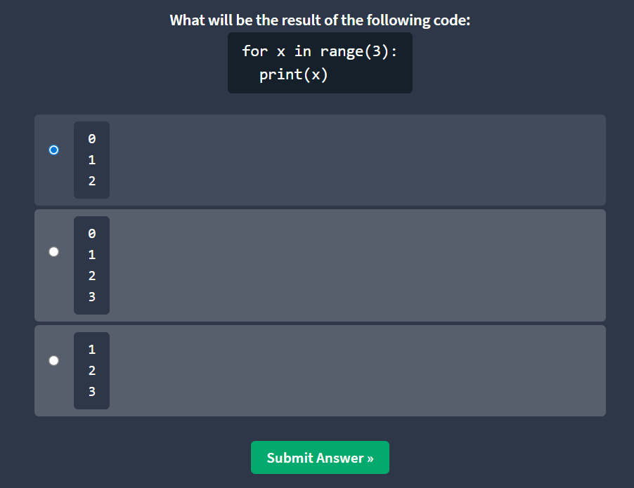
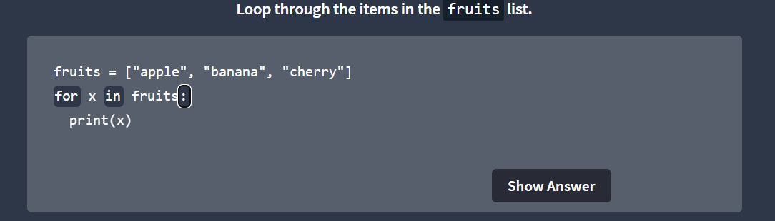
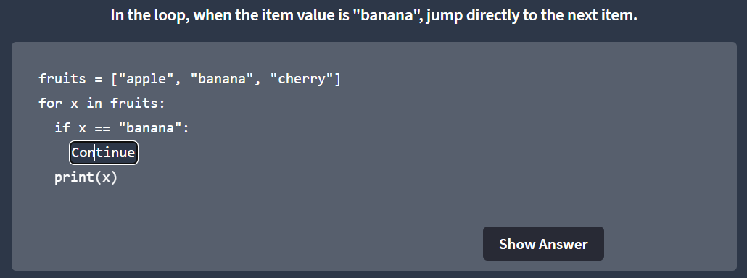
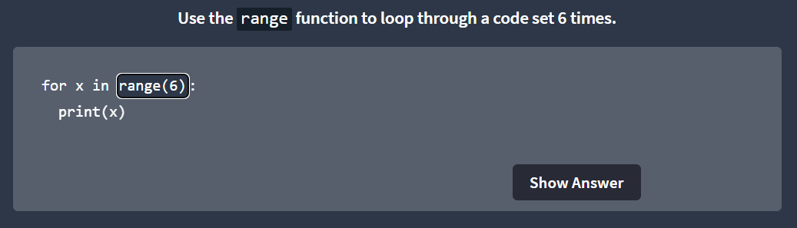
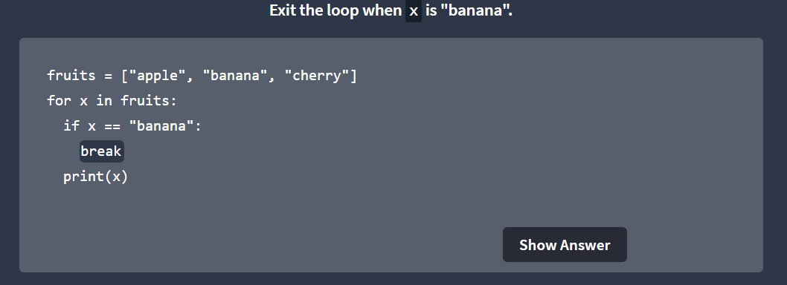
Challenge: For Loops
Test your understanding of Python for loops by completing a small coding challenge.
Instructions
Inside the editor, complete the following steps:
- Create a list called fruits with: "apple", "banana", "cherry"
- Write a for loop that prints each item in fruits
- Use break to stop the loop when the item is "banana"
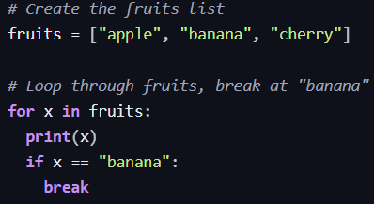

2.3 Python While Loops
The while Loop
With the while loop we can execute a set of statements as long as a condition is true.
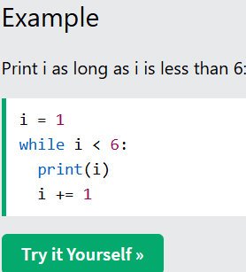
Note: remember to increment i, or else the loop will continue forever.
The while loop requires relevant variables to be ready, in this example we need to define an indexing variable, i, which we set to 1.
The break Statement
With the break statement we can stop the loop even if the while condition is true
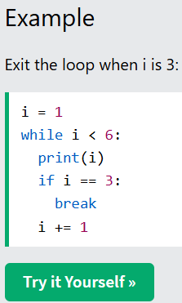
The continue Statement
With the continue statement we can stop the current iteration, and continue with the next:
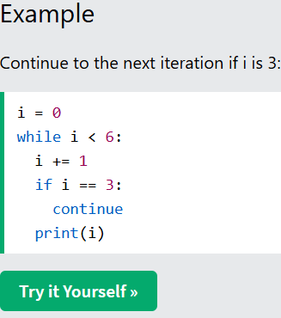
The else Statement
With the else statement we can run a block of code once when the condition no longer is true:
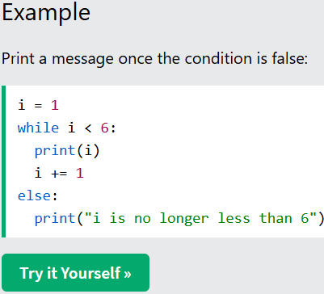
Note: The else block will NOT be executed if the loop is stopped by a break statement.
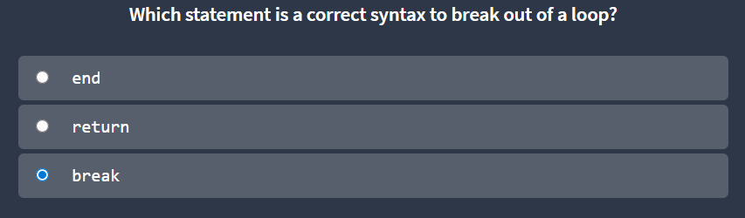
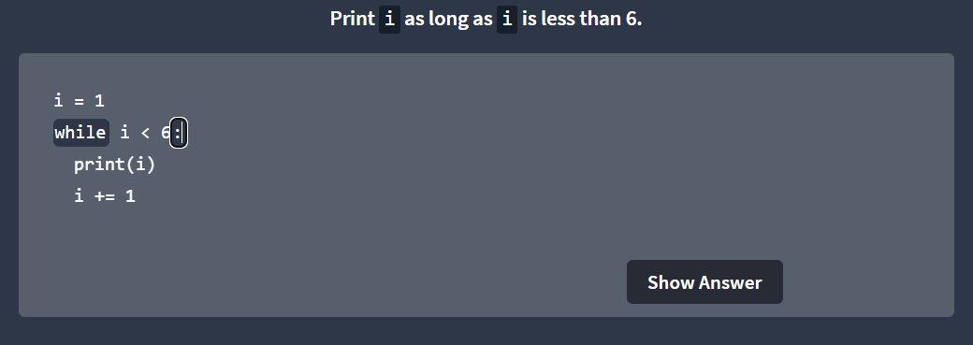
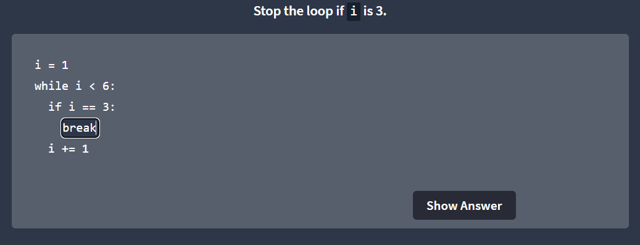
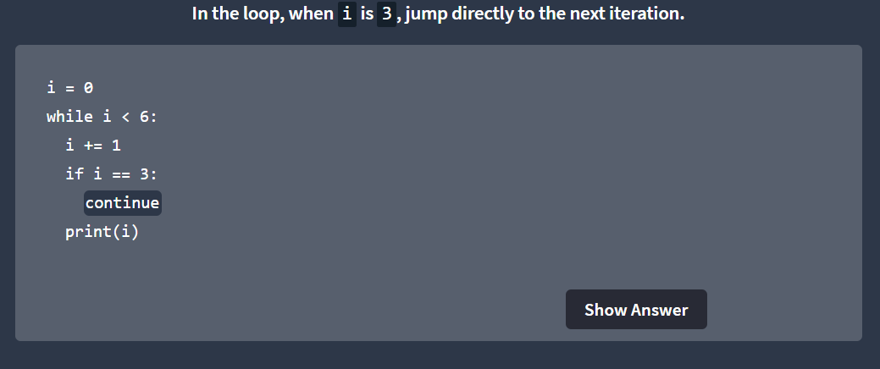
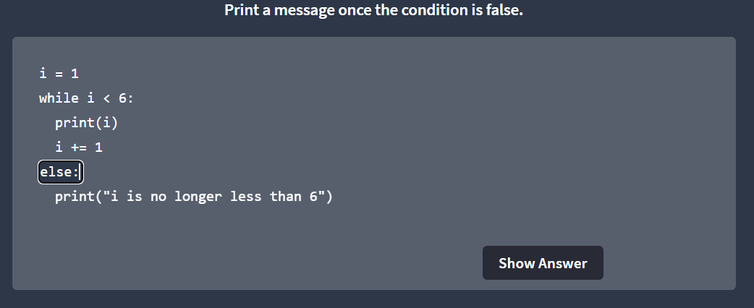
Challenge: While Loops
Test your understanding of Python while loops by completing a small coding challenge.
Instructions
Inside the editor, complete the following steps:
- Create a variable i with the value 0
- Write a while loop that runs as long as i is less than 6
- Inside the loop: increment i by 1
- If i equals 3, use continue to skip that iteration
- Print i
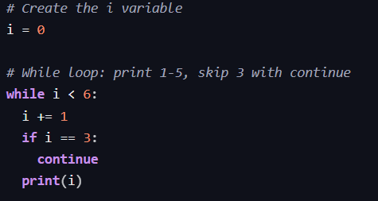

Module 3 – Input/Output Operations and File Handling
3.1 Input and Output
Input
Input means giving data or information to a program.
In Python, users can enter data using the keyboard while the program is running.
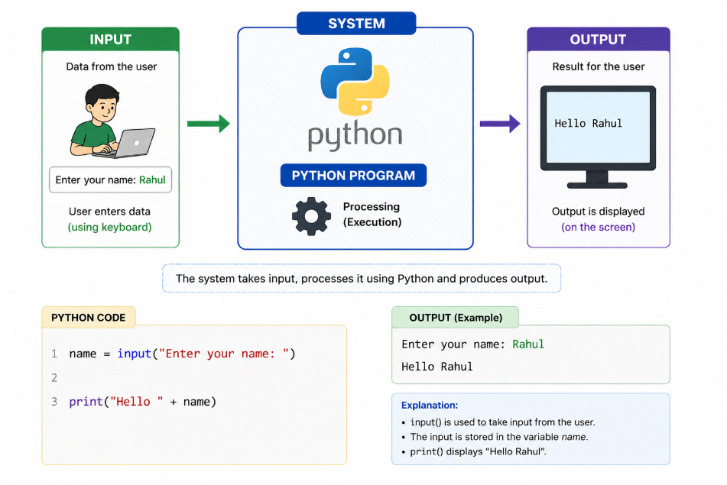
input () Function
The input () function is used to take data from the user through the keyboard.
The value entered by the user is stored in a variable.
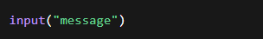
input() → function used to take input
"message" → text shown to the user
The entered value is returned and stored in a variable
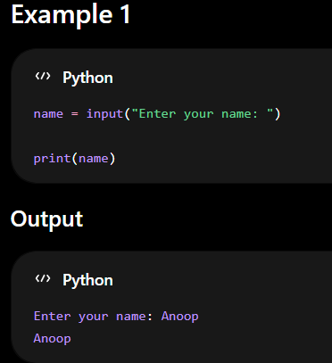
Put try this example button
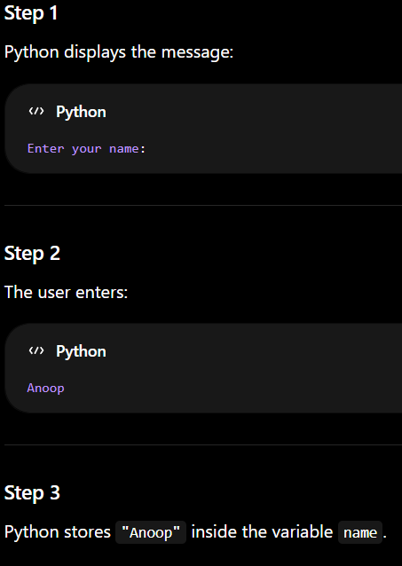
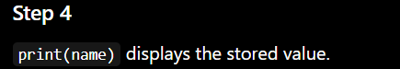
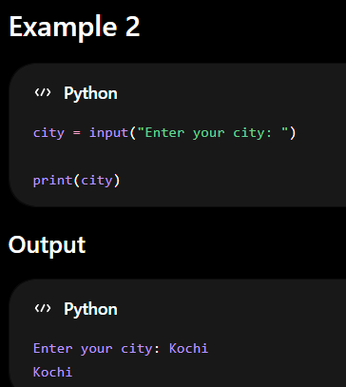

Default Datatype of input()
The input() function stores all values as string (str) by default.
Even if the user enters:
- numbers
- decimal values
Python stores them as text.
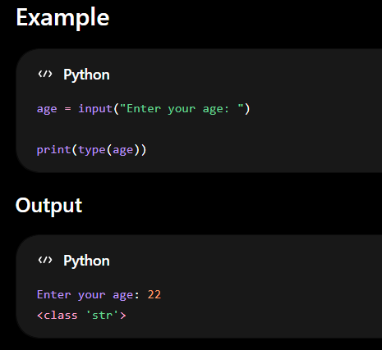
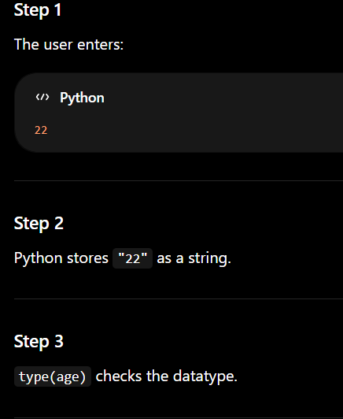
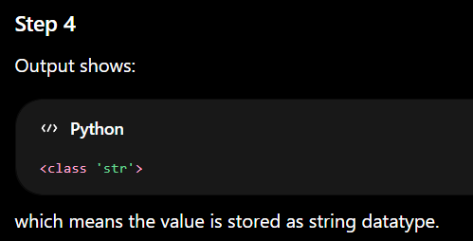
Why Does input() Store Data as String?
Python treats keyboard input as text by default because users can enter:
- letters
- numbers
- symbols
So Python safely stores everything as string.
Datatype Conversion
Datatype conversion means changing one datatype into another datatype.
Python provides built-in functions for conversion.
Common conversions:
- int() → integer
- float() → decimal number

int()
The int() function converts a string value into an integer.
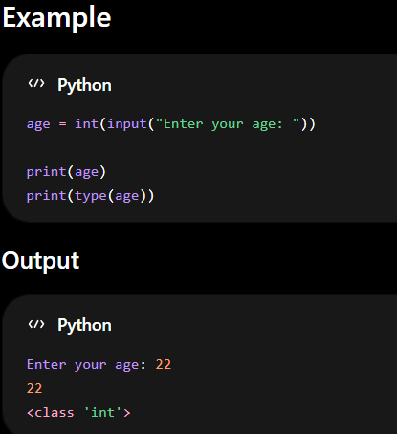
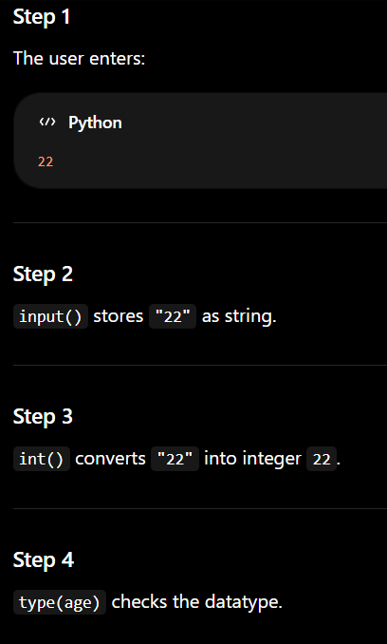
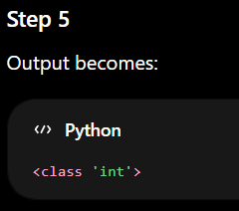
Why int() is Important?
int() is mainly used for:
- addition
- subtraction
- multiplication
- division
because arithmetic operations need numeric datatype.
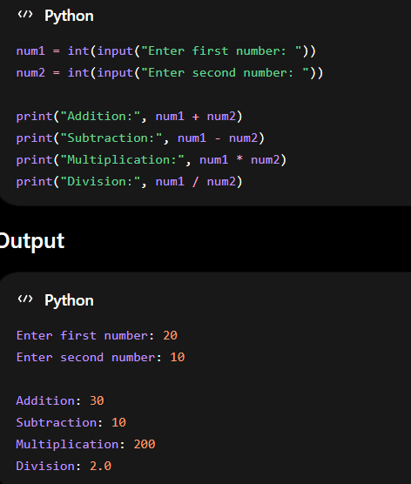
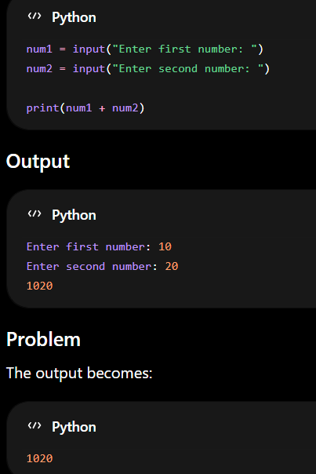
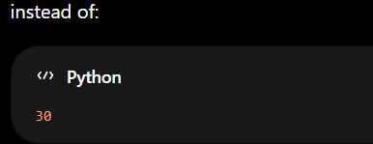
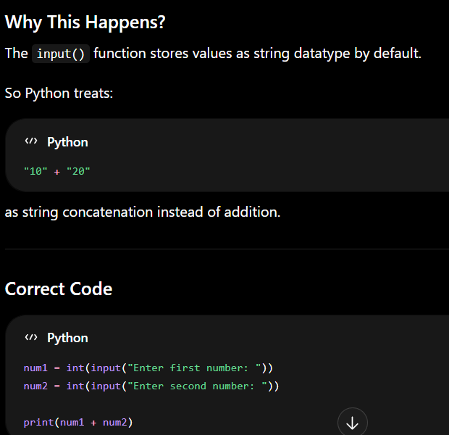
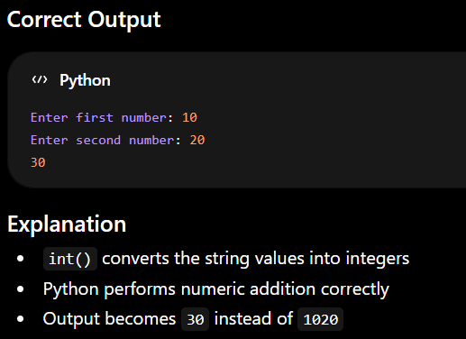
float()
The float() function converts a value into a decimal number.
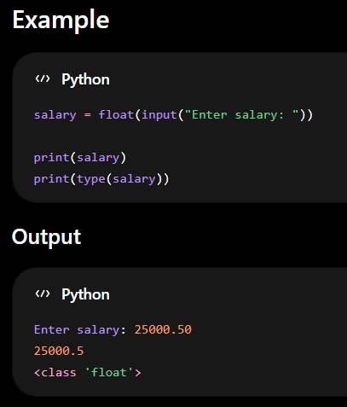

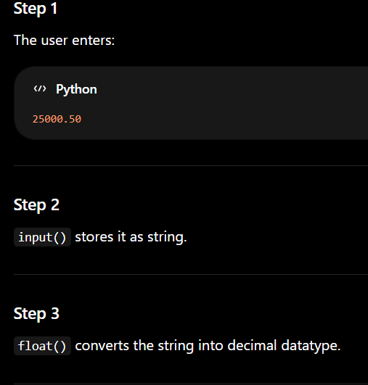
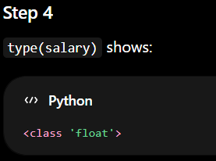
Why float() is Important?
float() is important because it allows Python to work with decimal values.
It is mainly used when calculations contain:
- decimal numbers
- fractional values
- accurate measurements
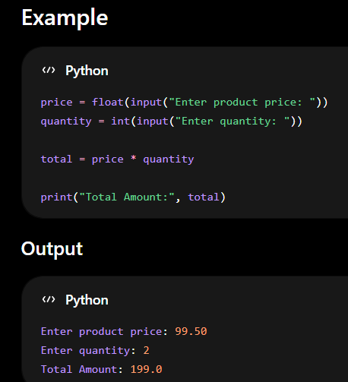
Multiple Inputs
Multiple inputs allow users to enter more than one value.
Programs often need multiple details from users.
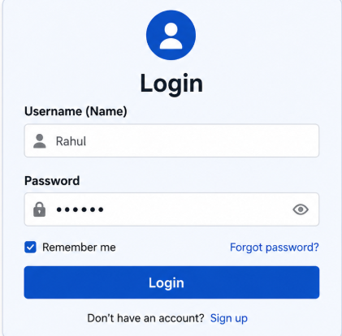
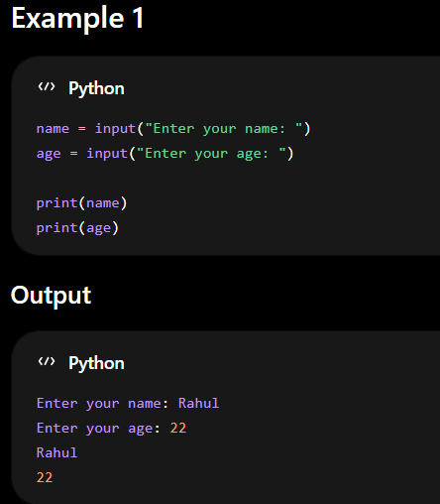
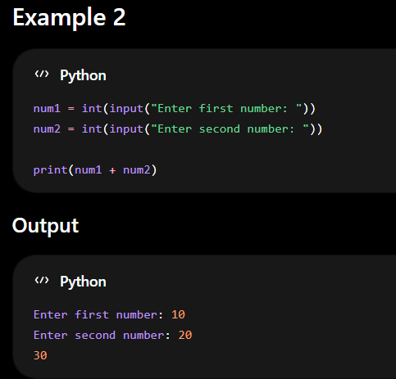
Output
Output means displaying information or results to the user.
Python uses the print() function to display output.
print() Function
The print() function is used to display:
- text
- numbers
- variables
- results
on the screen.
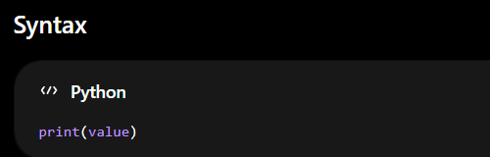
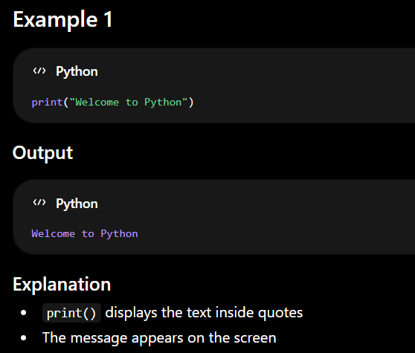
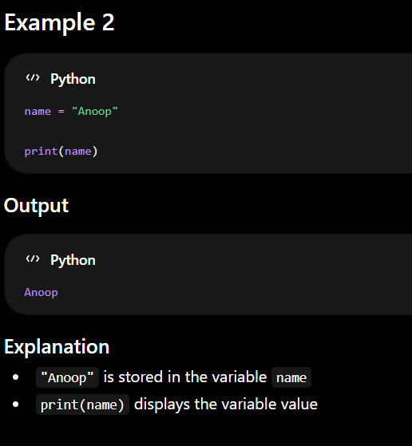
Output Formatting
Output formatting is used to display output in a neat and readable format.
It improves the appearance of program output.
Python provides:
- string.format()
- f-String
string.format()
The format() method inserts values into placeholders {} inside a string.
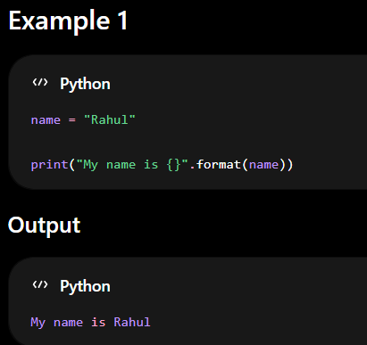
- {} is called placeholder
- format(name) inserts the value inside the placeholder
- "Rahul" replaces {}
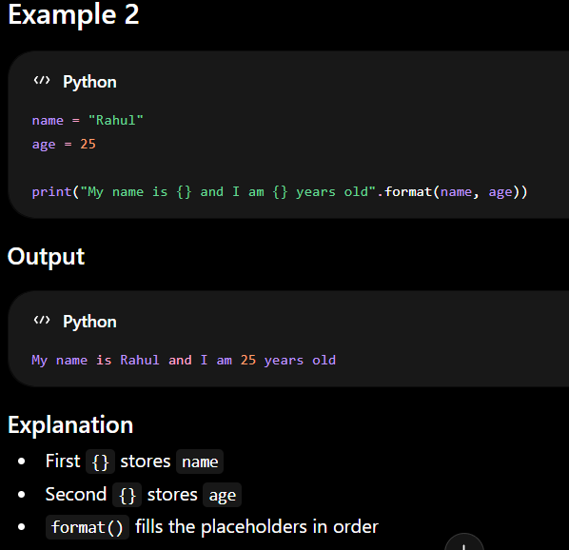
f-String
f-String is a modern and simple method used for formatted output.
It uses:
- f before the string
- variables inside {}
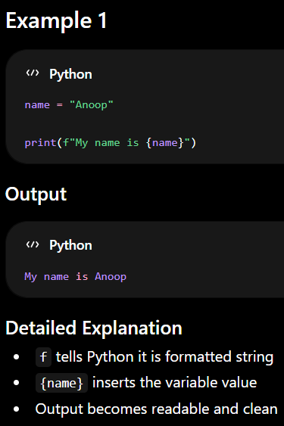
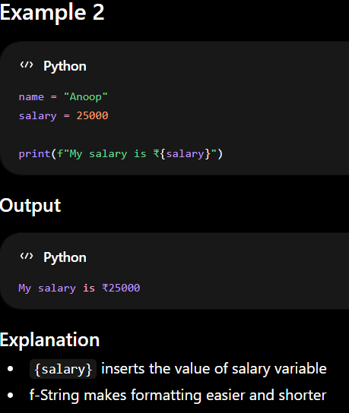

3.2 Command Line Argument
Command line arguments are values passed to a Python program while running the program from the command prompt or terminal.
These values are given after the Python file name.
Command line arguments help programs receive input directly during execution.
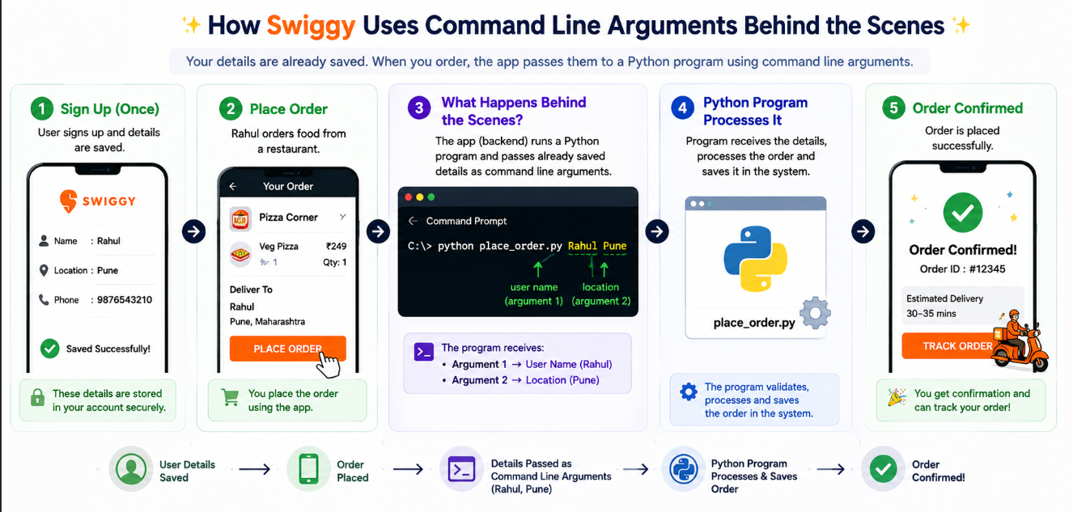
Example
Suppose a company wants to generate reports for different employees.
Instead of changing the program every time:
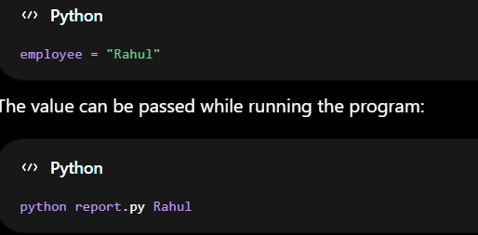
Here:
- Rahul is the command line argument
Why Command Line Arguments are Important?
Command line arguments are useful because:
- programs become flexible
- users can give values directly
- useful in automation
- no need to modify code repeatedly
sys Module
Python provides the sys module to work with command line arguments.
The sys.argv list stores all arguments passed to the program.
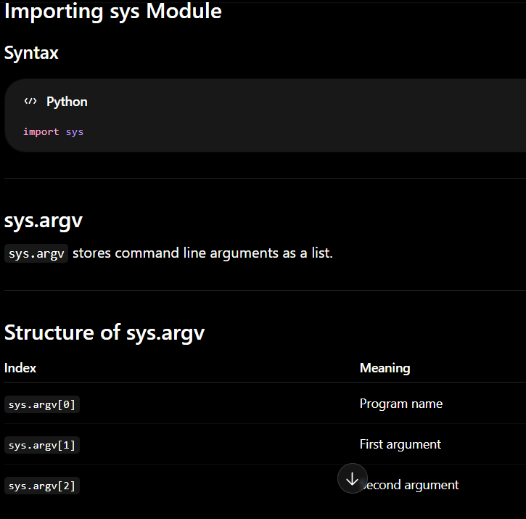
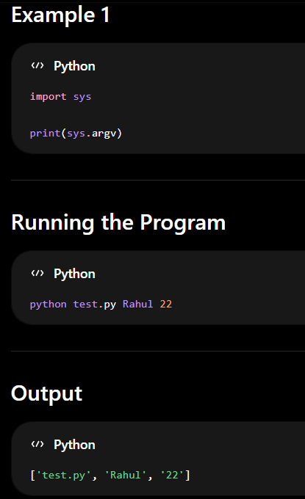
- test.py → program name
- Rahul → first argument
- 22 → second argument
Python stores all values inside a list.
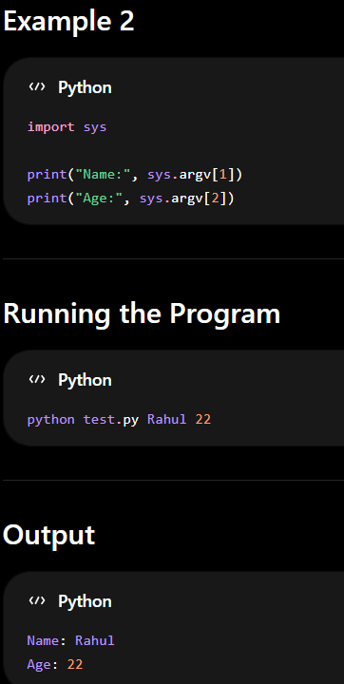
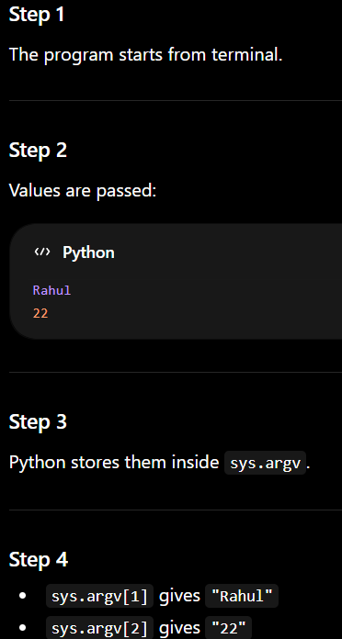
Default Datatype of Command Line Arguments
All command line arguments are stored as string (str) datatype by default.
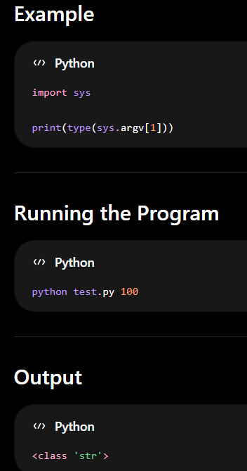
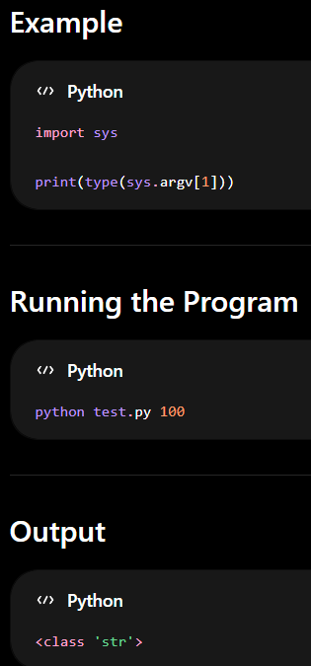
Datatype Conversion
Datatype conversion means changing one datatype into another datatype.
In command line arguments, all values are stored as strings (str) by default.
To perform arithmetic operations like:
- addition
- subtraction
- multiplication
- division
the values must be converted into numeric datatypes such as:
- int
- float
Otherwise, Python treats the values as text instead of numbers.
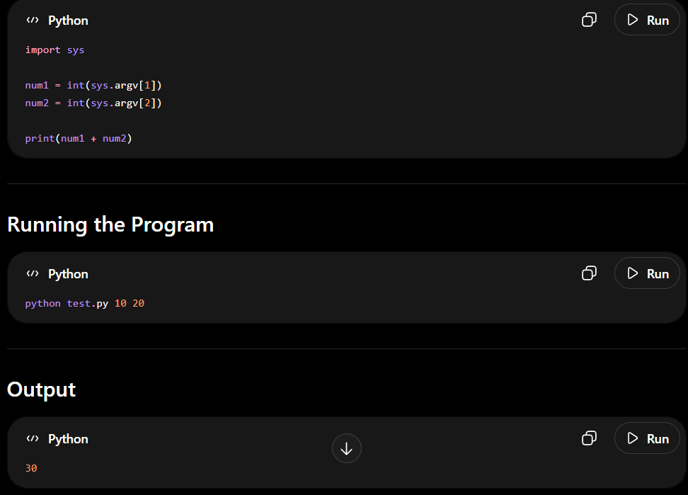
Difference between INPUT () and Command Line Argument
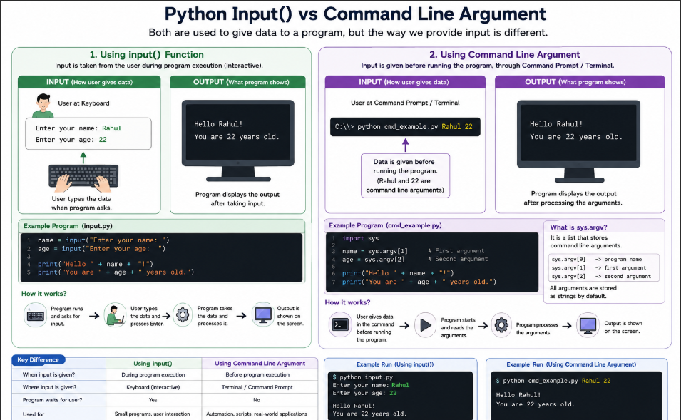
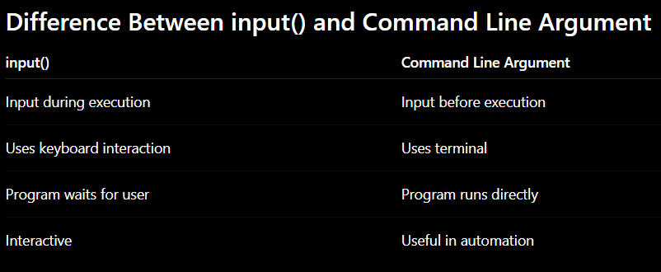

3.3 File Handling
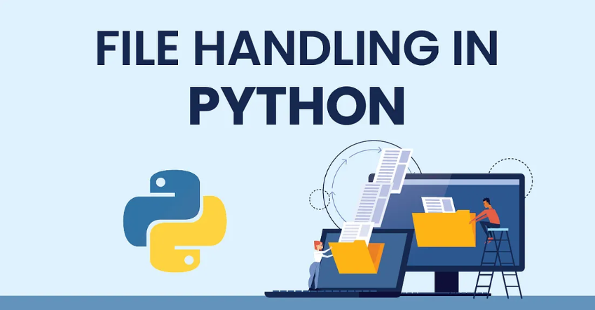
File handling is an important part of any web application.
Python has several functions for creating, reading, updating, and deleting files.
Functions:
The key function for working with files in Python is the open() function.
The open() function takes two parameters; filename, and mode.
There are four different methods (modes) for opening a file:
"r" - Read - Default value. Opens a file for reading, error if the file does not exist
"a" - Append - Opens a file for appending, creates the file if it does not exist
"w" - Write - Opens a file for writing, creates the file if it does not exist
"x" - Create - Creates the specified file, returns an error if the file exists
In addition you can specify if the file should be handled as binary or text mode
"t" - Text - Default value. Text mode
"b" - Binary - Binary mode (e.g. images)
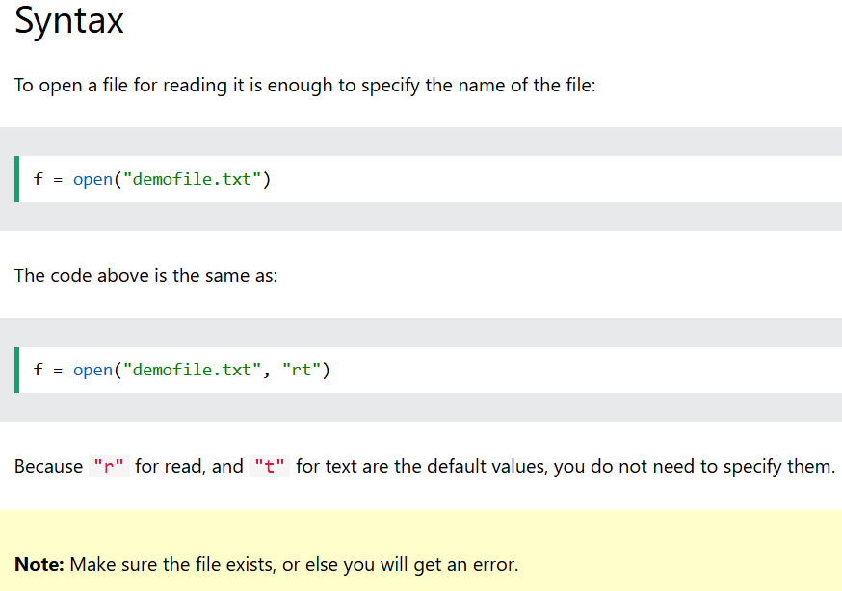
File Open
Open a File on the Server
Assume we have the following file, located in the same folder as Python:
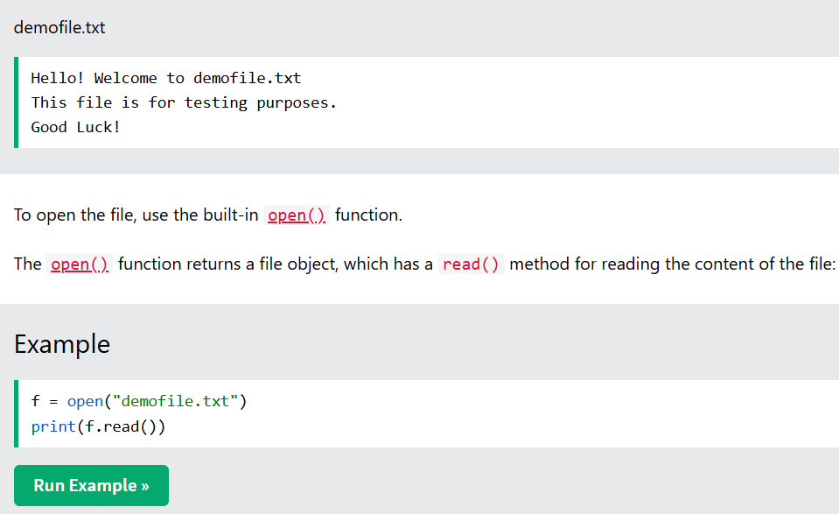
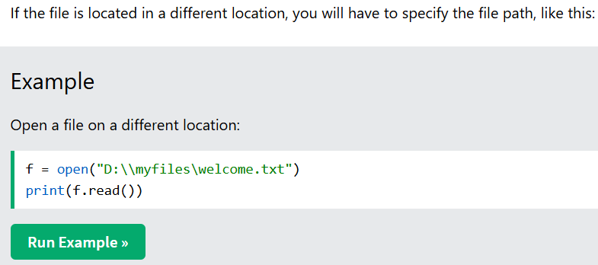
Using the with statement
You can also use the with statement when opening a file:
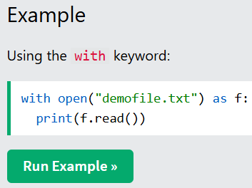
Then you do not have to worry about closing your files, the with statement takes care of that.
Close Files
It is a good practice to always close the file when you are done with it.
If you are not using the with statement, you must write a close statement in order to close the file:
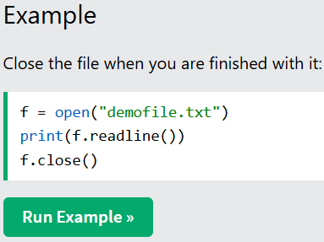
Note: You should always close your files. In some cases, due to buffering, changes made to a file may not show until you close the file.
Read Only Parts of the File
By default the read() method returns the whole text, but you can also specify how many characters you want to return:
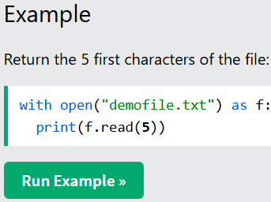
File Write
Write to an Existing File
To write to an existing file, you must add a parameter to the open() function:
"a" - Append - will append to the end of the file
"w" - Write - will overwrite any existing content
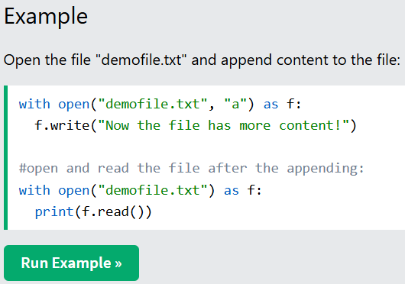
Overwrite Existing Content
To overwrite the existing content to the file, use the w parameter:
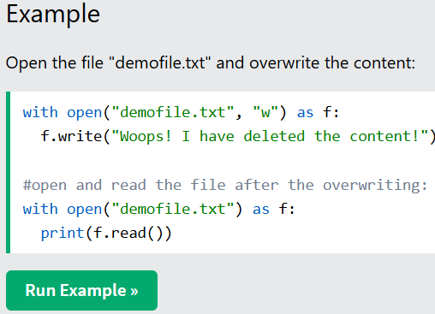
Note: the "w" method will overwrite the entire file.
Create a New File
To create a new file in Python, use the open() method, with one of the following parameters:
"x" - Create - will create a file, returns an error if the file exists
"a" - Append - will create a file if the specified file does not exists
"w" - Write - will create a file if the specified file does not exists
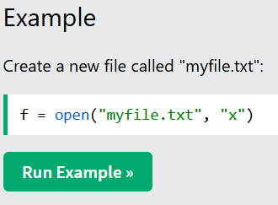
Note: If the file already exists, an error will be raised.
Delete File
To delete a file, you must import the OS module, and run its os.remove() function:
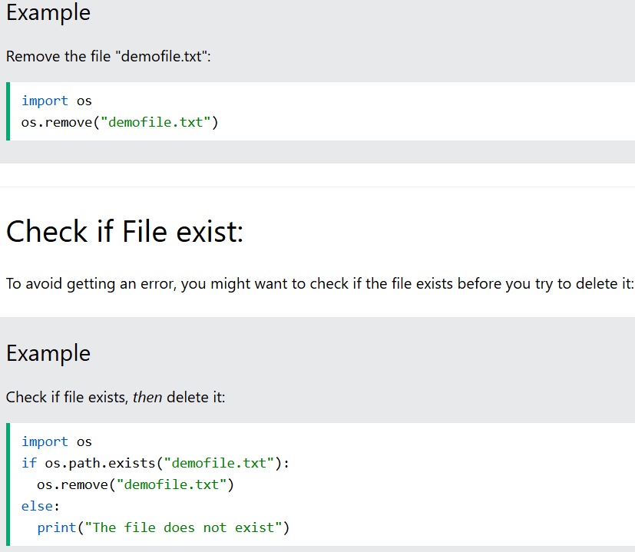
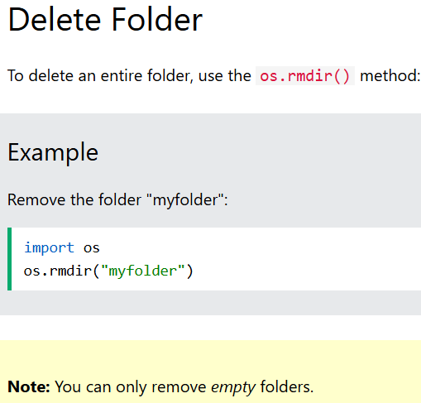

3.1 Input and Output
1. Which function is used to take input from the user in Python?
A. print()
B. input()
C. read()
D. write()
Answer
B. input()
2. The print() function is used to display output on the screen.
Answer
True
3. Complete the code to take user input.
name = _______("Enter your name: ")
Answer
input
4. Which Code is Correct?
Option A
print("Welcome")
Option B
print["Welcome"]
Answer
Option A
3.2 Command Line Argument
1. Which module is used for command line arguments in Python?
A. math
B. os
C. sys
D. random
Answer
C. sys
2. sys.argv stores command line arguments as a list.
Answer
True
- Complete the code.
import sys
print(sys.______)
Answer
argv
4. Which Code is Correct?
Option A
import sys
print(sys.argv[1])
Option B
import sys
print(sys.argument[1])
Answer
Option A
3.3 File Handling
1. Which mode is used to read a file?
A. "w"
B. "a"
C. "r"
D. "x"
Answer
C. "r"
2. The write() function is used to add data into a file.
Answer
True
- Complete the code to open a file in write mode.
file = open("students.txt", ______ )
Answer
"w"
- Which Code is Correct?
Option A
file = open("data.txt","r")
print(file.read())
Option B
file = open["data.txt","r"]
print(file.read())
Answer
Option A
5. Which function is used to check whether a file exists?
A. os.remove()
B. os.path.exists()
C. open()
D. read()
Answer
B. os.path.exists()
6. Complete the code to delete a file.
import os
os._________("data.txt")
Answer
remove
7.Which Code is Correct?
Option A
with open("students.txt","r") as file:
print(file.read())
Option B
with open["students.txt","r"] as file:
print(file.read())
Answer
Option A
Module 4: Built-in Modules
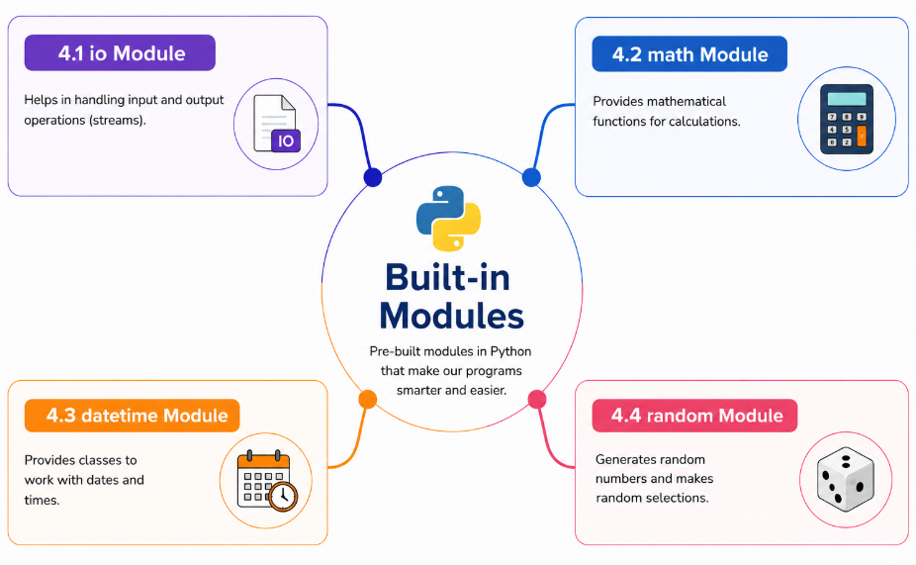
4.1 io Module
The io module is a built-in Python module used for handling input and output operations.
It helps programs:
- open files
- read files
- write files
- work with streams
The io module is mainly used in file handling and data processing.
Think of a notebook.
- Writing inside the notebook → Output
- Reading from the notebook → Input
Similarly, the io module helps programs:
- write data
- read data
from files and streams.
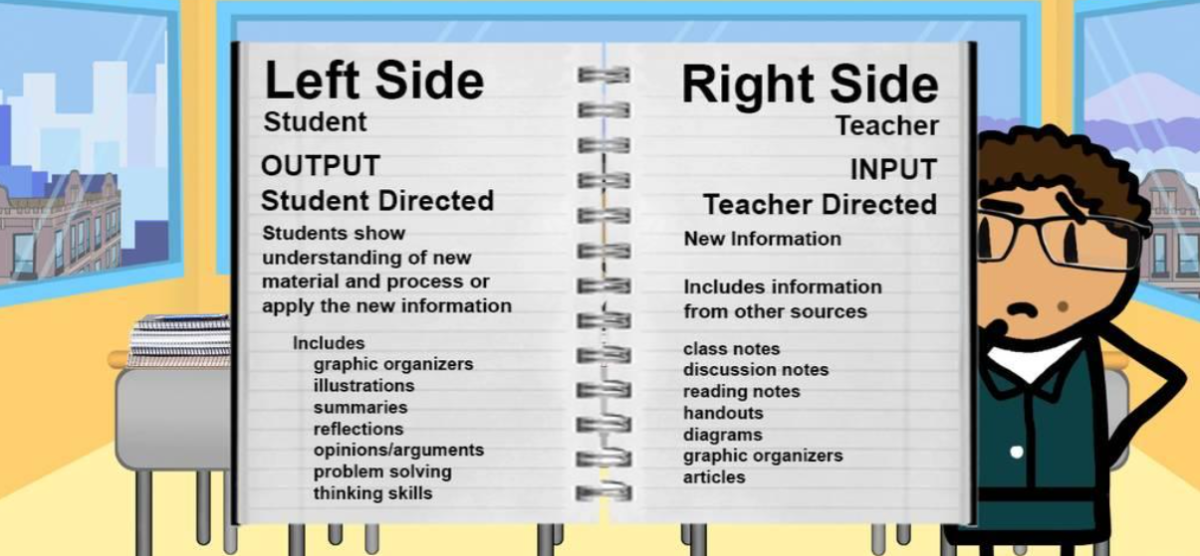
Importing io Module
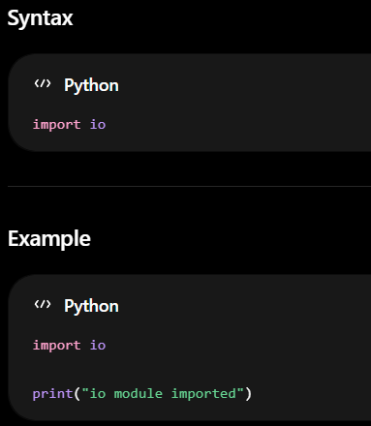
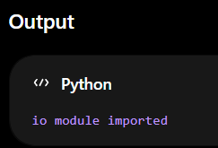
Opening Files using io Module
The open() function is used to open files.
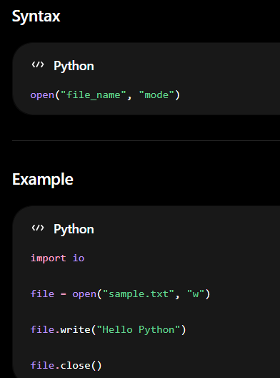
write() Function
The write() function is used to write data into a file.
It stores information permanently inside the file
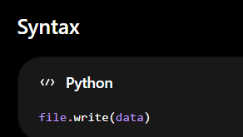
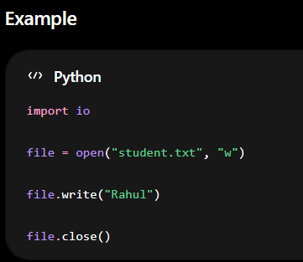
read() Function
The read() function is used to read the contents of a file.
It retrieves data stored inside the file.
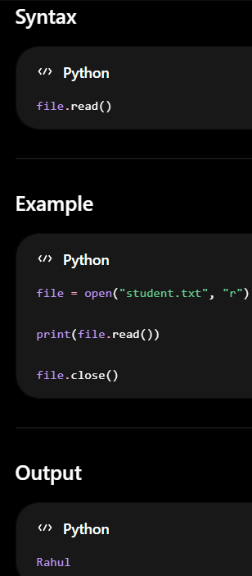
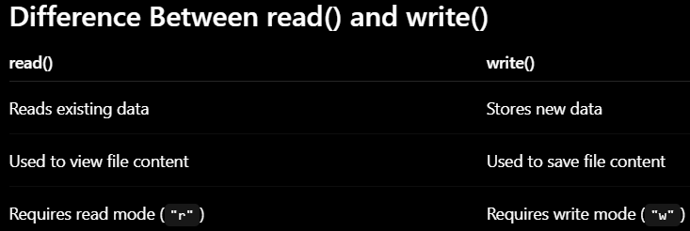

StringIO()
StringIO() is used to create an in-memory text stream.
It behaves like a file but stores data in memory instead of a physical file.
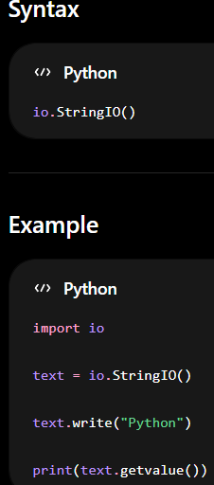
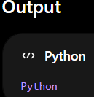
4.2 Math Module
Python has a built-in module that you can use for mathematical tasks.
The math module has a set of methods and constants.
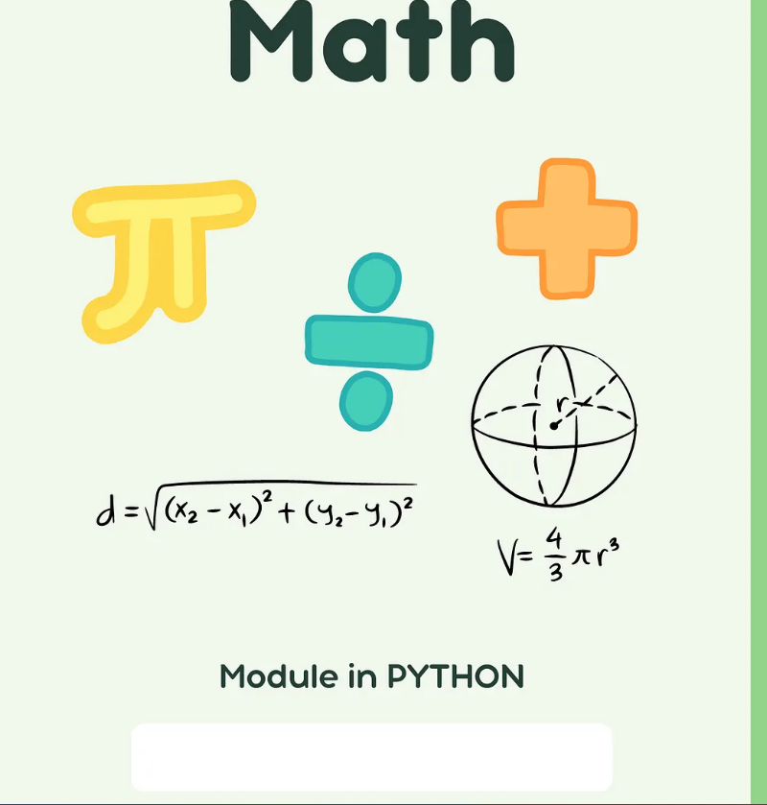
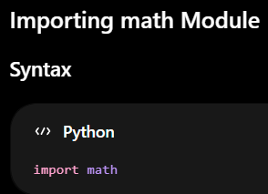
Methods | Descriptions
fabs() | Returns the positive absolute value of a number
ceil() | Rounds the number upward to the nearest integer
floor() | Rounds the number downward to the nearest integer
trunc() | Removes the decimal part from a number
fmod() | Returns the remainder after division
frexp() | Returns mantissa and exponent of a number
nan | Represents “Not a Number” value
isnan() | Checks whether a value is nan
sqrt() | Returns the square root of a number
isqrt() | Returns the integer square root of a number
pow() | Returns the power value of a number
pi | Returns the mathematical constant π

math Module Methods
fabs()
fabs() returns the absolute positive value of a number.
Even if the number is negative, Python converts it into a positive value.
Syntax
math.fabs(number)
Example 1
import math
print(math.fabs(-25))
Output
25.0
Example 2
import math
print(math.fabs(15))
Output
15.0
Example 3
import math
print(math.fabs(-99.5))
Output
99.5
Example 4
import math
temperature = -12

print(math.fabs(temperature))
Output
12.0
ceil()
ceil() rounds a decimal number upward to the nearest integer.
Syntax
math.ceil(number)
Example 1
import math
print(math.ceil(4.2))
Output
5
Example 2
import math
print(math.ceil(7.1))
Output
8
Example 3
import math
print(math.ceil(10.9))
Output
11
Example 4
import math
bill = 250.2
print(math.ceil(bill))
Output
251
floor()
floor() rounds a decimal number downward to the nearest integer
Syntax
math.floor(number)
Example 1
import math
print(math.floor(4.9))
Output
4
Example 2
import math
print(math.floor(7.8))
Output
7
Example 3
import math
print(math.floor(12.3))
Output
12
Example 4
import math
salary = 25000.95

print(math.floor(salary))
Output
25000
trunc()
trunc() removes the decimal part of a number.
Syntax
math.trunc(number)
Example 1
import math
print(math.trunc(8.9))
Output
8
Example 2
import math
print(math.trunc(15.7))
Output
15
Example 3
import math
print(math.trunc(99.99))
Output
99
Example 4
import math

marks = 89.75
print(math.trunc(marks))
Output
89
fmod()
fmod() returns the remainder after division.
Syntax
math.fmod(a, b)
Example 1
import math
print(math.fmod(10, 3))
Output
1.0
Example 2
import math
print(math.fmod(20, 6))
Output
2.0
Example 3
import math
print(math.fmod(50, 7))
Output
1.0
Example 4
import math
students = 25
print(math.fmod(students, 4))
Output
1.0
sqrt()
sqrt() returns the square root of a number.
Syntax
math.sqrt(number)
Example 1
import math
print(math.sqrt(25))
Output
5.0
Example 2
import math
print(math.sqrt(64))
Output
8.0
Example 3
import math

print(math.sqrt(100))
Output
10.0
Example 4
import math
area = 144
print(math.sqrt(area))
Output
12.0
pow()
pow() returns the power value of a number.
Syntax
math.pow(a, b)
Example 1
import math

print(math.pow(2, 3))
Output
8.0
Example 2
import math
print(math.pow(5, 2))
Output
25.0
Example 3
import math

print(math.pow(10, 2))
Output
100.0
Example 4
import math
print(math.pow(3, 4))
Output
81.0
pi
pi returns the mathematical constant π.
Syntax
math.pi
Example 1
import math
print(math.pi)
Output
3.141592653589793
Example 2
import math
radius = 5
print(math.pi * radius * radius)
Output
78.53981633974483
Example 3
import math
print(round(math.pi, 2))
Output
3.14
Example 4
import math
diameter = 10
print(math.pi * diameter)
Output
31.41592653589793
4.4 datetime Module
The datetime module is a built-in Python module used to work with:
- date
- time
- day
- year
It helps programs manage and display date and time information.

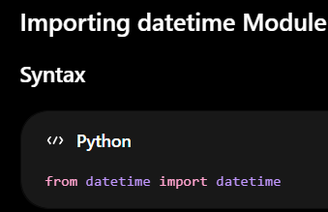
Method | Descriptions
now() | Returns current date and time
strftime() | Formats date and time
weekday() | Returns day number of week

now()
now() returns the current date and current time of the system.
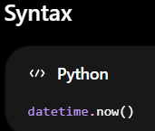
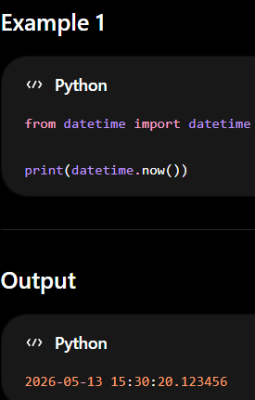
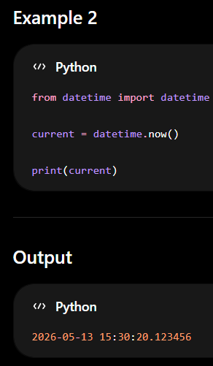
strftime()
The datetime object has a method for formatting date objects into readable strings.
The method is called strftime(), and takes one parameter, format, to specify the format of the returned string
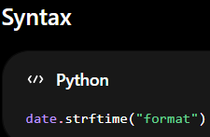
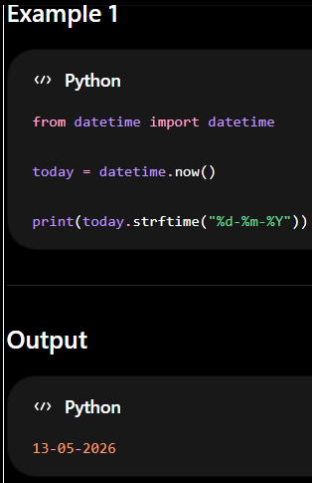
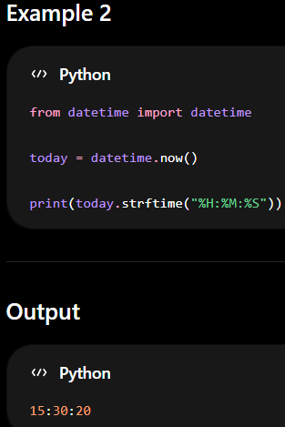
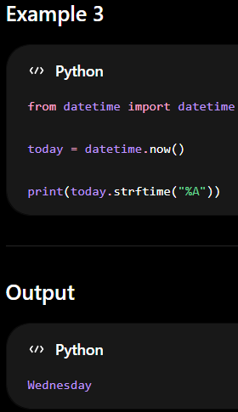
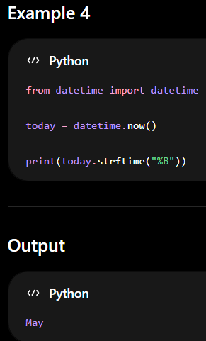
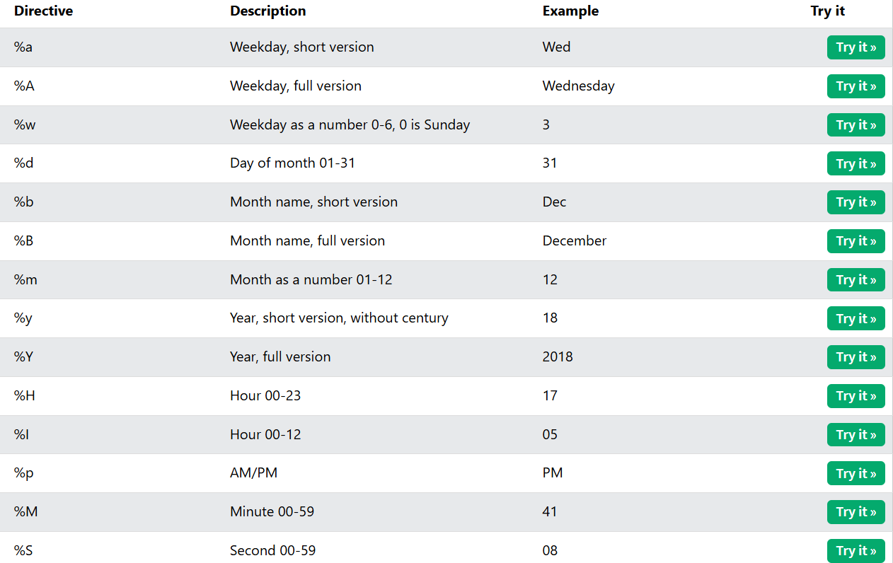
weekday()
weekday() returns the day number of the week.
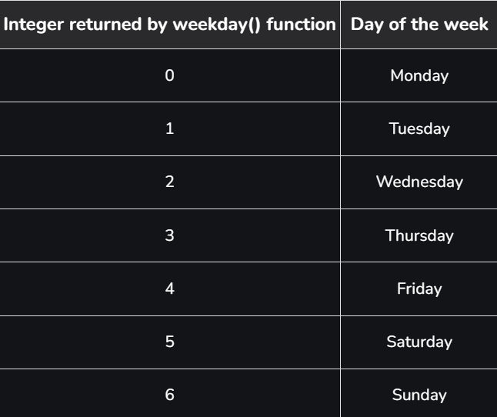
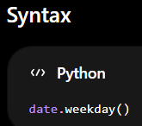
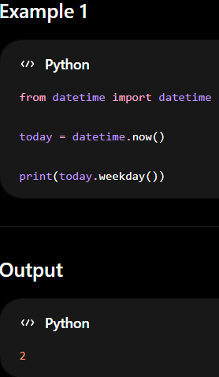
4.5 random Module
The random module is a built-in Python module used to generate random values.
It helps programs:
- generate random numbers
- select random items
- shuffle data

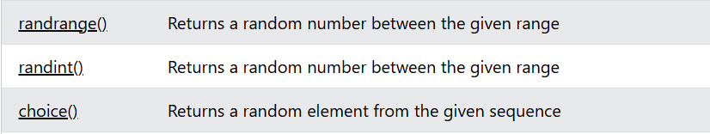
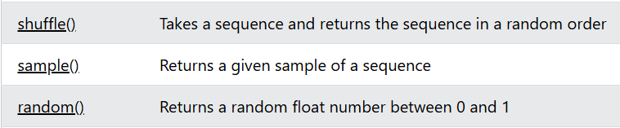
Python Random randrange() Method
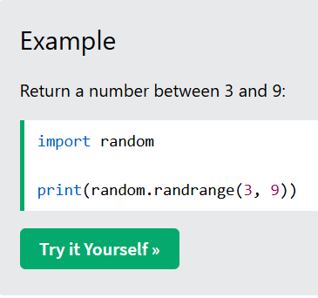
The randrange() method returns a randomly selected element from the specified range.
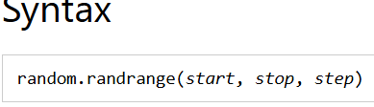Parameter Values
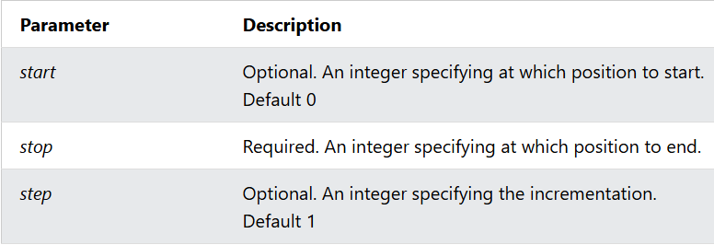
Python Random randint() Method
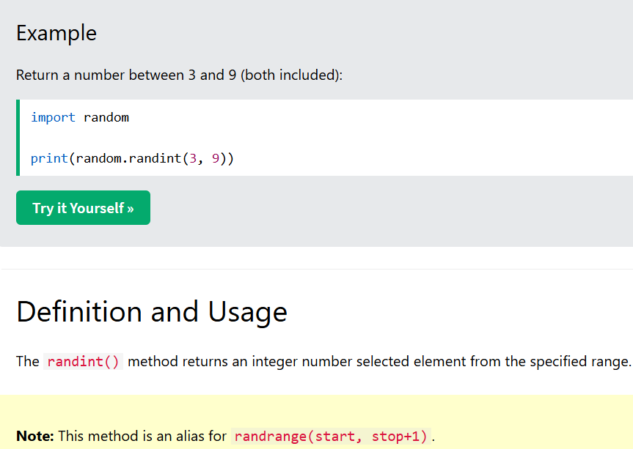
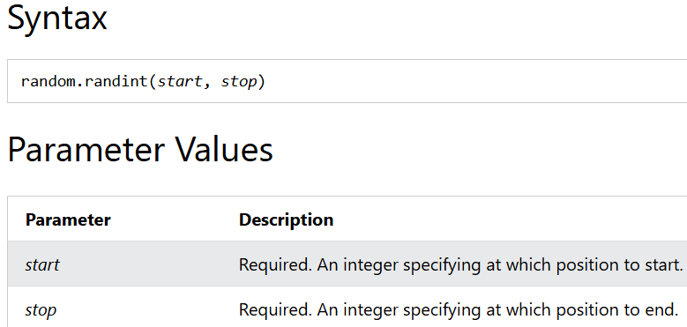
Python Random choice() Method
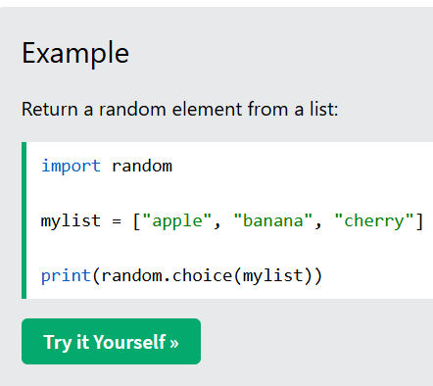
The choice() method returns a randomly selected element from the specified sequence.
The sequence can be a string, a range, a list, a tuple or any other kind of sequence.
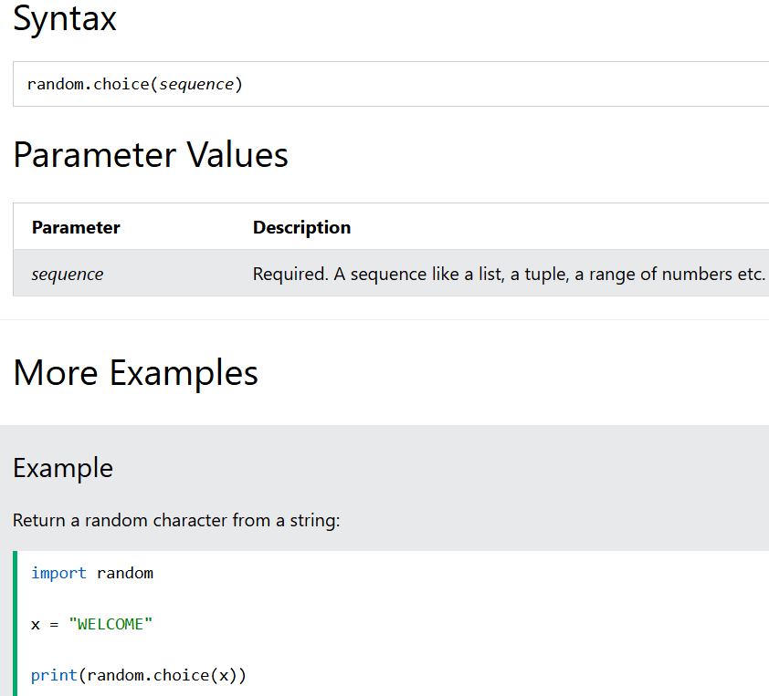
Python Random shuffle() Method
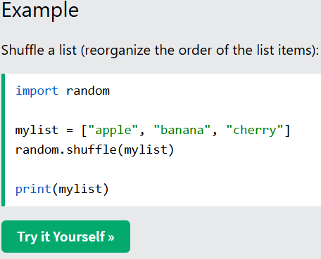
The shuffle() method takes a sequence, like a list, and reorganize the order of the items.
Note: This method changes the original list, it does not return a new list.
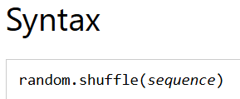
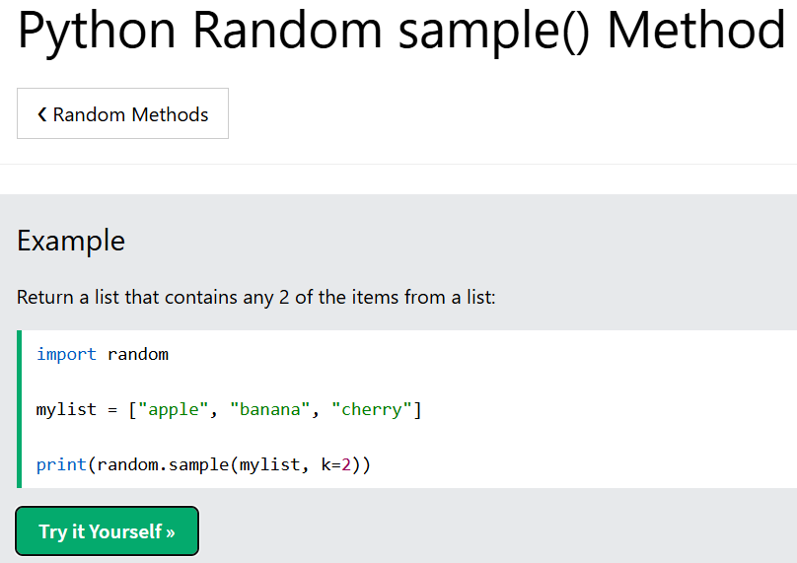
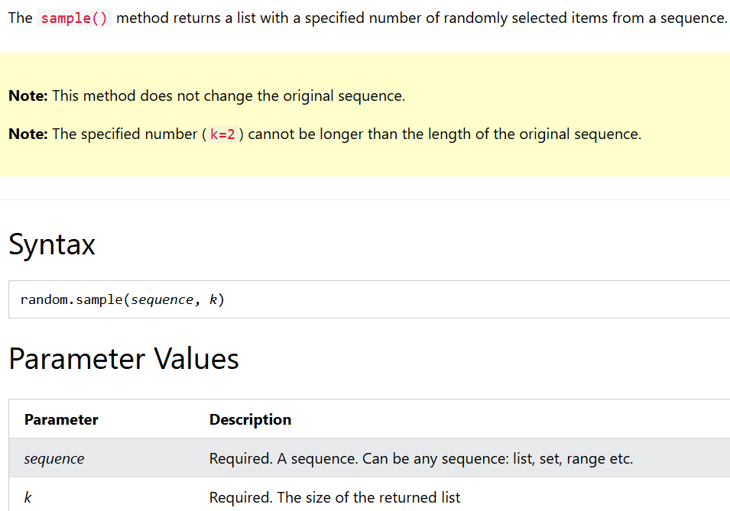
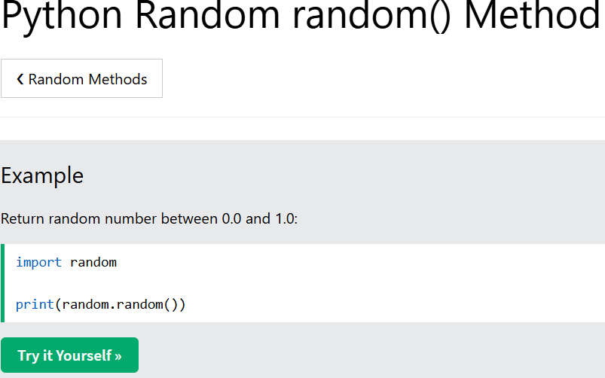
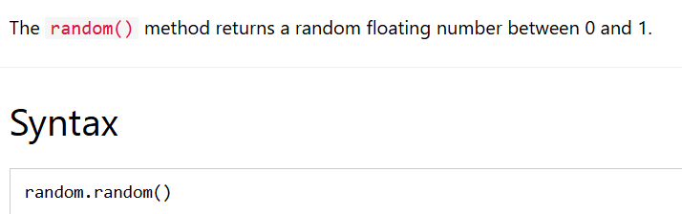
Module 5: Functions and Unit Test
5.1 Functions and Function Structure in Python
Functions
A function is a reusable block of code that performs a specific task.
Functions help divide large programs into smaller and manageable parts.
They make programs easier to write, understand, test, and maintain.
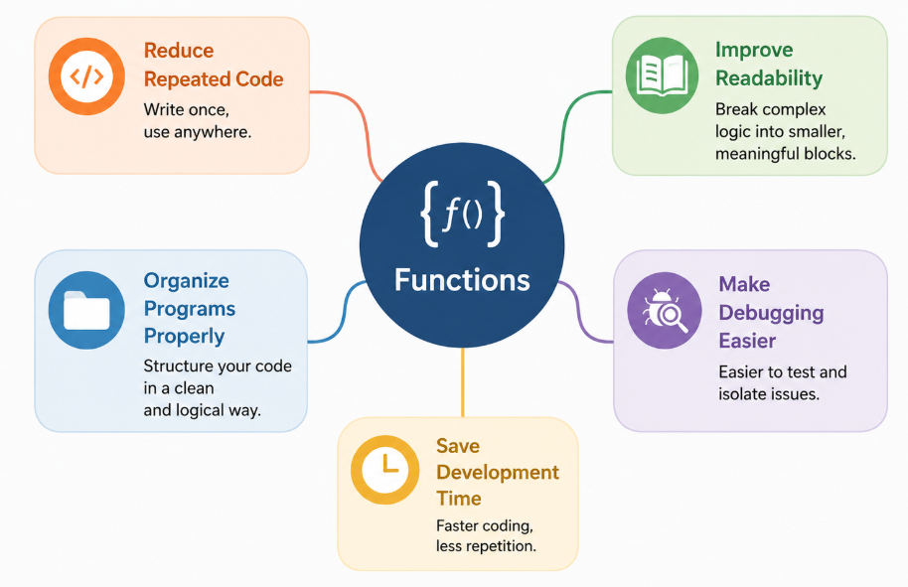
def Keyword
The def keyword is used to define or create a function in Python.
Properties of def
- def stands for define.
- It tells Python that a new function is being created.
- A function name is written after the def keyword.
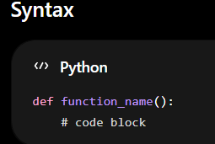
Indentation
- Indentation means giving spaces before the statements inside a function.
- Python uses indentation to identify the code block.
- Usually 4 spaces are used.
- Without proper indentation, Python gives an error.

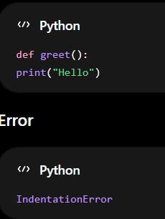
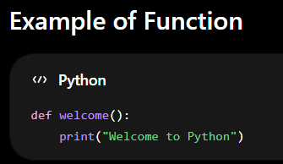
Function Call
Function call means executing the function to perform its task.
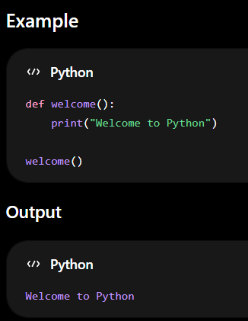
Properties of Functions
1. Functions Improve Code Reusability
The same function can be used many times without writing the code again.
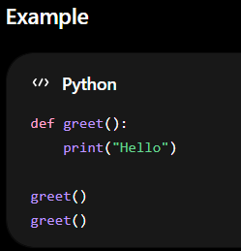
2. Functions Make Programs Modular
Instead of writing one large program, functions divide the program into smaller parts.
Each function handles a specific task, making the program easier to understand and maintain.
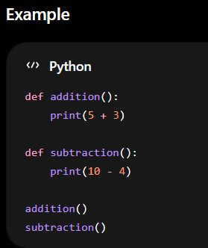
3. Functions Reduce Code Duplication
Functions avoid writing the same code multiple times.
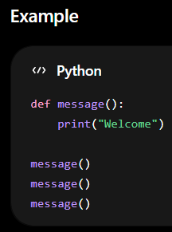
4. Functions Improve Readability
Functions make programs clean and easy to read.
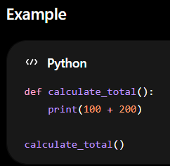
5. Functions Can Accept Inputs and Return Outputs
Functions can take values as input and send results back as output.
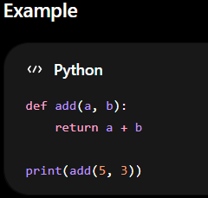
Valid Function Names
Rules
- Function names can contain letters, numbers, and underscores.
- Function names cannot start with numbers.
- Spaces are not allowed.
- Python keywords cannot be used.
Valid Examples
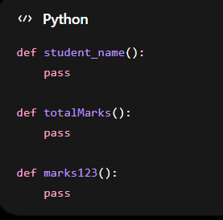
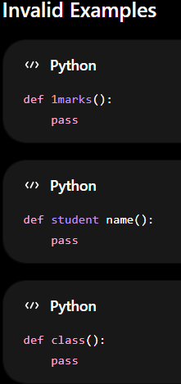
Why Functions Are Used?
- Reduce code repetition
- Make programs easier to understand
- Divide programs into smaller tasks
- Improve debugging
- Improve maintenance
Parameters
Parameters are variables written inside the function definition.
They receive values from the function call.
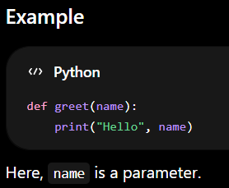
Arguments
Arguments are actual values passed to a function during the function call.
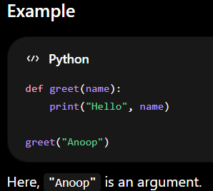
Difference Between Parameters and Arguments
Parameters | Arguments
Written in function definition | Passed during function call
Variables | Actual values
Example: name | Example: "Anoop"

Errors in Parameters and Arguments
1. Missing Argument Error
Occurs when fewer arguments are passed than required parameters.
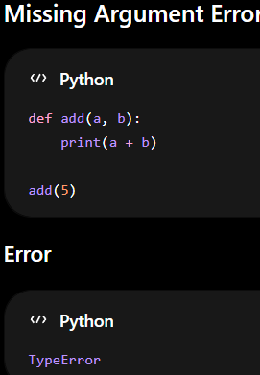
2. Extra Argument Error
Occurs when more arguments are passed than required parameters.
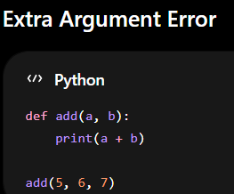
Default Values
Default values are predefined values assigned to parameters.
If no argument is passed, the default value is used automatically.
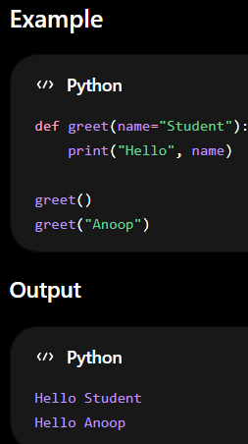
Keyword Arguments
Keyword arguments pass values using parameter names.
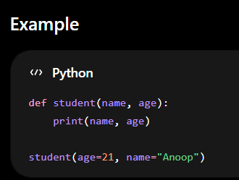
Different Types of Arguments
1. Positional Arguments
Values are assigned based on their position.

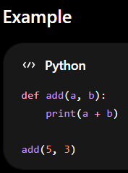
2. Keyword Arguments
Values are passed using parameter names.
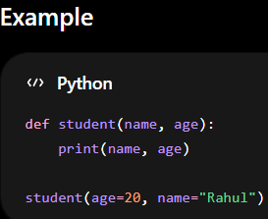
3. Default Arguments
Arguments use predefined default values if no value is passed.
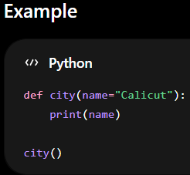
Return Values
The return statement sends a value back from the function to the caller.
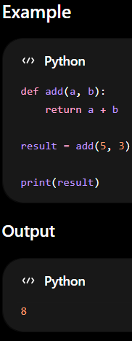
1. Returning One Value
A function returns a single value.
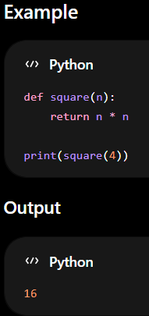
2. Returning Multiple Values
A function can return more than one value separated by commas.
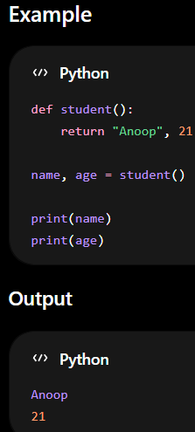
This returns two values:
- "Anoop"
- 21
These values are stored in:
name, age = student()
- "Anoop" goes to name
- 21 goes to age
3. Returning Boolean Value
A function returns either True or False.
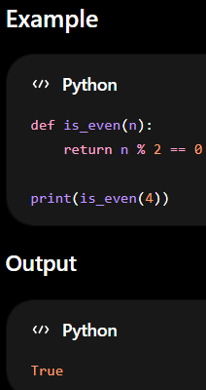
n % 2 == 0
Checks whether the number is divisible by 2.
- If divisible → True
- Otherwise → False
Pass Statement
The pass statement is used as a placeholder when no code is written inside a function.
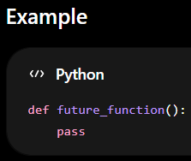
Difference Between return and print
return | print
Sends value back | Displays output
Used for further processing | Used only for display
Can store result in variable | Cannot return value

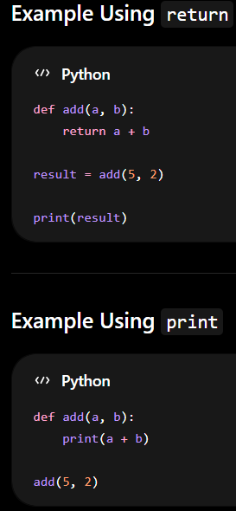
Doc String
A doc string is a special string used to explain what a function does.
It is written inside triple quotes below the function definition.
Why Are Doc Strings Used?
- Explain the purpose of the function
- Help programmers understand code
- Improve readability
- Useful in large projects
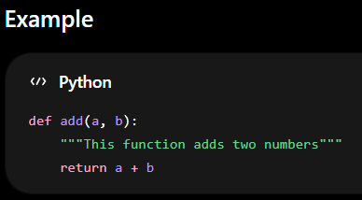
"""This function adds two numbers"""
This line explains the purpose of the function.
It tells the programmer:
- What the function does
- Why the function is used
Accessing Doc String
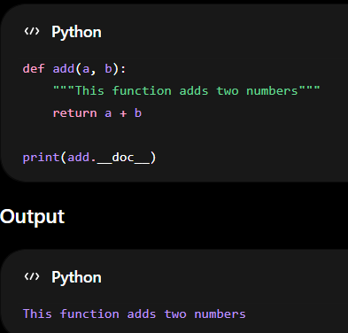
Documentation
Documentation means writing explanations about programs, functions, or modules.
It helps users and developers understand how the code works.
Why Documentation Is Important?
- Makes code easy to understand
- Helps beginners learn quickly
- Useful for teamwork
- Easier maintenance in future
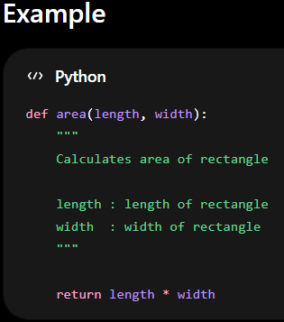
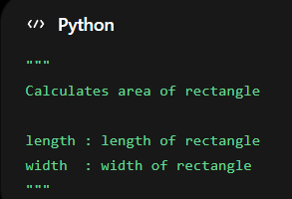
This documentation explains:
- Purpose of the function
- Meaning of parameters
- What values should be passed
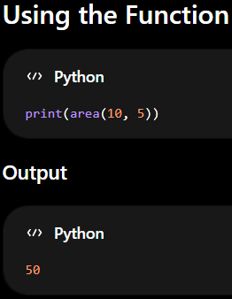
5.2 Unit testing
Class in Python
A class is a blueprint or template used to create objects in Python.
It helps organize related data and functions together in one place.
Classes make programs structured, reusable, and easier to manage.
Using classes, we can model real-world objects in programming.
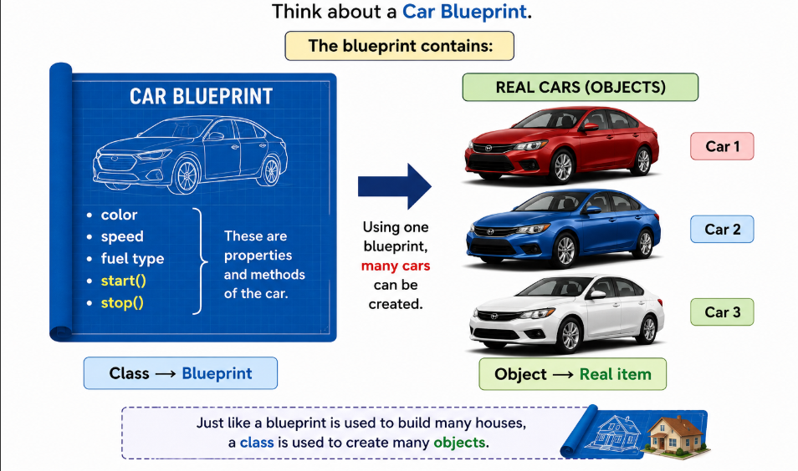
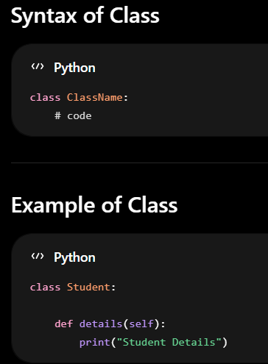
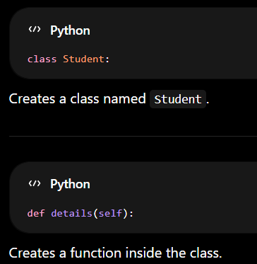

Connection Between Class and Function
A function written inside a class is called a method.
Methods are used to perform actions related to the class.
They help classes perform different tasks and operations.
Methods organize program functionality properly inside classes.
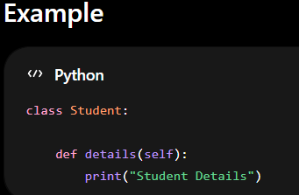
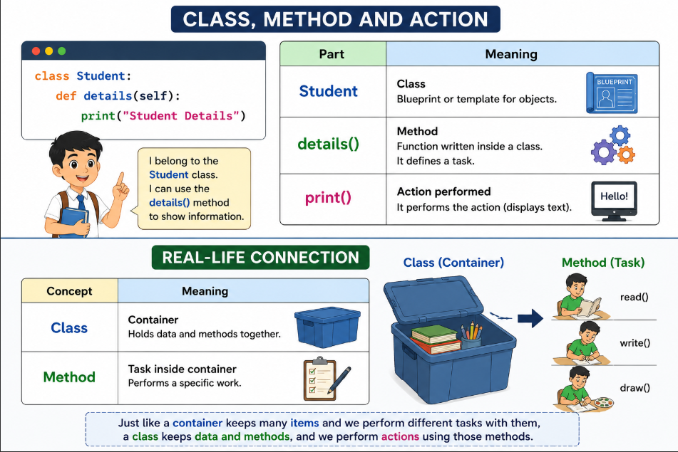
What is self?
self refers to the current object of the class.
It is used to access variables and methods inside the class.
Python automatically passes the current object to self.
self helps methods identify which object is using them.

When an object calls a method:
- self represents that object.
Example for self
Imagine a classroom.
There are two students:
- Anoop
- Rahul
Both students can introduce themselves.
When Anoop speaks:
“I am Anoop”
When Rahul speaks:
“I am Rahul”
Here:
- “I” changes depending on who is speaking.
Similarly in Python:
- self means:
“The current object using the method”

